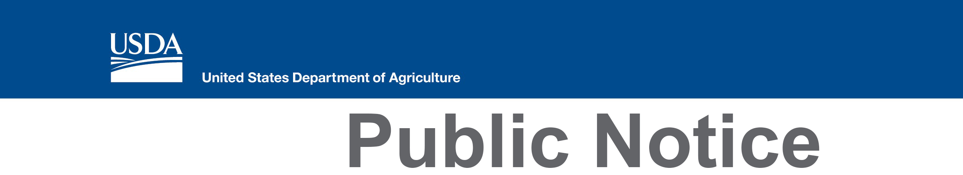
Natural Resources Conservation Service
230 North First Avenue, Suite 509
Phoenix, Arizona 85003
Voice (602) 280-8801
Web: http://www.az.nrcs.usda.gov
Contact:
Diana Cameron
(602) 280-8801

USDA-NRCS Arizona State Technical Advisory Committee Meeting

The public is invited to the next meeting of the Natural Resources Conservation Service State Technical Advisory Committee on May 15, 2018 from 9am–1130pm MST. The meeting will be held at the USDA, US Arid Land Agricultural Research Center, Water Management and Conservation Resources Unit, 21881 North Cardon Lane, Maricopa, Arizona 85138.

These meetings are open to the public. Typical agenda items include conservation priorities and programmatic updates. For more information, call 602-280-8801 or go to http://www.nrcs.usda.gov/wps/portal/nrcs/main/az/technical/stc/.

In accordance with Federal civil rights law and U.S. Department of Agriculture (USDA) civil rights regulations and policies, the USDA, its Agencies, offices, and employees, and institutions participating in or administering USDA programs are prohibited from discriminating based on race, color, national origin, religion, sex, gender identity (including gender expression), sexual orientation, disability, age, marital status, family/parental status, income derived from a public assistance program, political beliefs, or reprisal or retaliation for prior civil rights activity, in any program or activity conducted or funded by USDA (not all bases apply to all programs). Remedies and complaint filing deadlines vary by program or incident.

Persons with disabilities who require alternative means of communication for program information (e.g., Braille, large print, audiotape, American Sign Language, etc.) should contact the responsible Agency [Diana Cameron, Administrative Assistant, NRCS State Office, (602) 280-8801] or USDA's TARGET Center at (202) 720-2600 (voice and TTY) or contact USDA through the Federal Relay Service at (800) 877-8339. Additionally, program information may be made available in languages other than English.

To file a program discrimination complaint, complete the USDA Program Discrimination Complaint Form, AD-3027, found online at How to File a Program Discrimination Complaint and at any USDA office or write a letter addressed to USDA and provide in the letter all of the information requested in the form. To request a copy of the complaint form, call (866) 632-9992. Submit your completed form or letter to USDA by: (1) mail: U.S. Department of Agriculture, Office of the Assistant Secretary for Civil Rights, 1400 Independence Avenue, SW, Washington, D.C. 20250-9410; (2) fax: (202) 690-7442; or (3) email: program.intake@usda.gov.

