MEETING NOTES

Meeting presentations and additional information are available on the California NRCS TAC page.

Tribal Attendees

NAME | TRIBE/ORGANIZATION
Ken Sandusky | Modoc Nation
Diania Caudell | California Basketweavers Association
Ramona Rodriguez | California Basketweavers Association
Lee Frankel | Augustine Band of Cahuilla Indians
Allie Hostler | Klamath Trinity Resource Conservation District, Hoopa Valley Tribe
Christian Aceves | Soboba Band of Luiseño Indians
Brensa Tomaras | Lytton Rancheria
Emily Starnes | Chicken Ranch Rancheria
Audrey McGaughey | Modoc Nation
Kimmerz Davis | Hoopa Valley Tribe
Adam Robledo | Manzanita Band of Kumeyaay
Luya Rivera | Middletown Rancheria
Marina Nunez | Native Americans in Higher Education
Kurt Broz | Pala Band of Mission Indians
Felicia Hill | Iipay Nation of Santa Ysabel
Patie Harris | Pala Band of Mission Indians-Pattie is not with Pala. She is Tribal Member from Fort Peck Assiniboine and Sioux Tribes. She is working with a Tribal Member from Pala and called in from Pala.
Ali Meders Knight | California Open Lands
William Nelson | La Jolla Band of Luiseño Indians
Cody Walker | California Basketweavers Association
Valerie Reed | Wiyot Tribe
Katherine Barnes | California Open Lands
Alice Lincoln Cook | California Basketweavers Association, California Open Lands
Heather Bernikoff | California Association of Resource Conservation Districts
Kanyon Sayers | Indian Canyon Nation

NRCS/Agency Attendees:

NAME | NRCS Position
Jenna Ganoung | Assistant State Conservationist (NRCS CA Area 1)
Ann Stephens | Assistant State Conservationist
Margaret Smither-Kopperl | Plant Materials Center (PMC) Manager
Drew Logan | Acting State Conservationist (NRCS CA Area 2)
Carlos Suarez | CA State Conservationist
Hilary Philips | Acting Public Affairs Officer
Christine Chavez | State Public Affairs & Outreach
Christopher Null | State Archeologist
Cody Leslie | State Tribal Liaison- Southern CA ( NRCS CA Area 3 & 4)
Brandon Bates | Acting Assistant State Conservationist (NRCS CA Area 3)
Jim Cairns | Public Affairs Specialist
RaeAnn Dubay | Deputy State Conservationist
John Gustafson | State Resource Conservationist
Robert Thatcher | Program Staff
Kagat McQuillen | Tribal Liaison - Northern CA (NRCS CA Area 1 & 2)
Tony Rolfes | State Soil Scientist
Debra Denhart | Public Affairs & Outreach
Brooke Raffaele | FSA Outreach Coordinator and Beginning Farmer and Rancher Coordinator

INVOCATION - Kagat McQuillen, NRCS

INTRODUCTION AND WELCOME - Carlos Suarez, State Conservationist

- ISME-CEMA the TAC and the Tribal planning staff recognize the need of an evaluation on planning practices on Tribal lands and respecting Indigenous methods, they incorporate Indigenous and Tribal Cultural beliefs and practices in their practices
- NRCS Section 106 staff now prioritize projects by Federally Recognized Tribes on trust lands and Tribal consultation regarding cultural resources NRCS keeps information shared by Tribes confidential
- Training on Tribal perspective to ensure the staff is trained to work with Tribes- they want to be sure when working with Tribal members that they understand what is the Tribal perspective and implementation of their conservation plan
- Where NRCS is with funding they want to acknowledge their Tribal commitment base of $1 Million for EQIP that is solely dedicated for their Tribal projects and offered Tribal EQIP and highlight that they have requested an additional $1.6 Million in funding because of the demand from Tribal practices with the support of Tribal feedback and IAC in helping provide voice to this need
- Have 4 ISME-CEMA practices obligated in CA 2 in FY23 and 2 in FY24, NRCS will continue discussion with this as they promote the evaluation
- Would like to continue discussing AFA with Tribes that have eligible projects- a tool that allows Tribes in the States to provide direct funds to Tribes to implement conservation practices- it is in the Farm Bill and Farm Bill being extended it will still be available
- Staffing: Kagat and Cody Tribal Liaisons and supervised by RaeAnn and collaborate with IAC to continue providing support. The new administration in January set a hiring freeze nationally for all federal agencies with exceptions of enforcement. All federal agencies are on a hiring freeze, his plan was to add 7 Tribal planners in addition to the 2 that were existing at the time. They are still committed to supporting Tribal conservation

TRIBAL REPRESENTATIVES - PRIORITY CONCERNS
Facilitated by Kagat McQuillen, NRCS
Ken Sandusky, Modoc Nation
- They are using first foods farm because an effective wetland restoration is a traditional cultural materials production opportunity and use farm because Oregon water rights don't see wetlands as a beneficial use of water.
- The NRCS DC reached out to share the prohibitions in the conservation easement and will be a significant barrier for the Modoc people to gather traditional cultural resources in their homelands and the conservation easements are to keep farming but it hinders their ability to restore the wetlands int he current prohibitions. Hoping the Tribal relations folks to be involved to have a rounded perspective.
Diana Caudell, California Indian Basketweavers Association, San Luis Rey Band of Luiseno Indians
- In CA do have a traditional gathering discussions with USFS and BLM and basketweavers want to protect it.
- Promotes awareness of pesticides on any lands for protecting basketweavers

Ramona Rodriguez, California Indian Basketweavers Association
- Present to learn

Lee Frankel, Augustine Band of Cahuilla Indians
- Appreciative with NRCS’ high tunnel program to help extend the season and give a place where predatory insects wont fly away and in a real sandy soil area

Allie Hostler, Klamath Trinity Resource Conservation District
- Top priorities are from their producers- irrigation infrastructure and water conservation, prescribed fire, management of cultural resources for gathering
- supporting local food producers in achieving conservation goals, water storage, fencing, or invasive species removal

Christian Aceves, Soboba Band of Luiseño Indians
- Irrigation systems needs to improve, would like to support for those projects.
- Restoration of traditional landscapes
- Erosion affecting their adjacent farmland and where these programs can apply to would be beneficial other than just farm land- land type.
- Risks to fire- fuels reduction and removal of invasive species

Brenda Tomaras, Lytton Rancheria
- A lot of farming in Sonoma County area and water is the primary issue and being able to do farming in a eco friendly regenerative manner

Emily Starnes, Chicken Ranch Rancheria
- Work on their farm

Audrey McGaughhey, Modoc Nation
- Will there be any future opportunities for Tribes to co-develop or lead conservation initiatives that integrate traditional ecological knowledge, such as cultural burning practices?
- What steps is NRCS taking to incorporate Tribal consultation earlier in the planning and budgeting processes, especially regarding projects that may impact cultural sites or ancestral territories?
- How can Tribal Historic Preservation Officers (THPOs) and NAGPRA representatives engage with NRCS to ensure cultural resources are protected during conservation planning and implementation?

Kimmerz Davis, Hoopa Valley Tribe
- Climate change and its effects such as on water quality
- Risk of wildfire affecting natural resources
- Invasive plant species are impacting native species

Adam Robledo, Manzanita Band of Kumeyaay
- Oaks and Gold Spotted Oak Borrer (GSOB) are concerns especially in local Cleveland forest and continue to see the oak die off
- new water crisis pollution from Mexico is affecting their local fishing waters
- Using prescribed fires for GSOB management and land reclamation

Luya Rivera, Middletown Rancheria
- Invasive species and food sovereignty, they would like to get a garden going and some ag but just starting
- Concerns about land acquisitions and restrictions put on the Tribes with funding agencies specifically deed restrictions prohibiting work and putting on a timeline of forever access. Need to be looked at by those agencies

Marina Nunez, Native Americans in Higher Education and Mentorship (NAHEM )
- First time and listening in

Kurt Broz, Pala Band of Mission Indians
- Wildfire are big concerns and looking for ways for wildlife prevention and related to climate, heat, flooding from issues that go along with wildfire
- Forest health work and forest restoration, losing their forests because of GSOB, there are a couple species of oak and Coast Live Oak are getting hit badly

Felicia Hill, Iipay Nation of Santa Ysabel
- Continued effort with having their Tribes access to clean drinking water and monitoring surface water in respect to algae blooms.
- Building climate resiliency with climate change like taking back their food sources and prioritizing restoration work and culturally significant plants and expanding their native plant nursery and garden.
- Finding balance with fire mitigation and promoting healthy forest plans and restoring forest areas impacted by GSOB.
Patie Harris, Pala Band of Mission Indians Pattie is not with Pala. She is Tribal Member from Fort Peck Assiniboine and Sioux Tribes. She is working with a Tribal Member from Pala and called in from Pala.
- Building a teaching farm with a Tribal member and biggest concern is the water resources
- One thing they are doing is aquaculture and with aquaculture can grow food with 90% savings of water and it would be good if NRCS can fund aquaculture systems as a water savings measure
- Invasive species

Ali Meders-Knight, California Open Lands
- Manage a lot of Mechoopda Tribal lands and particularly Butte County Metafoam, an endemic species up there
- Collaboration for salmon habitat restoration is important. Recently brought in conversation with rice farmers and they want to collaborate with Tribes with wetlands and rice fields for the journey of salmon to get salmon habitat back. Enhance the areas with traditional plants and tending and maybe doing conservation easements on those rice fields for the salmon to travel through
- Have Climate Smart Block Grant up to 2027 and serve 8 Tribes with capacity building for crew development to working on the land. She is working with a lot of practitioners on the land and getting these projects

William Nelson, La Jolla Band of Indians
- GSOB is a big concern, wildfire, and providing advances at least for 25% completed work.
- Having a reimbursement process puts a strain on their Tribal government. Can NRCS accommodate if there can be work completed at 25% can NRCS provide reimbursement at the lower percentage?
- Can NRCS provide more employees for the contracting process and NEPA compliance?
- Assisting to train tribal members in doing conservation projects where they can share their knowledge in the community to multiply the impact of conservation

Cody Walker, California Indian Basketweavers Association
- Biggest issues is the proposal for a 100 year lease along the San Joaquin river, would put a 600 ft pole on the river and right along is salmon habitat that is trying to be restored. The areas along the river is significant. Need to get access to land in general for basket materials and areas where want to do more burning.

Valerie Reed, Wiyot Tribe
- working in community gardens and trying to get info to get her garden up and running to inform the community

Katherine Barnes- California Open Lands
- Present to listen

Alice Lincoln Cook- California Indian Basketweavers Association and California Open Lands
- Present to listen

Heather Bernikoff, California Association of Resource Conservation Districts
- Can help with connecting Tribal organizations to community needs and supporting TCDs

Kanyon Sayers, Indian Canyon Nation
- Protections (how to prevent land grabs) protect archeological sensitive areas. I'm concerned about Blue Wind studies garden who makes money off TEK yet doesn't invite natives and doesn't even acknowledge the land he benefits from and teaches on and does teach about the ripple of settler colonialism -the reason why his classes are so popular

NRCS TRIBAL TEAM UPDATES- Cody Leslie - Tribal Liaison
- NRCS Work in Indian Country- NRCS does work on conventional Ag lands and also work with Tribes on more Traditional Land Management with respect and appreciation for TEK
- A site does need to have plants in the ground and irrigation records needed for 3 years to be considered eligible for NRCS programs, NRCS cannot help in starting a farm
- Important reminders of EQIP program application deadlines in late fall
- Existing clients- contact field offices at the completion of practices for certification and payment of practices and ensure work is done for implementation requirements- so that there is no delay for payment process

INTERTRIBAL AGRICULTURE UPDATES- Lena Ortega - California Technical Assistant Specialist
- Accomplishments in 2024 with NRCS-IAC Cooperative Agreements
- WEWAI training for NRCS with the Shingle Springs Band of Miwok Indians
- Intertribal Nursery Training- represented CA Tribal Nations
- Outreach & Planning Sessions in Owens Valley, Tule River, and the California Tribal Nursery Training
- 2024 Interns: Amelia Houlgin & Haiwee Fredericks
- Pacific Region Summit at Coyote Valley Casino highlighted Tribal Food Sovereignty and cultural burning efforts across California

NRCS PROGRAM UPDATES- Robert Boettcher - Acting Assistant State Conservationist for Programs
- Although there are application deadlines, NRCS accepts applications anytime, the recommendation is to start the application process early
- EQIP, CSP, CIG, ACEP, RCPP
- Program Status- NRCS doing payments for all existing contracts and customers an EQIP and CSP moving forward and writing new contracts using the Farm Bill funds, and moving forward with RCPP and Easements, but there is a Pause on new IRA obligations
- FY24 Obligations Total $148,731,240 to EQIP
- Funded 13 applications in the Tribal pool in FY2024
- All Tribal applications are considered ‘high priority’
- The Tribal pool split into 2 categories: (1) Tribal diversified farms/or tribal traditional plant restoration (2) Tribal Range Health and/or forest health
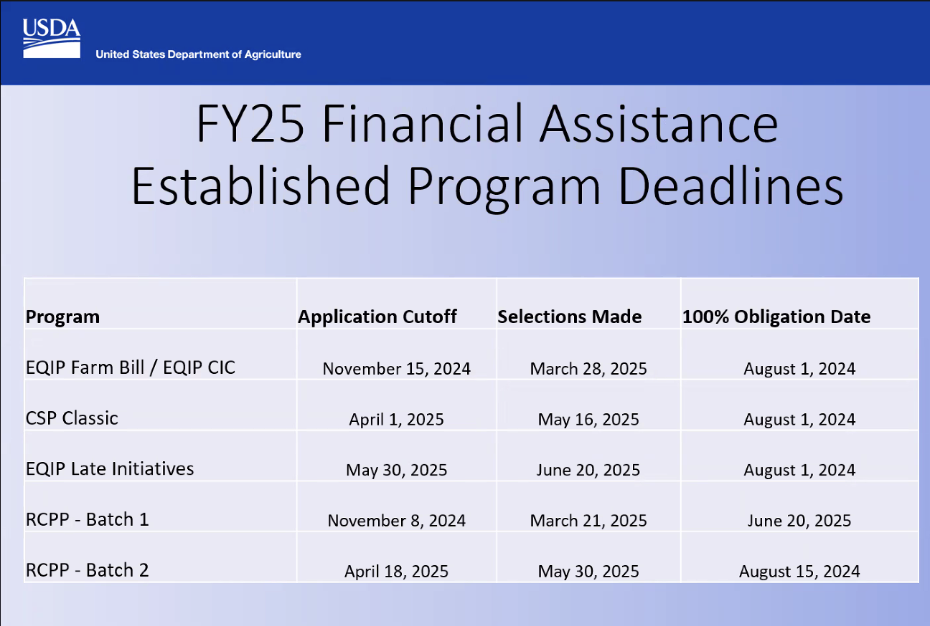

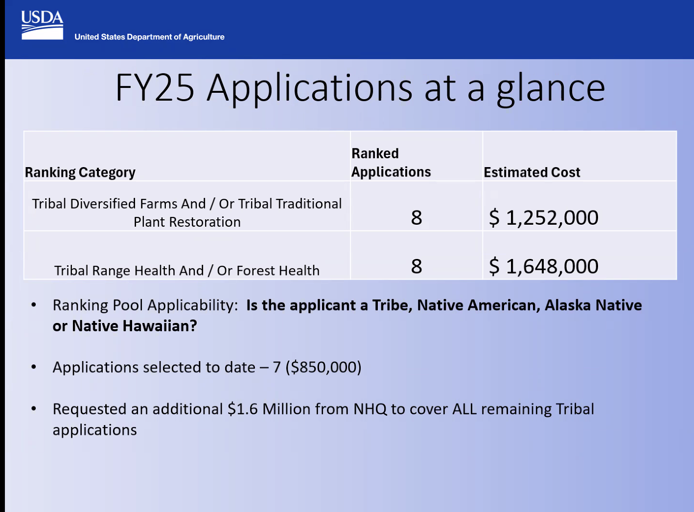
PARTNER PRESENTATION - FIRE & NRCS on Trust Land: La Jolla Reservation- Bill Nelson and Joelene Tamm
- Bill working with Joelene for the last 3 years on managing Gold Spotted Oak Borrer (GSOB), wildfires fires, drought, top soil loss, erosion
- In San Diego County roughly 8800 acres of deep terrain in certain areas and range 900-200 ft and have the San Luis Rey that goes through the middle of their reservation
- In 2007 had the fire that burned 95% of the reservation and 52 homes were burned
- Mainly worked in their camp area roughly 250 acres, 1000 trees in that 250 acres that have died and 800 of those they had to cut down and it is a lot of work and big cost. $3000-$10000 to cut down a tree
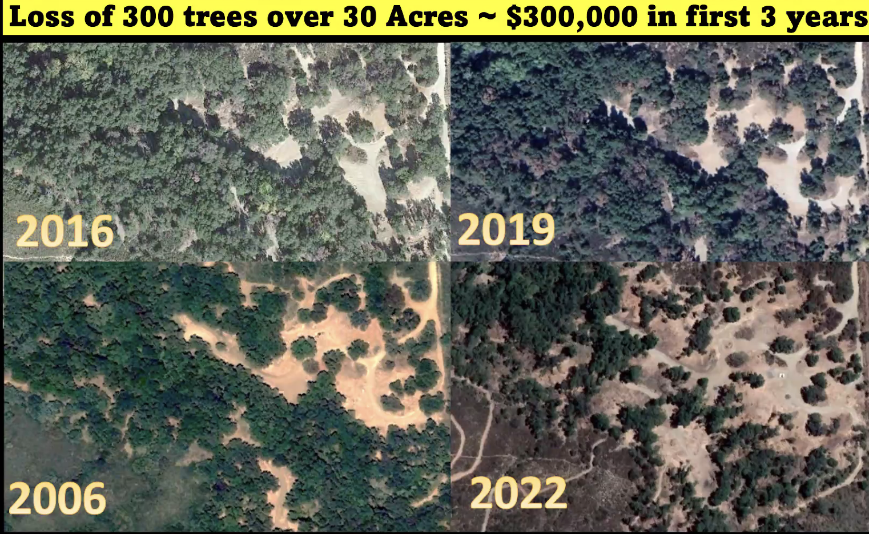
- These trees are culturally tied to them and they are their source of food and shade
- Some mitigation strategies for GSOB are capacity building, fuel banks and Rx Fire and chipping biomass. Did first cultural burn last year, replanting 200 trees, did outreach and training to educate the members on the effect of the beetle and what to look for when trees are stressed
- Capacity building to cut trees down and provide employment, focused on developing the capacity to handle the NRCS and other contracts
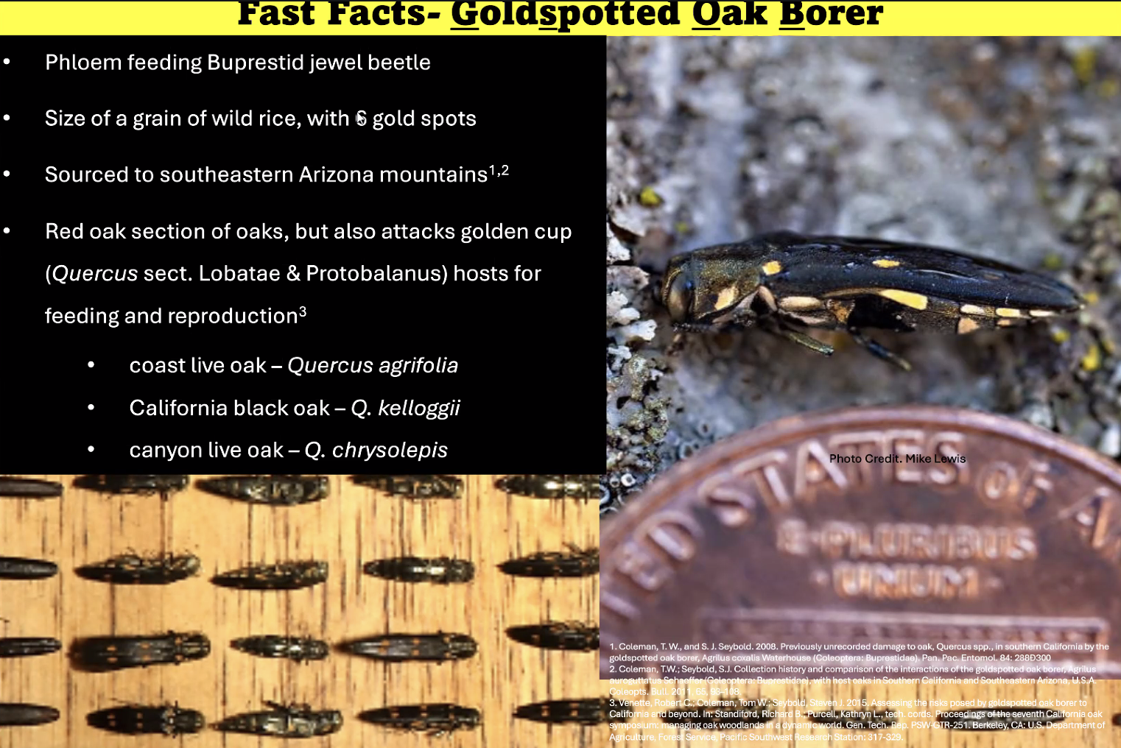
- Cambium is where GSOB feeds and destroys the Xylem and disturbed the Phloem, it happens until there is just poo in the vascular system of the tree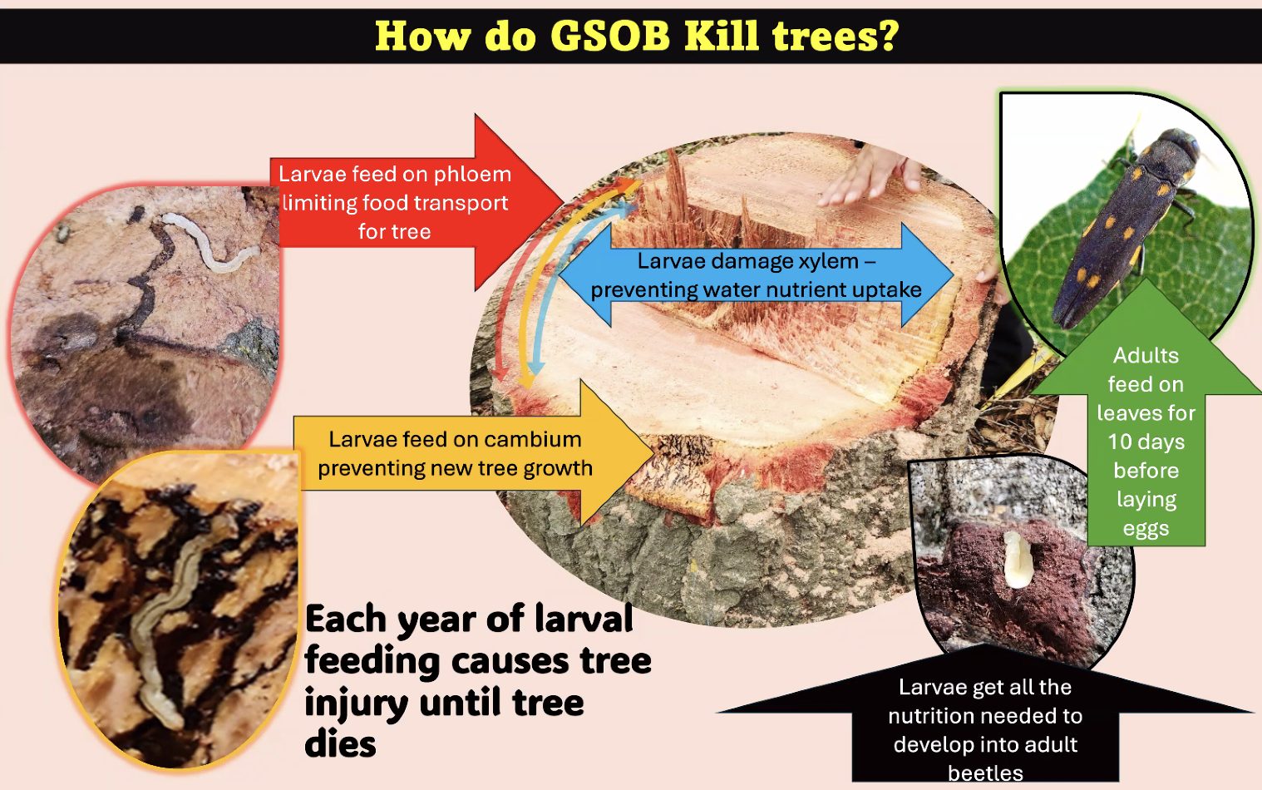
- It is hard to address treatment strategy because GSOB is protected in the tree trunk
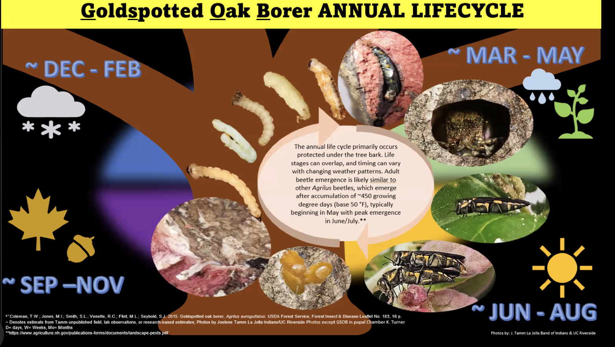
- Their path to burning is a 4-5 year process starting the fire management plan to forest management plan and training to have a qualified person on. NRCS completed NEPA
- 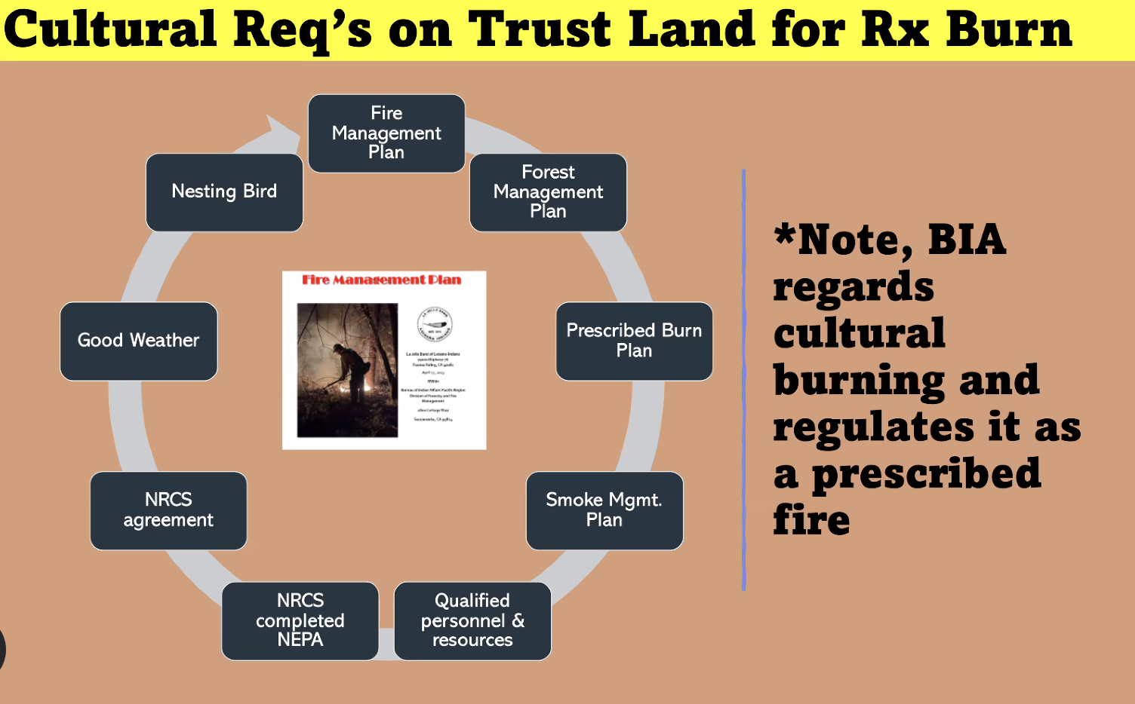
- They did 3 acres of cultural burning
- Fire management and forest management and Prescribed fire plan for BIA and comply with smoke management plan because of BIA agreement with the State agreement for Air resource quality board- once they have the templates, they are easy to edit and update. A smoke management plan is fairly simple: it identifies your sensitive receptors and determines how it will shut down the burn if it affects anyone or how to keep people for safety. This is an annual plan and easy after you do a few of them and update them. Forest and fire management plan is more intensive includes tribal member input and approved by council and by BIA last. They are technically required to do burning on trust plans and regional plans are outdated. Regional plans are not helpful in here
- 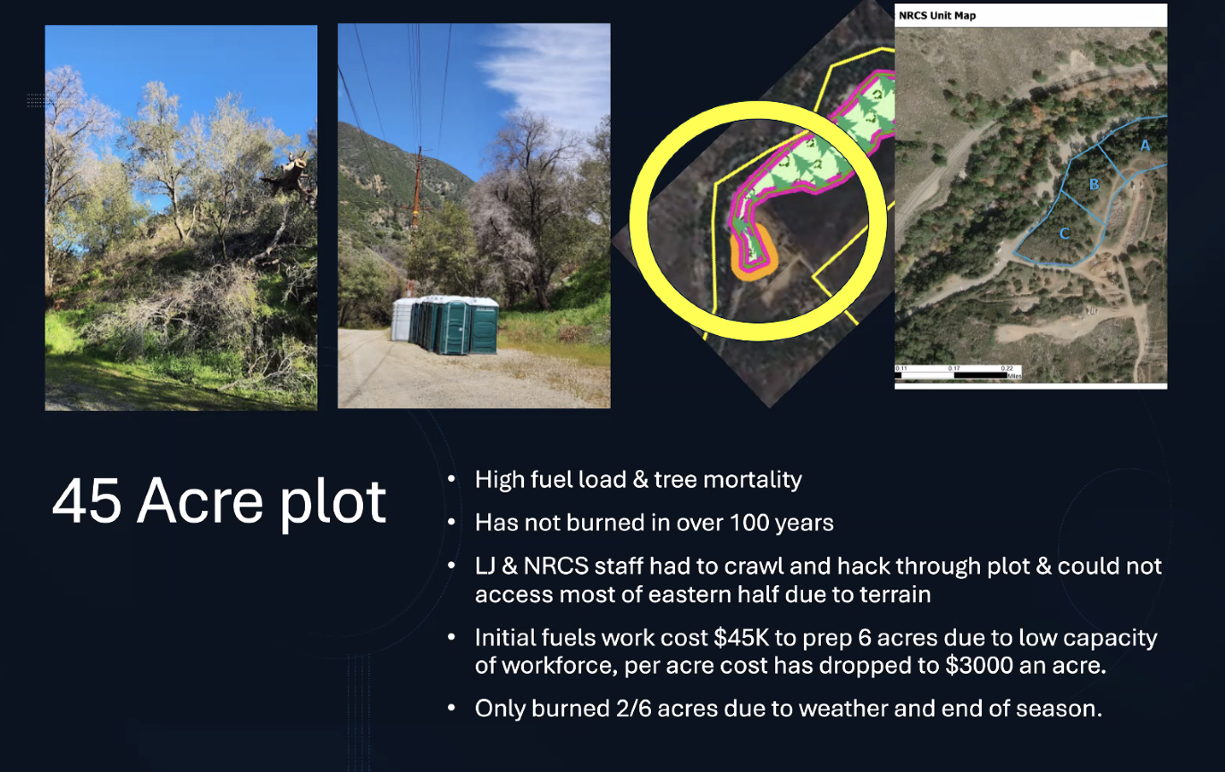
- USFS Cal Fire, State Parks, Neighboring Tribes for the burn, took a lot of staff to get this done and it was great training for their crew
- Only burned plot A of the burn unit because of weather (wind) they had to stop
- They put up a sign to talk about the burn in English and Spanish
- Have nice revegetation of the host site and trees are doing better
- 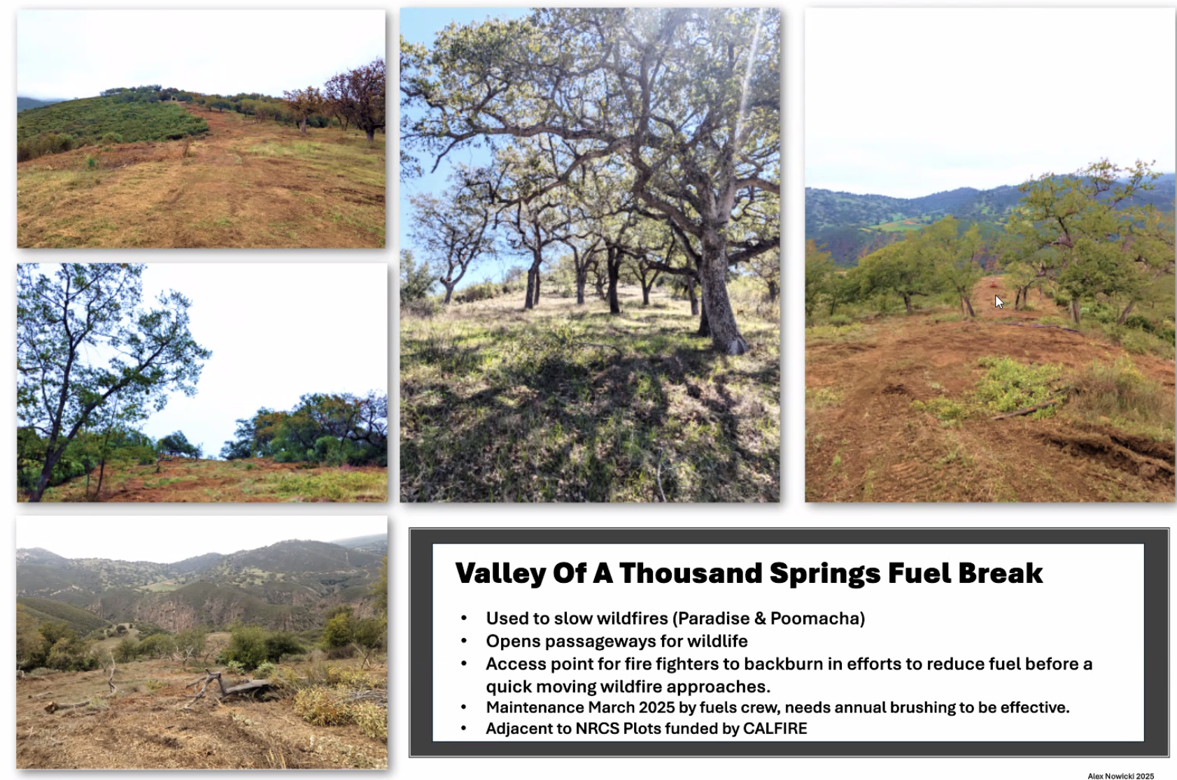
- Burn plots have opened up for wildlife that were choked out by heavy fuel load like deer, turkeys, and
- This was funded by CalFire
- They have a prescribed fire Template and can send a fire and forest management template to share. She took all other plans and copy and pasted until it made sense and used google gemini to help out. Email Joelene if you want the templates and have a workshop on the 28th for invasive species management for Tribal employees.

PARTNER PRESENTATION - Tribal Assistance Programs”- Bureau of Reclamation- Water Resources Specialist, Kerri Denhalter
- They have in-house NEPA status access
- They usually offer WaterSMART Programs: Basin Study Program, Title XVI Program, WaterSMART Gramts, Water Conservation Field Services Program, Drought Response Program, Cooperative Watershed Management Program- their funding is currently on hold
- No cost share with the Native American Funding Opportunities- (1) the funding provides technical assistance to assist Indian Tribes to develop, manage, and protect their water and related resources and (2) Emergency Drought Relief assists eligible Tribes in developing, managing, and protection their water resources to mitigate drought impacts
- Tips on applying for funding- be specific when applying, no fluff, answer every part of the application even if it doesn't apply, write in that it doesn't apply because leaving it blank will mark it down. Tell your story because people on these committees are from all over and don't know what affects you. If your grant isn't awarded, ask for a debrief.
- Some of the funding does take time to get awarded. From NOFO posting to Award of funding = 12-14 months

REVIEW ACTION ITEMS DISCUSSED DURING MEETING- Cody Leslie & Kagat McQuillen
- Issue regards to funding and how it is based regional, NRCS has rolled out a payment calculator and it is set by county and the cost of living. It might have not accomplished getting the full funding
- Speeding up the NEPA compliance Section 106 because producers shared how it was slowing it down
- Projects on Tribal Trust land is prioritized
- Tribal humility classes working to keep providing WEWAI and as a liaison he is trying to assist field offices on initial site visits
- If you have issues demonstrating land control give Cody or Kagat a call or email and they can strategize on how they can move forward
- Their EQIP practices are set nationally based on the average cost to implement, plan, and monitor those practices, in CA they set some different rates for those practices. It is County by County now. One strategy to get away from those specific rates and practices for Tribes is the AFA program to justify a higher cost if it is costing them more money than what the practices are paying
- ISME-CEMA practice is getting off the ground and seeing more examples from CA and around the Nation and have wrinkles smoothed out on those Indigenous stewardship practices. More planners are more familiar with it and a good way to begin working with NRCS or further a contract if already working with NRCS
CLOSING REMARKS

