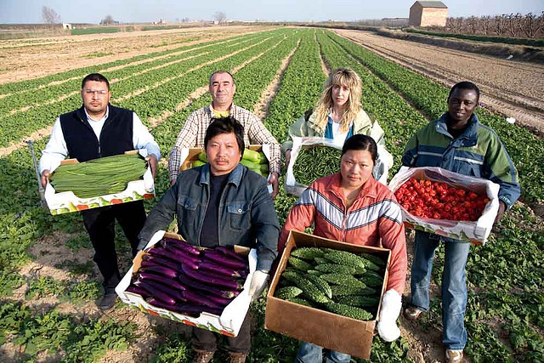

**Southeastern Agriculture Conference & Outreach for Multicultural Famers**

**Where:** Mobile Convention Center

1 S Water ST, Mobile AL 36602

203 Conference Room

**When:** Wednesday August 21, 2024

**Time:** 9:30 am – 3:00 pm

|  |  |
| --- | --- |
| 9:30 Moderator ------------------------------------------------- | Jerome Brown, Ag Consultant |
| 9:30 Introduction ------------------------------------------------- | Ernest Harvey, Cultivating Alliance Inc. |
| 9:35 NRCS Farm Bill Programs -------------------------------- | Jason Gardener, ASTC-Programs, USDA-NRCS |
| 10:00 Eligibility/Applications for USDA Programs -------- | Lashannda James, Mobile County FSA CED, USDA-FSA |
| 11:00 Urban Agriculture/Climate Smart Programs ------ | Christine Cooley, District Conservationist, USDA-NRCS |
| 11:30 Agriculture Partnerships & Outreach --------------- | Andrew Williams, Retired NRCS Employee |
| 12:00 Lunch/ Keynote Speaker ------------------------------- | Micheal Jackson, Urban Ag Farmer |
| 1:00 Increasing Demond for Agriculture Tourism -------- | Jerome Brown, Wandalands Vineyard & Orchards |
| 1:30 Heir’s Property & Re-lending --------------------------- | Heir’s Property Center |
| 2:30 Success Stories --------------------------------------------- | Multicultural Successful Farmer Panel |
| 3:00 Adjourn & Group Photo |  |