600-CPS-1



**United States Department of Agriculture**

**Natural Resources Conservation Service CONSERVATION PRACTICE STANDARD TERRACE**

**CODE 600**

**(ft)**

# DEFINITION

An earth embankment or a combination ridge and channel, constructed across the field slope.

# PURPOSE

This practice is used to accomplish one or more of the following purposes:

* Reduce erosion and trap sediment.
* Manage runoff.
* Soil moisture conservation.

# CONDITIONS WHERE PRACTICE APPLIES

This practice applies only where the soils and topography are such that terraces can be constructed, a suitable outlet can be provided, and where one or more of the following conditions exist:

* Soil erosion caused by water and excessive slope length is a concern.
* Excess runoff is a concern.
* Water conservation is needed.
* The predominant land slope is 18% or less.
* The soil survey land capability class is IV or less.

# CRITERIA

## General Criteria Applicable to All Purposes

Plan, design, and construct the terrace to meet all Federal, State, Tribal, and local regulations.

Avoid areas of shallow or dense bedrock and acidic or saline layers that will adversely affect plant growth when locating terraces. Utilize field investigations and soil surveys to identify potential problems areas.

## Types of Terraces

Terraces come in many configurations and designs. Choose the type of terrace based on the client’s conservation objectives, cultural practices, field topography, soils, etc. The following is a brief description of the types of terraces available and the typical functional settings in which they are applied.

Gradient terraces can be either parallel or non-parallel. They may be constructed of any cross section type defined within this standard and use either a vegetated or an underground outlet to discharge runoff.

Level terraces can be either parallel or non-parallel. They may be constructed of any cross section type defined within this standard and use either the infiltration capacity of the soil or an underground outlet to discharge runoff. Level terraces work best on deep soils with high infiltration rates.

## Alignment

Terraces must follow the contour of the land. Limit deviations from the contour and allow only when necessary to obtain good alignment. To accommodate farm machinery and farming operations, design cropland terraces with long gentle curves, where feasible. When multiple terraces are used in a field, design the terraces to be as parallel to one another as practicable. Refer to Iowa NRCS Conservation Practice Standard (CPS) Contour Farming (Code 330) for guidance on planning farming operations.

Use land forming, extra cut or fill along the terrace line, multiple outlets, variations in grade, channel blocks, and other methods to achieve good alignment. Use correction areas where needed to achieve a better contour row pattern.

## Spacing

Space terraces at intervals across the slope to achieve the intended purpose. The maximum spacing of terraces for erosion control is that necessary to achieve the soil loss tolerance (T) or other soil loss criteria that is documented in the Field Office Technical Guide. Maximum spacing for erosion control based on soil loss tolerance may be increased by as much as 10 percent to provide better location and alignment to accommodate farm machinery or to reach a satisfactory outlet.

The methods to determine terrace spacing include the current NRCS accepted erosion prediction technology, the vertical interval equation, or current spacing table(s) published as an Iowa Amendment to Title 210, National Engineering Handbook, Part 650 – Engineering Field Handbook, Chapter 8, “Terraces” (210-NEH-650-8). Refer to the current NRCS accepted erosion prediction technology to determine soil loss. The slope length used when checking soil loss for a proposed terrace spacing is the distance from the terrace ridge to the next lower terrace channel measured along the natural flow direction as shown in Figure 1.

Include both the terrace system with design slopes and cultural practices such as residue management when determining soil loss. Refer to the NRCS National Engineering Handbook (NEH) (Title 210), Part 650, Chapter 8, “Terraces” for use of the vertical interval equation.

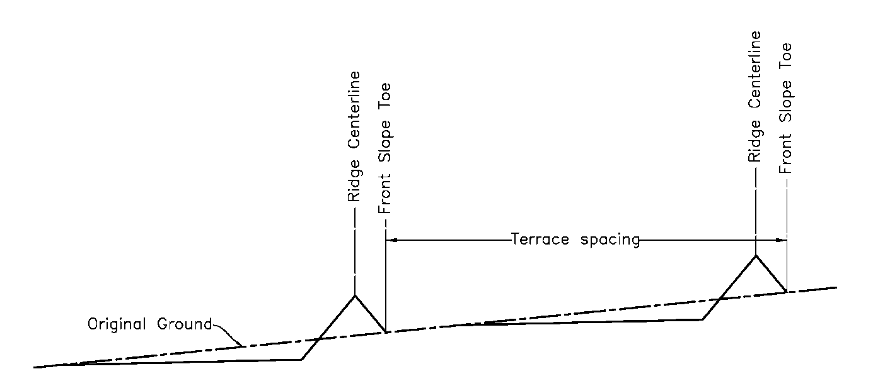

Figure 1. Spacing Between Terraces

## Capacity

At a minimum, design terraces to have enough capacity to control runoff from a 10-year-frequency, 24-hour storm without overtopping. For terrace systems designed to control excess runoff or to function with other structures, choose a larger design storm that is appropriate to the risk associated with the installation.

For terraces with underground outlets, the capacity to contain the design storm can be a combination of storage and outflow through the underground outlet. Regardless of flood routing results, the minimum storage capacity must not fall below 60% of the total runoff plus the estimated sediment accumulation. For terraces that store runoff (storage or level terraces), increase the storage capacity by the estimated 10-year sediment accumulation, unless the operation and maintenance plan specifically addresses periodic removal of sediment.

For terraces with open outlets, base the terrace channel size on the capacity using the densest and longest vegetation. Base the capacity of the channel on a bare earth channel for cropped fields, or in the case of a permanently vegetated channel, the appropriate vegetation. Channels must also be stable. Refer to the **Channel Grade** section for stability requirements.

For bare earth channels, use a Manning’s n value of 0.035 or greater to calculate capacity. For permanently vegetated channels, refer to Iowa NRCS CPS Grassed Waterway (Code 412) for design criteria to determine capacity and Iowa NRCS CPS Critical Area Planting (Code 342) for seeding criteria.

Except as noted for Ida and Monona soils in the **Level Terrace** section of this standard, storage for runoff must be provided over a sufficient length of the terrace to prevent ponding unless an underground outlet is used.

## Terrace cross section

Proportion the terrace cross section to fit land slope, crops grown, and farm machinery used. Avoid use of terrace cross sections that results in disturbance of the majority of the soil in the spacing between terraces. Add ridge height, if necessary, to provide for settlement, channel sediment deposits, ridge erosion, the effect of normal tillage operations, or safety. Use a minimum settlement allowance of 10% for narrow-base terraces and a minimum of 5% for other terrace types. At the design elevation, the ridge must have a minimum width of 3 feet.

Design gradient terraces, non-storage sections of level terraces, and terraces with underground outlets with a minimum design height of 1 foot measured from the bottom of the channel to the top of the terrace ridge.

Design all farmable terrace slopes and cut slopes no steeper than 5 horizontal to 1 vertical and in increments of machinery width but no shorter than 15 feet to allow safe operation of farming equipment. For nonfarmable terrace slopes, the steepest slopes allowable are 2 horizontal to 1 vertical unless an analysis of site specific soil conditions indicate that steeper slopes will be stable.

See Additional Criteria sections for cross section criteria specific to each terrace type.

## Channel grade

Design the terrace channel to be stable with nonerosive velocities but with sufficient grade to prevent prolonged flooding that would damage crops or delay farming activities. For cultivated terraces, base the channel stability on a bare earth condition using a maximum Manning’s n value of 0.035. For permanently vegetated channels, base the channel stability on the appropriate vegetation. Refer to Iowa NRCS CPS Grassed Waterway (Code 412) and 210-NEH-650, Chapter 7, “Grassed Waterways” for design criteria and procedures to determine stability for both bare and vegetated conditions.

For distances lass then 100 feet in the upper reaches of a channel, grades may be increased to improve alignment. For terraces with an underground outlet, the channel grades may be up to 8% in the channel section that is below the 70% storage depth elevation within the impoundment area.

## Level terraces

Construct the channel and ridge of level terraces, including basin terraces, to be level over the entire length of the terrace, except that the channels on Ida or Monona soils need not be leveled if the temporary ponding is acceptable to the landowner.

For short reaches near the end of the level terrace, graded channels may be used if adequate storage is provided in the storage sections. Do not exceed channel grades specified for gradient terraces.

The volume of water stored in level terraces is proportional to the length. To reduce the potential risk from failure, limit the length of level terraces to 2,000 feet unless the channel is blocked at intervals not exceeding 2,000 feet. Level terraces can have either full- or partial-end closures or be open-ended. If a partial-end closure is used, areas downstream from the end closure must be protected from damage by flow that will exit from the closure before the design storm is reached.

## Outlets

All terraces must have adequate outlets. The outlet must convey runoff water to a point where it will not cause damage. Combinations of different outlet types may be used on the same terrace system to optimize water conservation, improve water quality, accommodate farming operations, or provide for economical installation. The capacity of any surface outlet must be large enough so the terrace can properly discharge at the design flow.

Do not outlet terraces on the right of way of public road or highway or other public utility without approval of the proper authorities.

Underground outlets are suitable for use on all terrace types. The outlet consists of an intake and an underground conduit. If underground outlets are to be constructed, use Iowa NRCS CPS Underground Outlet (Code 620). Design the outlet so the water storage time does not exceed the inundation tolerance of the planned crop. If sediment retention is a primary design goal, adjust the release rate according to sediment particle size. Locate the intake structure for the underground outlet to accommodate farming operations and to allow for sediment accumulation.

Offset the inlet from the main conduit with at least 8 feet of non-perforated conduit between the inlet and the main conduit. The topmost inlet may be placed directly on the main conduit when non-perforated conduit is installed from the inlet to the toe of the terrace back slope.

Soil infiltration may be used as the outlet for level terraces. Soil infiltration rates under average rainfall conditions must permit infiltration of the design storm from the terrace channel within48 hours or shorter if necessary for the health of the growing crops..

## Vegetation and Topsoiling

Salvage topsoil from the footprint of the construction area of the terrace to spread over the excavated slopes and terrace ridges to facilitate restoration of the field or establishment of vegetation unless the excavated slope or ridge surface is of similar texture as the available topsoil.

Stabilize all areas planned for vegetation as soon as possible after construction. Refer to Iowa NRCS CPS Critical Area Planting (Code 342) or State planting guide for seeding criteria, and as needed, use the criteria in Iowa NRCS CPS Mulching (Code 484). Establish temporary cover on disturbed areas such as channels and borrow areas that are not planned for permanent vegetation, but will not have a crop planted within 90 days.

**Additional Criteria Applicable to the Cross Section of a Broadbase Terrace**

Do not install broadbase terraces on land that is steeper than 6% slope.

Where excavation for the terrace ridge is taken on the uphill side, the final cut slope shall not exceed 8%. All portions of the broadbase terrace may be farmed. Refer to Figure 2 for additional criteria.

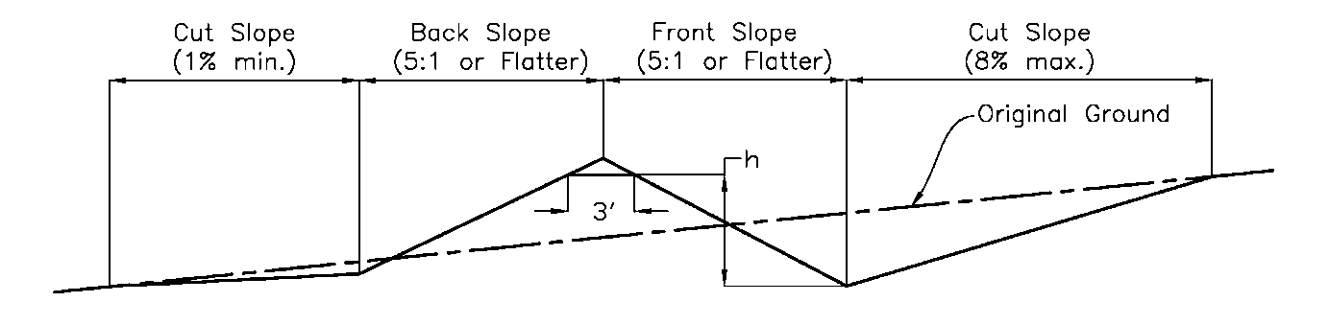

Figure 2. Broadbase Terrace Cross Section

**Additional Criteria Applicable to the Cross Section of a Grassed Front, Farmable Backslope Terrace**

Do not install grassed front, farmable backslope terraces on land that is steeper than 6% slope.

Borrow excavation for this type of terrace may be taken from either uphill or downhill sides of the terrace. Where borrow is obtained from the uphill side, the final cut slope must not exceed 8%.

Seed the front slope to grass.

Design the front slope no steeper than 2:1. Refer to Figure 3 for additional criteria.

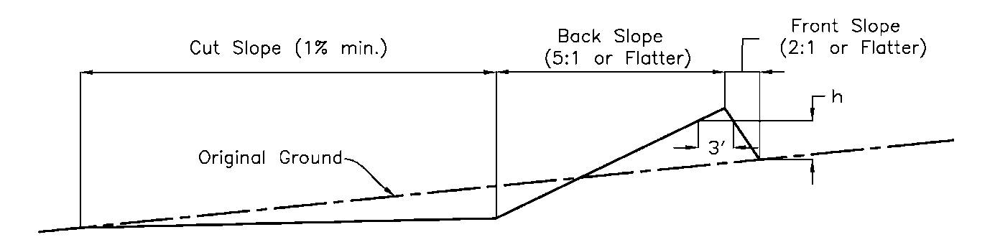

Figure 3. Grassed Front, Farmable Backslope Terrace Cross Section

**Additional Criteria Applicable to the Cross Section of a Grassed-Back, Farmable Front Slope Terrace**

Take borrow for the grassed-back, farmable front slope cross section from the downhill side except where excavation from other areas is needed to enhance alignment or farmability.

Seed the backslope to grass. Design the backslope no steeper than 2:1.

Refer to Figure 4 for additional criteria.

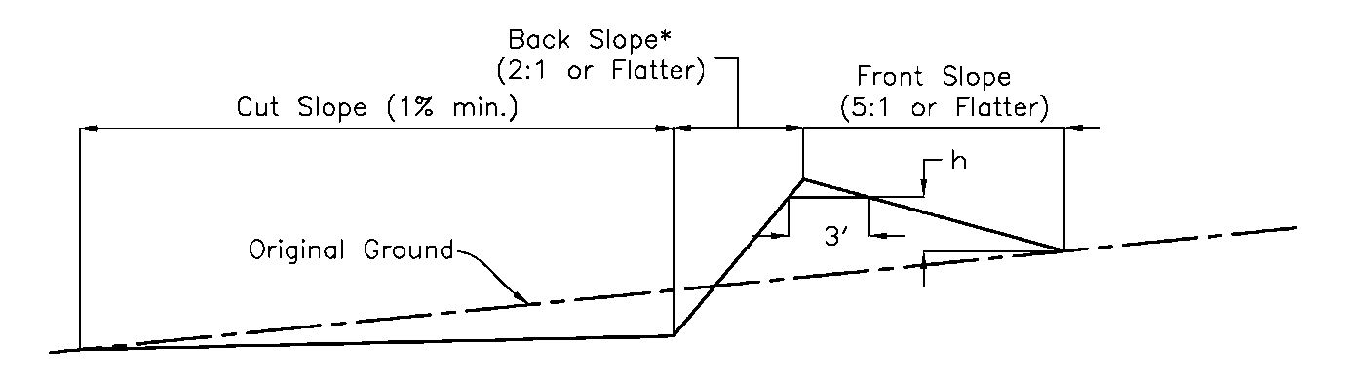

Figure 4. Grassed Back, Farmable Front Slope Terrace Cross Section

*Ida and Monona soil series may have a backslope constructed no steeper than 1 ½ horizontal to 1 vertical

**Additional Criteria Applicable to the Cross Section of a Narrow-Base Terrace**

Seed the front and backslope of a narrow-base terrace to grass. Take excavation for this type of terrace from the downhill side except where borrow from other areas is needed to enhance alignment or farmability.

Design the front slope and the backslope no steeper than 2:1. Refer to Figure 5 for additional criteria.

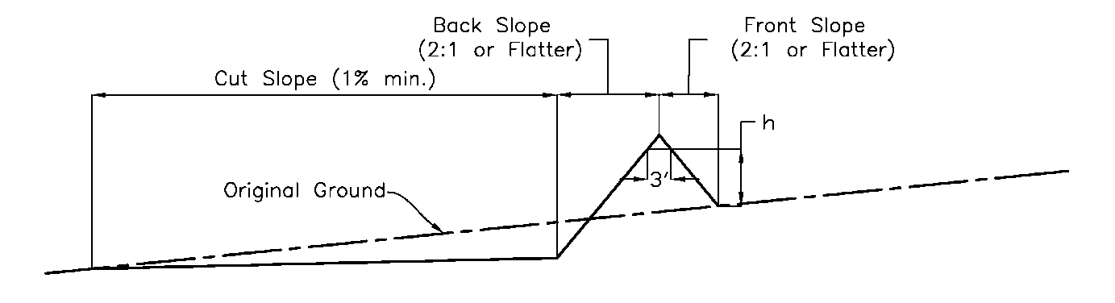

Figure 5. Narrow-Base Terrace Cross Section

## Additional Criteria for Managing Runoff and Soil Moisture Conservation

For terraces installed to retain runoff for moisture conservation, perform a water budget analysis to determine the volume of water that must be collected to meet the requirements of the water budget.

For terraces installed to manage runoff to reduce flooding or ponding, size the detention volume of all terraces in the system such that the necessary downstream flood protection is achieved.

As a minimum, the terrace must still meet the design storm runoff volume and sediment volume requirements in the Capacity section above.

# CONSIDERATIONS

Consider climate change impact on determining channel’s capacity.

Outlets from terraces might provide a direct conduit to receiving waters for contaminated runoff from cropland. Consider impacts on downstream source water due to erosion and sediment load and impacts on important fish and wildlife habitats such as streams, creeks, riparian areas, groundwater, and wetlands. Consider providing an increased level of designed treatment for sites with high priority areas for source water protection or are upstream of community drinking water withdrawal sites. Terraces should be installed as part of a conservation system that addresses issues such as nutrient and pest management, residue management, and filter areas.

Consider farm equipment size when determining layout. This may include making curves long and gentle and spacing terraces so the operator can make an even number of trips between terraces in order to end up on the same side of the field they started.

When revegetation is needed, consider using species or diverse mixes that are native or adapted to the site and have multiple benefits. In addition, where appropriate, consider a diverse mixture of forbs and wildflowers to support pollinator and other wildlife habitat. If USDA certified-organic and or transitioning-to- organic operations, all materials need to comply with the USDA National Organic Program (NOP) Standards, including all seeds, planting stock, fertilizers, and other production inputs.

Terrace ridges and cut slopes can introduce steep and potentially hazardous slopes into a crop field. Where slopes will be farmed, make sure they can be safely negotiated with the operator’s equipment. Where steep slopes are unavoidable make sure the operator is aware of the location and potential danger of the slopes.

Steep-sided terraces that are in permanent vegetation can provide significant areas of habitat for wildlife. Planting native species can provide food and cover for wildlife.

Hillside seeps in a crop field can cause cropping problems. Consider aligning terraces and/or installing subsurface drainage to intercept and correct seepage problems. Install the drainage prior to terrace construction by using Iowa NRCS CPS Subsurface Drain (Code 606).

Intakes for underground outlets can be easily damaged during cultivation, planting, and harvesting operations. Using brightly colored inlets, barriers around the inlet, or otherwise clearly marking the inlet will help prevent damage.

# PLANS AND SPECIFICATIONS

Prepare plans and specifications that describe the requirements for applying the practice according to this standard. As a minimum the plans and specifications must include—

* A plan view of the layout of the terrace system.
* Typical cross sections of the terrace(s).
* Profile(s) or planned grade of the terrace(s).
* Details of the outlet system.
* If underground outlets are used, details of the inlet and profile(s) of the underground outlet.
* Seeding requirements, if needed.
* Site-specific construction specifications that describe in writing the installation of the terrace system.
* Use Iowa NRCS standard drawings where appropriate.

The following list of Construction Specifications is intended as a guide to selecting the appropriate specifications for a specific project. The list includes most, but may not contain all, of the specifications needed:

* IA-5 Pollution Control
* IA-6 Seeding and Mulching for Protective Cover
* IA-600 Terraces
* IA-620 Underground Outlets

# OPERATION AND MAINTENANCE

Prepare an operation and maintenance plan for the operator to follow for the design life of the terrace system. The minimum requirements to be addressed in the written operation and maintenance plan are—

* Intended orientation of the primary farming operations, usually parallel to the terrace(s).
* Periodic inspections, especially immediately following significant runoff events.
* Prompt repair or replacement of damaged components.
* Maintenance of terrace ridge height, channel profile, terrace cross sections and outlet elevations.
* Removal of sediment that has accumulated in the terrace channel to maintain capacity and grade.
* Regular cleaning of inlets for underground outlets. Repair or replacement of inlets damaged by farm equipment. Removal of sediment around inlets to ensure that the inlet remains the lowest spot in the terrace channel.
* Where vegetation is specified, complete seasonal mowing, control of trees and brush, reseed and fertilize as needed.
* Repair damages from burrowing animals.
* Notification of hazards about steep slopes on the terrace.

# REFERENCES

USDA NRCS. 2004. Revised Universal Soil Loss Equation, Ver. 2 (RUSLE2). <http://fargo.nserl.purdue.edu/rusle2_dataweb/RUSLE2_Index.htm>

USDA NRCS. 2021. National Engineering Handbook (Title 210), Part 650, Engineering Field Handbook, Chapter 7, Grassed Waterways. Washington, D.C. https://directives.sc.egov.usda.gov/OpenNonWebContent.aspx?content=46771.wba

USDA NRCS. 2021. National Engineering Handbook (Title 210), Part 650, Engineering Field Handbook, Chapter 8, Terraces. Washington, D.C. https://directives.sc.egov.usda.gov/OpenNonWebContent.aspx?content=46257.wba