



August 17, 2023

Invitation to the Tribal Conservation Advisory Council Meeting:

The [USDA-Natural Resources Conservation Service (NRCS) in South Dakota](https://www.nrcs.usda.gov/wps/portal/nrcs/site/sd/home/) routinely invites and welcomes Tribal input on NRCS programs and activities. The next Tribal Conservation Advisory Council (TCAC) meeting is scheduled to be held virtually on Thursday, September 28, 2023. The meeting will start at 10 a.m. CDT and those participating can join through Microsoft Teams Meeting video or by audio through a direct phone line.

These meetings are an opportunity to hear your Tribal natural resource needs and your conservation efforts. The NRCS in turn will share information on agency activities, assistance programs, training opportunities, and partnership efforts. You do not need to pre-register or be listed as a committee member to attend; however, if possible, please let us know prior to the meeting if you have a specific topic you would like to discuss so we can be better prepared to assist you. Based on the attached tentative agenda, we anticipate the meeting may run approximately one to two hours.

A Microsoft Teams Meeting invite notice with the meeting link and phone number will be sent soon to past TCAC participants’ email address. 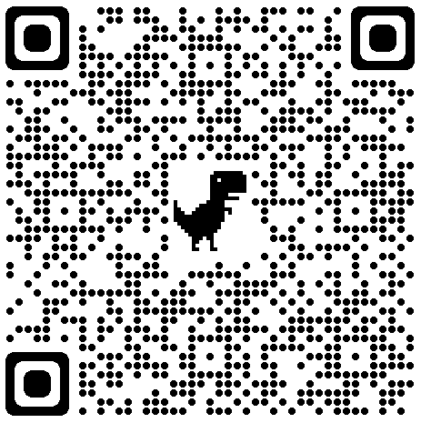If you desire to be removed from this list, to receive an emailed notice, or if you suggest others who should be notified instead, please notify your appropriate Tribal Liaison (listed below) or send to Randi Papka, Secretary, at [randi.papka@usda.gov](mailto:randi.papka@usda.gov). We will email you the meeting notice and link to access the Teams Meeting through video by August 28, 2023. If you are interested in joining by phone only, please use the following information below:

Scan for past TCAC meeting information.

Phone Conference #: (202) 650-0123 Phone Conference ID: 668 748 423#

Please contact your local NRCS Tribal Liaison (listed below) or my office if you would like to discuss a topic but are unable to participate in this next TCAC meeting. For more information, call (605) 352-1200, or leave a message on our 24-hour voicemail messaging service by dialing 1-800-872-7502, Extension 1205.

Persons needing special accommodations should contact Tami Burmeister, Secretary, at (605) 352-1200, or by e-mail at [tami.burmeister@usda.gov](mailto:tami.burmeister@usda.gov), at least one week in advance of the meeting date.

Sincerely,

ANTHONY M. SUNSERI

State Conservationist

**Natural Resources Conservation Service**

200 Fourth Street SW, Room 203, Huron, SD 57350

Voice: 605.352.1200 Fax: 855.256.2565

An Equal Opportunity Provider, Employer, and Lender

Attachments

cc: Jeff Vander Wilt, ASTC(P), NRCS, Huron SO Jennifer Wurtz, EQIP Coordinator, NRCS, Huron SO Christi Grant, ARC(P), NRCS, Brookings FSO

Michelle Burke, ASTC(FO), NRCS, Brookings FSO Deron Ruesch, Acting, ASTC(FO), NRCS, Pierre FSO

Tate Lantz, ASTC(FO), NRCS, Rapid City FSO

Dave Pesicka, TL, NRCS, Dupree FO [david.pesicka@usda.gov](mailto:david.pesicka@usda.gov) Mary Scott, TL, NRCS, White River FO [mary.scott@usda.gov](mailto:mary.scott@usda.gov) Lorne Aadland, TL, NRCS, Sisseton FO [lorne.aadland@usda.gov](mailto:lorne.aadland@usda.gov) Merris Miller, TL, NRCS, McIntosh FO [merris.miller@usda.gov](mailto:merris.miller@usda.gov)

Kelly Tschumper, Acting TL, NRCS, Lake Andes FO [kelly.tschumper@usda.gov](mailto:kelly.tschumper@usda.gov)

Shane Reis, Acting TL, NRCS, Kennebec FO shane.reis@usda.gov

Rhonda Nelson, DC, NRCS, Flandreau FO [rhonda.nelson@usda.gov](mailto:rhonda.nelson@usda.gov) Russell Felicia, TL, NRCS, Chamberlain FO [russell.felicia@usda.gov](mailto:russell.felicia@usda.gov) Robert Goodman, TL, NRCS, Martin FO [robert.goodman@usda.gov](mailto:robert.goodman@usda.gov)

Darrel DuVall, STL, NRCS, Huron SO [darrel.duvall@usda.gov](mailto:darrel.duvall@usda.gov)

# Tribal Conservation Advisory Council Meeting Virtual Agenda

**September 28, 2023**

Meeting Purpose: To collaborate on Tribal conservation concerns from across South Dakota and share NRCS activities and assistance.

* NRCS Welcome and Introduction – Tony Sunseri, State Conservationist
* Questions/ New items for agenda
* Follow-Up from Our Last Meeting
* NRCS Tribal Liaison Updates
* Prescribed Burn for Native Rangeland / Woody Encroachment Effort at Lower Brule
* Financial Assistance Programs Update
* Farm Service Agency (FSA) Updates
* Partner Topics - We have updated our agenda to include time for Partner Updates. If you want to share success stories, new programs or need feedback, please contact [randi.papka@usda.gov](mailto:randi.papka@usda.gov) and we will include your name in the agenda.
* Other
* Next Quarterly Tribal Conservation Advisory Council Meetings
  + Next Tentative Date
  + Suggested Agenda Items