NRCS at 2023 National Western Stock Show – Education Hall
by
Mary Ellen Cannon

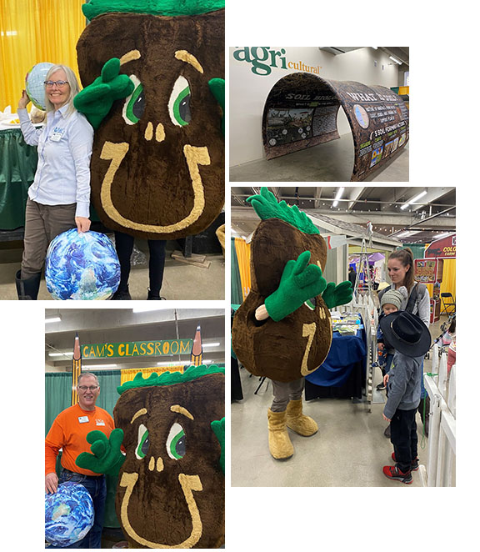
Sammie Soil, the USDA Natural Resources Conservation Service soil ped mascot, joined staff at Ag Adventures during the National Western Stock Show. Colorado State University hosts the Ag Adventures area full of free fun for children and adults. For the entire stock show an NRCS Soil Tent graced the entrance of Ag Adventures as folks walked path of Colorado potato, corn, pork, dairy, bee, sugar beet, CSU veterinary, poultry, and other ag displays.
On January 19, 2023, NRCS soil scientists Kari Sever and Mary Ellen Cannon, and NRCS soil conservationist Glenn Ledall with Dr. Aryn Baxter, Extension Ag Economist showed children and adults sprouting pea seeds, cover crop seeds, potato and new plant growth at the CAMS Classroom section of Ag Adventures. Tossing inflatable world globes—how often does thumb land on water versus land-helped bring home the message that we only have so much land in the world. Following up with orange as the world activity-interacting with audience on what lands are tough to grow food on and slicing that part away—comes down to the very small part of the orange-our world- that works well for growing food. We send home the thought of the preciousness of agricultural land. An infiltration activity showed how water moves faster through sand than through clay loam soils. CSU staff counted 130 folks at CAMS Classroom on Jan 19. Sammie Soil interacted with folks outside of the classroom as well as inside. Sammie Soil danced and hanged out for photos. Sammie the soil ped was taken by some to be a sugar beet. In 2022 over 19,000 people came through Ag Adventures. Count for 2023 not released yet but the expectation is even more folks visited Ag Adventures and walked through the soil tent in 2023.

