**National Coastal Blue Carbon Assessment Project**

The National Coastal Blue Carbon Assessment (NCBCA) is a nationwide effort by the United States Department of Agriculture, Natural Resources Conservation Service (USDA NRCS), Soil and Plant Science Division (SPSD), to inventory blue carbon soil stocks in coastal ecosystems with a focus on mangroves, coastal tidal marshes and seagrass meadows. These habitats store large amounts of carbon, called [blue carbon](https://oceanservice.noaa.gov/facts/bluecarbon.html), within the soil.

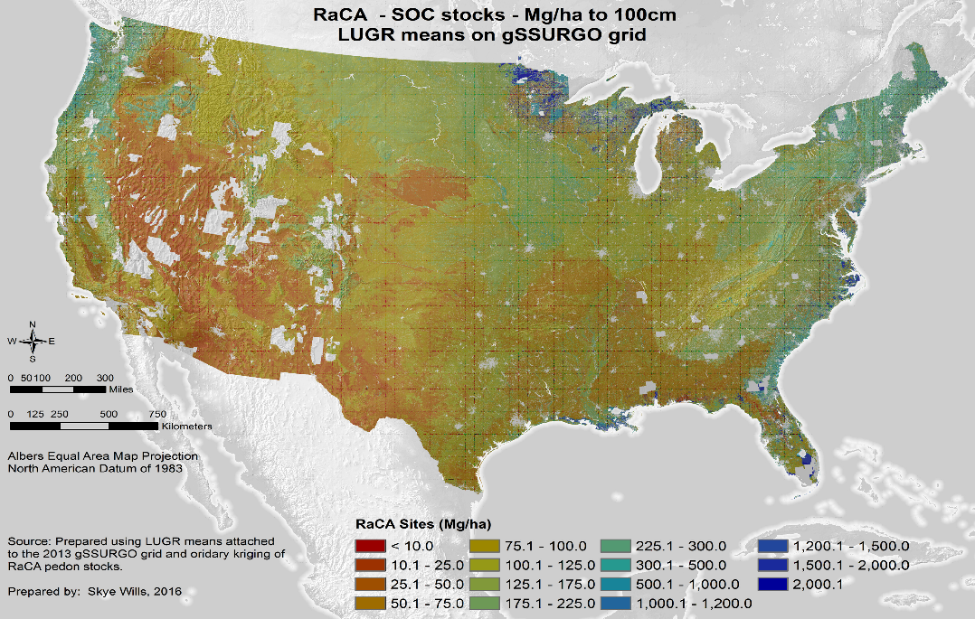

**Objective:** To provide accurate soil carbon stock data for blue carbon pools through the [Coastal Zone Soil Survey (CZSS)](https://www.nrcs.usda.gov/wps/portal/nrcs/detail/soils/focusteams/?cid=nrcseprd1319232).

**Justification:** Recent publications from partner organizations have highlighted the fact that current soil data provided by the National Cooperative Soil Survey (NCSS) is insufficient for calculating accurate coastal wetland blue carbon stocks due to lack of measured bulk density and soil carbon data in coastal soils. In 2010, the USDA NRCS Rapid Carbon Assessment (RaCA) undertook the nationwide effort to determine soil carbon stocks by land use (cropland, forest land, pasture and rangeland, and wetlands). This project, however, did not adequately capture coastal ecosystems like mangroves, tidal marshes, and seagrass meadows as a major land use type. As the NCSS progresses into the coastal and subaqueous realm, ongoing coastal projects are providing pedon and spatial soils data. Additionally, numerous blue carbon sampling studies have provided coastal soils datasets that could be leveraged to add to the accuracy of blue carbon accounting.

Although there is a significant amount of coastal blue carbon data being collected, there remains no national standard for collecting, analyzing and reporting this data. The NCBCA aims to standardize soil sampling protocols across agencies, increase the accuracy of coastal soil mapping, and improve public accessibility to coastal wetland blue carbon data. The statistical and scientific NCBCA project would be a defensible soil carbon stock inventory on coastal wetland ecosystems (tidal marshes, mangroves, subaqueous, and near shore wetlands).

One of the major values of Soil Survey data is the capability for scaling up individual soil sampling points to produce regional and national spatial coverages based on geology and landscape. This is especially important in calculating blue carbon stocks as coastal ecosystems vary in shape, size, and soil composition across landscapes.

**Objective:** To provide accurate spatial inventories of coastal soils mapped to the soil series level with measured soil carbon values and bulk density to a depth of at least 1 meter.

**Timeline and Deliverables:**

1. Evaluate existing blue carbon soil data from Universities, research institute and organizations, NOAA, NRCS, USGS, USFWS, Restore America’s Estuaries (RAE), NASA, NEP’s, NERR’s, state environmental protection groups, etc. Incorporate all data (with permission), including existing coastal zone soil survey publications, into a standard soil survey database. (Current soil carbon data networks, which could serve as examples on how to deliver NCBCA products, include but aren’t limited to: 1 - <http://iscn.fluxdata.org/> and 2 - <https://serc.si.edu/coastalcarbon>. After compiling all data, determine spatial data gaps and select coastal zone sampling sites accordingly. **FY2018 – FY2020.**
2. Cooperatively establish national sampling protocols for soil bulk density (Appendix A) and soil organic carbon to be used across agencies that conduct or have conducted similar carbon sampling (USGS, NOAA, NASA, etc.). Select standard soil sampling protocols to be used by all agencies to ensure accurate, reliable and scientifically acceptable soil blue carbon values.
   * Establish a soil sampling protocol decision tree similar to the USDA NRCS RaCA project. Establish a NCBCA pilot project with National Soil Survey Center (NSSC) research scientists and Kellogg Soil Survey Laboratory (KSSL) staff exploring various sampling techniques, developing a sample decision tree, and ensuring appropriate lab methods are used. Test the soil sampling decision tree on multiple coastal sampling sites and soil conditions to refine the tree as needed. **FY2018 – FY2020.**
3. Establish partnerships with agencies and organizations that are already monitoring coastal sites such as NOAA, USFWS, NEP, NERR, universities and state environmental protections groups. **FY2018 – FY2020.**
4. Provide soil sampling protocol training to both NRCS soil scientists and partner agencies. **FY2018 – FY2020.**
5. Select and sample NCBCA sites. Soil samples should be prepared, stored, packaged and shipped to the Kellogg Soil Survey Laboratory (KSSL) in Lincoln, NE for full characterization. **FY2019 – FY2026 and beyond.**
6. Update spatial soil survey data where current data has incomplete soil map unit documentation, and / or insufficient soil map unit design. **FY2019 – FY2026 and beyond.**

**Project Needs:**

* Current USDA NRCS SPSD staffing levels are insufficient in coastal areas. Job announcements and hiring of qualified staff would be required to ensure successful completion of this NCBCA project. Key “coastal” soil survey office positions and resource soil scientists should be filled preferably with coastal pedologists. (examples include New Bern, NC; Mayaguez, PR; Denham Springs, LA).
* Current KSSL staffing levels are inadequate to support the NCBCA project. Staff should be hired accordingly and as needed to ensure successful completion of data analyses
* Field equipment and sampling supplies will be required to ensure successful completion of the NCBCA project. Soil sample retrieval should be conducted minimally at each site to a depth of 1 meter with 2 meters as a standard preference. Examples of equipment required include sample bags, augers, auger extensions, auger handles, bulk density cores, YSI meters (EC, pH, temperature, and DO), tripods, vibracore machines, aluminum piping, McCauley augers, duct tape, chain hoists, ratchets, nuts, bolts, WD-40, tape measures, cameras, GPS units, Munsell colors books, muck boots / waders, soil knives, etc. Additional equipment could include research vessels (boats) and scuba gear.
* Travel, training, sample storage and sample shipping costs will be incurred to ensure the successful completion of the NCBCA project.
* Sampled sites will be coastal tidal marsh platforms, mangrove swamps, or seagrass meadows. Soil samples with special considerations for bulk density (Appendix A) should be retrieved per NCSS protocols and available sampling equipment for each soil horizon to minimally a depth of 1 meter and maximum to 2 meters. Sampled sites and analyses will be grouped by coastal ecosystem, soil series and/ or soil map unit. Appendix B is a supplemental organic soil horizon description scale that could be utilized throughout the project.
* The vegetative coverage at each sampling site should be documented and coastal blue carbon values should be included in coastal ecological site descriptions (ESDs). Soil sampling site selection should be dictated by vegetative community structure (amount of sampling points). The final results and carbon values may help identify more suitable and desirable vegetative condition where sequestration can be maximized.
* The blue carbon soil sampling at each pre-selected site will likely highlight many CZSS data deficiencies. The SPSD staff should propose adequate future MLRA update projects if current soil survey product deficiencies are identified while sampling. Examples of potential proposed projects would include: Tm or Tml (tidal marsh) map units, salt marsh soil map unit complex or associations, subaqueous soil survey areas, considerably eroded shoreline areas, mapping unit data documentation deficiencies, etc.
* Each particular coastal blue carbon sampled site will take considerable time and resources to retrieve adequate samples. Successful sampling 1 coastal blue carbon site should be valued at mapping 10,000 acres for NASIS / acre / goal reporting purposes. Success and acres will be awarded only if blue carbon values are determined and calculated at the KSSL.

1. **10,000 acres per CBCA sampled point.**
2. **5,000 acres per NASIS approved CZSS project.**
3. A considerable amount of CZSS projects will be identified, approved, conducted, and completed as a result of the National CBCA project. These CZSS project will further justify hiring the needed SPSD staff to complete the CBCA project. Coastal blue carbon pools are dynamic soil properties and their values will change throughout time further justifying long-term and continued support for the National CBCA. **FY2019 – Fy2100**

The data and blue carbon maps will be utilized by coastal ecologists as accurate and reliable values now and into the future. Coastal ecosystems sequester and store a tremendous amount of carbon that would otherwise be a contributing factor through climate change. **FY2019 -….**

**Appendix A. Coastal Zone: Bulk Density and Carbon Field Sampling Methodologies**

**Notes for all samples:**

* All sample methods include roots & seashells; do not take them out of the sample.
* All sample methods report bulk density for the <2 mm soil fabric. The mass and volume of rock fragments are subtracted from the total mass and volume of the sample.

**Clod (Once submerged now drained or diked)**

When used:

* When a soil pit can be dug and an intact sample can be removed from pit face

Citations/who uses:

* Soil Survey Staff. 2014. R. Burt (ed.) Kellogg Soil Survey Laboratory Methods Manual, Soil Survey Investigations Report No. 42 Version 5.0. USDA NRCS.
  + 3B1c

Summary of Method:

Collect field-occurring clods, ≈100 to 200 cm3 in volume (fist−sized), from the face of the excavation. Remove a piece of soil larger than a clod from the face of sampling pit. From this piece, prepare a clod by gently cutting or breaking protruded peaks and compacted material from clod. If roots are present, trim roots with shears. One coat of plastic lacquer is applied in the field. Additional coats of plastic lacquer are applied in the laboratory. The clod is dried in an oven at 110 °C and then weighed in air to measure its mass and in water to measure its volume.

**Brownie**

When used:

* In organic soils that can be cut with a knife and maintain an intact shape due to fibers or roots.

Citations/who uses:

* Soil Survey Staff. 2014. R. Burt (ed.) Soil survey field and laboratory methods manual. Version 2.0. Soil Survey Investigations Report No. 51. USDA–NRCS.
  + p. 15, Pedon Sampling Types, Organic Soils

Summary of method:

If undisturbed blocks can be removed for bulk density, carve out cubes of known dimension (e.g., 5 cm on a side). Note the sample dimensions in the sampling notes.

**Macaulay**

When used:

* Beneath water table when Macaulay peat sampler can retrieve an undisturbed sample;
* When soil is fluid enough to be penetrated by peat sampler and roots and fibers do not clog sampler.

Citations/who uses:

* Soil Survey Staff. 2014. R. Burt (ed.) Soil survey field and laboratory methods manual. Version 2.0. Soil Survey Investigations Report No. 51. USDA–NRCS.
  + P. 16, Pedon Sampling Types, Organic Soils
* Coastal Blue Carbon Manual – <http://thebluecarboninitiative.org/wp-content/uploads/English_Blue_Carbon_LR.pdf> Howard, J., Hoyt, S., Isensee, K., Pidgeon, E., Telszewski, M. (eds.) (2014). Coastal Blue Carbon: Methods for assessing carbon stocks and emissions factors in mangroves, tidal salt marshes, and seagrass meadows. Conservation International, Intergovernmental Oceanographic Commission of UNESCO, International Union for Conservation of Nature. Arlington, Virginia, USA. - Piston Corer & USGS

Summary of method:

Collect samples with a Macaulay peat sampler. Mark undisturbed sample in 10-cm segments, slice with a knife, and place a single segment in a plastic bag. Note sample volume keeping in mind that the sample shape is a half cylinder.

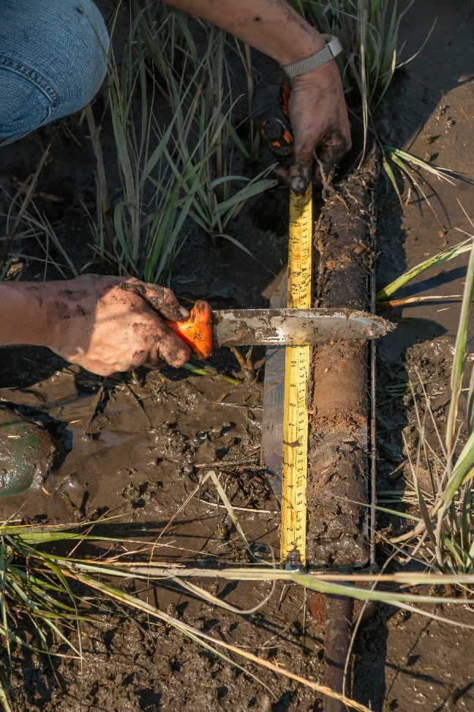

*photo credit Gerald Beetham*

**Hole Saw Sampler**

When used:

* In organic soils with high amounts of roots or fibers that can maintain an intact sample when removed.

Citations/who uses:

* Mike Wilson used this method in Alaska
* Maine utilizes the ratchet method. (Purchased and assembled at any hardware store.)

Summary of method:

Push and twist sampler into the soil in a circular or ratchet motion. Remove soil core and cut slices (cookies) of a desired thickness. Trim roots or fibers with serrated knife or sheers. Record hole saw bit size (ex: 3” or 4” Hole Saw Bit), and sample thickness in the sampling notes. This method can be used vertically into the soil surface or horizontally in the soil pit face.

Wilson’s Hole Saw Sampler Dorman’s Hole Saw Sampler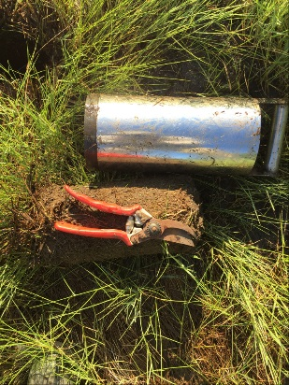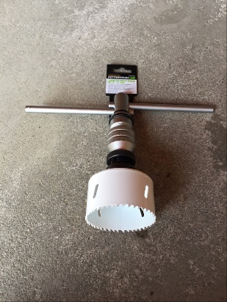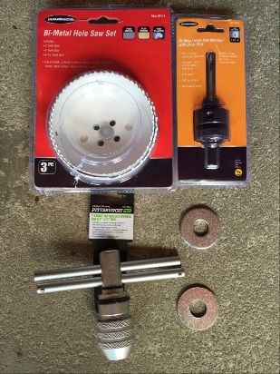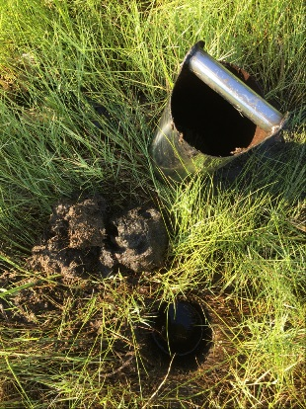

**Core methods**

Multiple core methods exist for sampling bulk density. These methods all utilize a cylindrical sampler of a known volume pressed, hammered or vibrated into the soil. In general, larger sample sizes result in more accurate measurements. For those methods that do not collect a large volume of sample, multiple cores can be combined or averaged.

**Standard Core**

When used:

* When a core can be pressed, hammered or vibrated into the soil without interference from rock fragments and without compaction from coring device.

Citations/who uses:

* Soil Survey Staff. 2014. R. Burt (ed.) Kellogg Soil Survey Laboratory Methods Manual, Soil Survey Investigations Report No. 42 Version 5.0. USDA NRCS.
  + 3B6a
* Soil Survey Staff. 2014. R. Burt (ed.) Soil survey field and laboratory methods manual. Soil Survey Investigations Report No. 51. Version 2.0. USDA–NRCS.
  + 3.3.1.4
* Wills S. and E Benham. 2010. Procedures and protocols for field data and sample collection, Rapid carbon assessment project. National Soil Survey Center, Lincoln, NE.
* US EPA. 2016. National Wetland Condition Assessment; Field Operations Manual Version 1.1a. <https://www.epa.gov/sites/production/files/2017-08/documents/nwca2016_fom_v1_1a_full_0.pdf>

Summary of method:

A metal cylinder, generally 3 inches in diameter and 3 inches in length, is pressed or driven into the soil. The cylinder is removed, extracting a sample of known volume.

Prepare flat surface, either horizontal or vertical, at required depth in sampling pit. Press or drive core sampler into soil. If a hammer is required, place a wood block on top of the core tube before striking it. Strike squarely on wood block. Remove the core from the soil by digging out beside it and cutting the soil in front of the core cutting edge so excess soil in front of the core is still attached. Trim protruding soil flush with ends of cylinder.

**Vibracore**

When used:

* In subaqueous or saturated environments when a vibracore sample is taken and sample has not experienced significant compaction due to vibration.

Citations/who uses:

* Soil Survey Staff. 2014. R. Burt (ed.) Soil survey field and laboratory methods manual. Soil Survey Investigations Report No. 51. Version 2.0. USDA–NRCS.
  + 3.3.1.4.1
* Coastal Blue Carbon Manual – <http://thebluecarboninitiative.org/wp-content/uploads/English_Blue_Carbon_LR.pdf> Howard, J., Hoyt, S., Isensee, K., Pidgeon, E., Telszewski, M. (eds.) (2014). Coastal Blue Carbon: Methods for assessing carbon stocks and emissions factors in mangroves, tidal salt marshes, and seagrass meadows. Conservation International, Intergovernmental Oceanographic Commission of UNESCO, International Union for Conservation of Nature. Arlington, Virginia, USA. - Piston Corer & USGS

Summary of method:

* A core sample is collected using a vibracore. After splitting core in half lengthwise, a half-cylinder shaped sample is collected of a known length (ie 10 cm length). Note sample dimensions.

**Syringe**

When used:

* when samples have been collected in a vibracore and fluid Oa & A horizons

Citations/who uses:

* Soil Survey Staff. 2014. R. Burt (ed.) Soil survey field and laboratory methods manual. Soil Survey Investigations Report No. 51. Version 2.0. USDA–NRCS.
  + 3.3.1.4.1
* Coastal Blue Carbon Manual – <http://thebluecarboninitiative.org/wp-content/uploads/English_Blue_Carbon_LR.pdf> Howard, J., Hoyt, S., Isensee, K., Pidgeon, E., Telszewski, M. (eds.) (2014). Coastal Blue Carbon: Methods for assessing carbon stocks and emissions factors in mangroves, tidal salt marshes, and seagrass meadows. Conservation International, Intergovernmental Oceanographic Commission of UNESCO, International Union for Conservation of Nature. Arlington, Virginia, USA. - Piston Corer & USGS

Summary of method:

* Vibracore or other undisturbed sample is collected. A plastic syringe from which the end has been removed is used to collect a mini-core. The plunger can be fixed at the 10-mL mark, and the syringe is gently pushed into the sample to collect a known volume (10cc) of sample. 3 subsamples are taken of each sampled horizon and average is calculated.

**Other tools used in core method:**

**Slide Hammer Probe**

* Use in mineral soils

**Soil Piston Corer**

* Use in mineral soils

**King Sampler Soil Extractor**

* Use in soft estuarine, organic or fluvial sediments i.e. High (N Value), organic, plastic, fluid, and saturated. Not recommended for use in sands.
* US EPA. 2016. National Wetland Condition Assessment; Field Operations Manual Version 1.1a. <https://www.epa.gov/sites/production/files/2017-08/documents/nwca2016_fom_v1_1a_full_0.pdf>

**Thompson corer**

**Langlinais Air Injector**

**Sample Storing and Shipping Procedures:**

* Minimize air in sample bag by utilizing Ziploc bags and squeeze as much air out of sample bag as possible prior to sealing.
* Freeze samples and ship in a cooler. If shipping from field use Frozen Carbon Dioxide (Dry Ice) when available or with wet ice in a cooler.

**Coastal Zone: Bulk Density and Carbon Lab Analysis Methodologies**

**Bulk Density Lab Analysis:**

**Field State: 3B6a** – Soil Survey Lab Methods Manual

Include all sea shell fragments, roots or organic fragments including fragments larger than 2mm in the sample.

**Carbon Lab Analysis:**

Temperature and time for LOI for carbon and carbonates (400 degrees Celsius for 16 hours).

**Analysis of Organic Carbon**– Soil Survey Lab Methods Manual

Include fiber fragments larger than 2mm and up to 2cm in the sample. (Fiber fragments as large as 2cm in cross section that can be crushed and shredded with the fingers are included.) – Soil Taxonomy 2nd Edition 1999

**Analysis of Carbonates**– Soil Survey Lab Methods Manual

Include all sea shell fragments larger than 2mm in the sample to determine carbonates.

Soft and fragile sea shells will be reduced to <2mm with normal sieve processing. Larger fragments will be sieved out and weighed for carbonate determination.

**KSSL Procedure Recommendations for coastal soils (Tidal Marsh & Subaqueous):**

Determine the percent Organic Carbon in all horizons. Determine Clay percentage in all horizons, including Oi, Oe, Oa. Include root and shell fragments for all Organic and Mineral horizons. Run LOI for Organic and Mineral horizons.

**Appendix B. Proposed von Post organic soil material humification scale for soil horizon description and communication purposes.**

|  |  |
| --- | --- |
| von Post Humification Scale Table Source: Damman and French, 1987 | |
| **Scale** | **Peat Characteristics** |
| H1 | Completely undecomposed peat; only clear water can be squeezed from peat |
| H2 | Almost undecomposed; mud free peat; water squeezed from peat is almost clear and colorless |
| H3 | Very little decomposition; very slightly muddy peat; water squeezed from peat is muddy; no peat passes through fingers when squeezed; residue retains structure of peat |
| H4 | Poorly decomposed; somewhat muddy peat; water squeezed from peat is muddy; residue is muddy but it shows structure of peat |
| H5 | Somewhat decomposed; muddy; growth structure discernible but indistinct; when squeezed some peat passes through fingers but most muddy water passes through fingers; compressed residue is muddy |
| H6 | Somewhat decomposed; muddy; growth structure indistinct; less than one-third of peat passes through fingers when squeezed; residue very muddy |
| H7 | Well decomposed; very muddy, growth structure indistinct; about one-half of peat passes through fingers when squeezed; exuded liquid has a "pudding-like" consistency |
| H8 | Well decomposed; growth structure very indistinct; about two-thirds of peat passes through fingers when squeezed; residue consists mainly of roots and resistant fibers |
| H9 | Almost completely decomposed; peat is mud-like; almost no growth structure can be seen; almost all of peat passes through the fingers when squeezed |
| H10 | Completely decomposed; no discernible growth structure; entire peat mass passes through fingers when squeezed |