NATURAL RESOURCES ASSESSMENTS

Soil Evaluations in Washington State

A Guide for High School

Land Judging Contests

October 2016
PURPOSES OF LAND JUDGING CONTEST

Land judging serves as a tool to teach youth and adults about the field of soil science and the use and management of soils. It is a program designed to guide them toward the understanding and importance of:

- Basic soil properties as they affect the use and management of soils.

- Management practices applicable to the care and management of soil and water.

SPONSORS

Coordinated planning and organization is needed from the beginning. The Washington Association of Conservation Districts, in cooperation with the Division of Vocational Education of the Superintendent of Public Instruction office, provides leadership. Other interested parties may provide leadership or support for the contest including the Natural Resources Conservation Service, Washington Society of Professional Soil Scientists, Cooperative Extension Service, local Conservation Districts, Vocational Agriculture, and local leaders.

The official copy of this guide is maintained by the State Soil Scientist, Natural Resources Conservation Service, Spokane, Washington.

Washington NRCS Website: http://www.nrcs.usda.gov/wps/portal/nrcs/site/wa/home/

Revised October 2016

CONDUCTING A LAND JUDGING CONTEST

Before judging begins, the following should be done:

- Set the date for the contest.

- Estimate possible participation

- Locate land (or adjacent lands) where different soils can be studied and judged.

- Secure permission from owners to use the selected areas.

- The day before the contest select sites, dig pits, and determine official scoring and placing. The pits should be two buckets wide with a maximum depth of 4 feet. An additional pit may be used to brief coaches on the scoring and placement prior to the contest.

- Prepare packets of cards, consisting of a registration card and four land judging cards for each individual. Combine them in packages of four for the teams. Number the cards so teams can be readily separated and scores grouped.

On the day of the contest, the following should be done:

- Prepare a few extra sets of tabulation cards and land and homesite judging cards for individuals.

- On the morning of the contest (if this has not already been done) select leaders and tabulators (graders).

- Allow about 1-1/2 hours for judging.

- Arrange for transporting contestants to the fields.

- Place the contestants into groups of four or more so no two members of the same team are in the same group.

- Arrange for a grading place and someone to bring in the cards, as contestants finish a field.

SELECTING THE SITES

Soil scientists of the Natural Resources Conservation Service and Cooperative Extension Service should select sites used in the contest.

Each site should have a pit excavated to show the soil profile; samples of topsoil and subsoil in boxes, flags or stakes to indicate study area, given information cards, and bottles of water for moistening the soil. An instrument for determining slope will be available at each site, except for the homesite.

Provide each contestant with a score card for each field or homesite location being judged and the following information on each field:

SITE INFORMATION

SITE NO._

- Soil test results, parts per million (PPM).

  - Phosphorus - _____ parts per million (PPM).

  - Potassium - _____ parts per million (PPM).

  - Nitrogen – (adequate or deficient).

  - Soil pH (surface 6 inches) _____.

- Number of frost free days ______.

- Average annual precipitation ______.

- Thickness of original topsoil ______.

- Treat for most intensive use.

- Other factors: (Ex.: overland flow (surface runoff), concentrated flow, flooding frequency, depth to seasonal high water table).

- Current use of the site may not reflect proper use and management therefore pay no attention to present use and treatment of the site.

SIZE OF SITE

The site area to be judged should be approximately 100 feet by 100 feet. Flags or stakes must be set to indicate the boundary of the area to be considered. Flags of a different color will be used to indicate slope stakes, if needed. Both slope stakes should be set at an equal height of 3.5 feet above the ground.

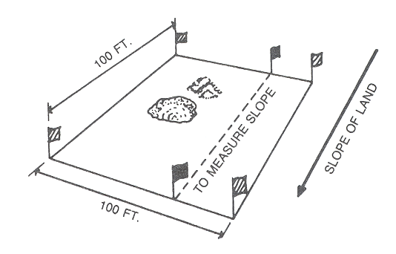
Figure 1. Preparing a Field Site

OBSERVING THE SOIL AND SITE

The contestants should disregard practices and/or cover on the site at the time of the contest except for brush and trees.

The contestants must be able to see the soil in order to determine the important characteristics. Roadside cuts may be used where suitable for training purposes. For a contest, however, a site away from a road is preferable.

In advance of the contest, holes are dug to expose the soil profile. The contestants can then measure the thickness and determine textures of the topsoil, subsoil, and the permeability of the subsoil. The excavation should be deep enough to show the topsoil and the subsoil, and restrictive layers such as hardpans or bedrock if they occur within a depth of 60 inches. Students will be expected to determine the boundary between the topsoil and the subsoil. In cases where the boundary is not evident, a nail may be inserted in the pit face to identify the boundary.

SOIL SAMPLES

In order to be sure each contestant studies the same surface (topsoil) and subsoil, samples will be placed in containers near the pits and labeled for contestants to judge. This will speed up the contest and provide more uniform conditions for each contestant. The area from which the samples were taken is marked with vertical strings or flagging on the face of the pit. Measurements for erosion and soil depth are done within the indicated area. All probing to observe other properties must be done outside the marked area.

SCORING THE CONTEST

Part I of Land Judging |  | Part II of Land Judging
Score Card |  | Score Card
Soil Features | Points | Soil Treatments | Points
- Surface texture | 3 | Vegetative | 15
- Subsoil texture | 3
- Permeability | 4 | Mechanical | 10
- Depth of soil | 5
- Slope | 5 | Fertilizer | 5
- Erosion | 4
- Surface runoff | 4
- Surface stones | 3
- Flooding | 4
- Major factors | 5
- Land capability class | 5
Total Points | 45 | Total Points | 30
(Part I) |  | (Part II)
Total points of Part I plus Part II |  |  | 75

DEFINITION OF A TEAM

Five contestants can participate in the state contest. The four highest scores out of five are used for the team score. A team of only three members is permissible.

GENERAL CONTEST RULES

- No talking or comparing of cards.

- No clipboards, bubble vials, tape measures, or other measuring devices allowed except an Abney level or clinometer, which will be provided. No measurement tools are used at homesite.

- Contestants can have the following pieces of equipment:

  - Writing utensils

  - Nail

  - Contest cards

- The land judging handbook and the soil scientist’s interpretation shall be used to resolve contest differences.

- Concerning state contests, information applicable only to the area in which the contest is held or other information pertaining to this contest not in the land judging handbook shall be sent to participants of the contest at least two weeks prior to the contest; so they are made aware of possible differences in a particular area. If no information is sent then the guidelines as set forth in this manual shall be strictly adhered to.

IN CASE OF TIES

When contestants tie for individual scores, columns of the contest card will be used to break a tie. Starting with the score on Field 1, Part I, the individual having the highest score would be the winner. This would be used as a first “tie breaker”. If this does “break the tie” the rule will be to continue to Part II of Field 1 and continue numerically through Field 2, Part I and Part II, then Field 3 and Field 4, in the same numerical order.

In case this method fails to break the tie, the tabulating committee will use a method of drawing the names from a hat. The names will be placed on the back of blank tabulation cards and all cards placed in the hat (or use some other practical method).

As cards are taken from the hat numerically, first, second, third, etc., this will list the winners in order. For example, if three people tie for individual first place, by using the method of drawing the names from a hat, their placings would be determined by first, second, and third place by the order in which their names were taken from the hat by the “game of chance”.

In case of a tie in a team score, (using the top three scores), using the score of the fourth will break the tie individual as the “tie breaker”.

In case a team with an alternate member is tied with a team without an alternate member (fourth member), the team that has the fourth team member (alternate) will be declared the winner.

In the case where two teams tie that have only three members each and no alternates, the winner can be decided by using Field No. 1 to break the tie. If this does not break the tie, then use Field 2, Field 3, and Field 4. If this does not break the tie, names will be drawn from a hat, by game of chance, as related above.

FORMS TO BE USED

The following material contains the forms, instructions, and clarifications required for the process of land judging in Washington. Suggestions from teachers, contestants, coaches, and leaders over several years have been carefully considered along with all old brochures and instructions in this preparation. For the homesite evaluation, the USDA-NRCS National Soils Handbook was the basic guideline.

TABULATION

For any official contest, record keeping forms are required. Tabulators may want to make up their own forms. Hosts for the contest are responsible for the record keeping forms and tabulation of results.
Each contest card must be numbered in some way to identify it with a certain contestant.

Washington Land Judging Score Card
Contestant No.__________________ |  |  |  |  | Field No._________________
Part I |  |  |  |  | Part II
Land Class Factors |  |  |  |  | Recommended Land Treatments
Indicate by an “X” in the circles by numbers |  |  |  |  | Needed for different land capability classes
Score |  |  |  |  | Score
3 pts | - SURFACE TEXTURE |  |  |  | 15 pts | VEGETATIVE (Establishment & Management)
 | 0 1. Coarse |  |  |  |  | Use soil conserving and/or soil improving crops:
 | 0 2. Mod. Coarse |  |  |  |  | 0 1. Every 4th or 5th year
 | 0 3. Medium |  |  |  |  | 0 2. Every 3rd or 4th year
 | 0 4. Mod. Fine |  |  |  |  | 0 3. Every 2nd year
 | 0 5. Fine |  |  |  |  | 0 4. Every year
3 pts | - SUBSOIL TEXTURE |  |  |  |  | 0 5. Do not burn crop residue
 | 0 1. Coarse |  |  |  |  | 0 6. Residue management, minimum tillage, and/or no till
 | 0 2. Mod. Coarse |  |  |  |  | 0 7. Establish recommended grass
 | 0 3. Medium |  |  |  |  | 0 8. Proper pasture and range management
 | 0 4. Mod. Fine |  |  |  |  | 0 9. Protect from burning
 | 0 5. Fine |  |  |  |  | 0 10 Control grazing
4 pts | - PERMEABILITY |  |  |  |  | 0 11. Plant recommended trees
 | (Most restrictive layer) |  |  |  |  | 0 12. Harvest trees selectively
 | 0 1. Rapid |  |  |  |  | 0 13. Use only for wildlife or recreation
 | 0 2. Moderate |  |  |  | 10 pts | MECHANICAL
 | 0 3. Slow |  |  |  |  | 0 14. Control brush or trees (mechanical or chemical)
 | 0 4. Very slow |  |  |  |  | 0 15. Farm on contour/cross slope
5 pts | - DEPTH OF SOIL |  |  |  |  | 0 16. Use divided slopes and/or strips
 | 0 1. Very deep |  |  |  |  | 0 17. Construct level terraces
 | 0 2. Deep |  |  |  |  | 0 18. Install grassed waterways and/or diversions
 | 0 3. Moderately deep |  |  |  |  | 0 19. No mechanical treatment needed
 | 0 4. Shallow |  |  |  | 5 PTS | FERTILIZER AND SOIL AMENDMENTS
 | 0 4. Very shallow |  |  |  |  | 0 20. Lime requirement test
5 pts | - SLOPE | DRYLAND% |  | IRRIGATED% |  | 0 21. Phosphate (P₂O₅)
 | 0 1. | 0-3 |  | 0-2 |  | 0 22. Potash (K₂O)
 | 0 2. | >3-8 |  | >2-5 |  | 0 23. Nitrogen (N)
 | 0 3. | >8-15 |  | >5-10 |  | 0 24. Fertilizer or soil amendments not needed
 | 0 4. | >15-30 |  | >10-15
 | 0 5. | >30-40
 | 0 6. | 40+
4 pts | - EROSION – WIND & WATER
 | 0 1. None to slight
 | 0 2. Moderate
 | 0 3. Severe
 | 0 4. Very severe
4 pts | - SURFACE RUNOFF
 | (Not considered in land capability classification)
 | 0 1. Rapid
 | 0 2. Moderate
 | 0 3. Slow
 | 0 4. Very slow or ponded
3 pts | - SURFACE STONES
 | 0 1. Stony
 | 0 2. Nonstony
4 pts | - FLOODING
 | 0 1. None
 | 0 2. Rare
 | 0 3. Occasional
 | 0 4. Frequent
5 pts | - MAJOR FACTORS THAT KEEP AREA OUT OF CLASS I LAND |  |  |  |  |  | SCORE PART I TOTAL  (Possible 45) ______
 | 0 1. Surf. Tex. |  | 0 6. Surface rock
 | 0 2. Perm. |  | 0 7. Flooding |  |  |  | SCORE PART II TOTAL
 | 0 3. Depth |  | 0 8. Other |  |  |  | (Possible 30) ______
 | 0 4. Slopes |  | 0 9. None
 | 0 5. Erosion |  |  |  |  |  | TOTAL SCORE
5 pts | - LAND CAPABILITY CLASS |  |  |  |  |  | (Part I plus Part II)
 | 0 1. Class I |  | 0 5. Class V |  |  |  | (Possible 75) ______
 | 0 2. Class II |  | 0 6. Class VI
 | 0 3. Class III |  | 0 7. Class VII
 | 0 4. Class IV |  | 0 8. Class VIII

HOW TO USE THE LAND JUDGING SCORE CARD

PART I

- The total possible score (Part I and Part II) on one field is 75 points.

- The total possible score on Part I is 45 points and on Part II is 30 points.

- Part I (left side of the score card) has to do with those factors the contestant must determine about the field and soil.

- Part II (right side of the score card) lists the soil management and improvement practices the contestant is to select.

- The contestants are given 15 minutes to fill in the answers on their score card on each field, unless otherwise designated.

- An “X” is used to mark in the contestant’s answers on Part I and Part II of the score card.

- Part I, J. MAJOR FACTORS – number “9”. “None” should be checked for Land Capability Class I.

- If the land capability class is Class II, III, IV, V, VI, VII, or VIII under Part I, J. the rule is to mark only the major factor or factors that keep it from being Class I land. If too many or too few factors are marked, the contestant’s score will be zero in this block. Factor 9 will be used only when appropriate “other factors” are shown on the field condition sheet.

PART II

- The officials will not give the number of conservation practices needed on each field.

- Use applicable practices (vegetative) number 1 through 6 for Land Capability Class I, II, III, and IV. The practices are listed on the scorecard. Use applicable practices number 7 through 13 for Land Capability Classes V, VI, VII, and VIII.

- Use practices (mechanical) number 14 through 18 when needed, according to the judgment of the contestant and other factors shown, if any. Number 19 would be checked when no mechanical practices are needed.

- Use practices (fertilizer and soil amendments) number 20 through 24 according to the soil test. Use the practice number which corrects the deficiencies indicated for the conditions on each field.

DEFINITION AND EXPLANATION OF LAND CHARACTERISTICS TO BE JUDGED - PART I

Organic horizon of undecomposed and decomposed organic matter. Absent in cultivated and many other soils.

Mineral surface soil which has accumulated decomposed organic matter and is usually darker colored than lower layers.

Mineral horizon that usually has a finer texture, or a darker, stronger, redder color and a distinctly different developed structure. Structure is often more distinct than the “A” horizon. This layer has accumulated clay, iron and aluminum from above horizons by downward movement.

Mineral horizon of weathered parent material like the material from which the soil developed or other substratum of unconsolidated not related to the above soil.

Underlying consolidated bedrock. Absent under many soils.

Figure 2. Generalized soil profile showing letter designation used in describing the major kinds of horizons usually present.

SOIL TEXTURE

Texture of the soil as determined by feel is an estimate if the proportion of sand, silt, and clay that make up the soil mass. An accurate determination of the proportions can be made by laboratory analysis. For the purpose of the contest, the student is expected to estimate the texture by feel of the surface and subsoil layers. Samples (with rock fragments removed) will be provided at all sites for determining texture.

Properties of Sand, Silt, and Clay

1. “Sand” is the gritty material that is felt when soil is rubbed between the fingers. Individual grains can be readily seen or felt.

2. “Silt” is the floury (smooth) material that is felt when soil is rubbed between the fingers. It is neither gritty nor sticky.

3. “Clay” usually forms very hard lumps or clods when dry, and is plastic and usually sticky when wet. Moist soil, when pinched out between the thumb and finger will form a long flexible “ribbon”. The surface appearance of the ribbon can appear polished.

4. “Loam” is a combination or mixture of sand, silt, and clay.

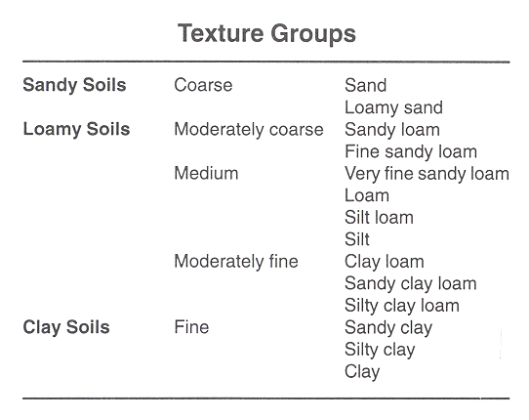
Figure 3. Texture Groups

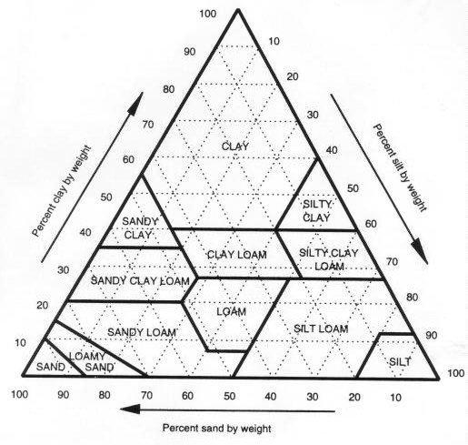

Figure 4. Soil Texture Triangle with the 12 texture classes

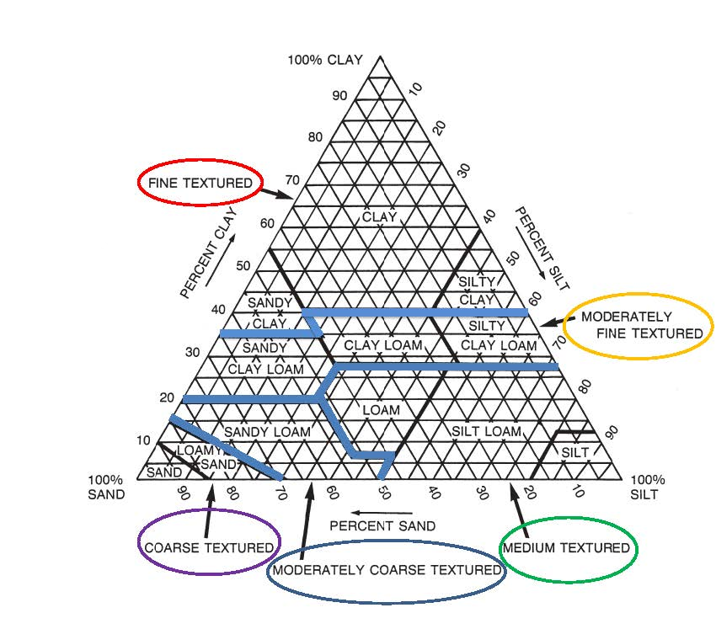

Figure 5. Soil texture triangle with 12 texture classes. For land judging purposes, the 12 texture classes are grouped into five categories (separated by thick blue lines) – coarse, moderately coarse, medium, moderately fine and fine.

PERMEABILITY (Movement of air and water in the most restrictive layer of the top 60 inches)

For land judging purposes, permeability classes are based on texture, but where other factors are evident they should be considered in the final permeability placement. (rupture resistance: force required to rupture (break) a soil unit, with a soil moisture content of slightly dry or wetter)

    - Rapid – These soils have a sandy texture with loose or porous soil with little, if any, defined structure other than single grained (very little restriction to movement of water and air).

    - Moderate – These soils have a loamy texture, friable to firm rupture resistance or have well developed structure.

    - Slow – These soils have loamy or clayey textures with very firm rupture resistance.

    - Very Slow – These soils generally have clayey textures with extremely firm to rigid rupture resistance (dense, compact appearance).

Rapid Moderate Slow Very Slow

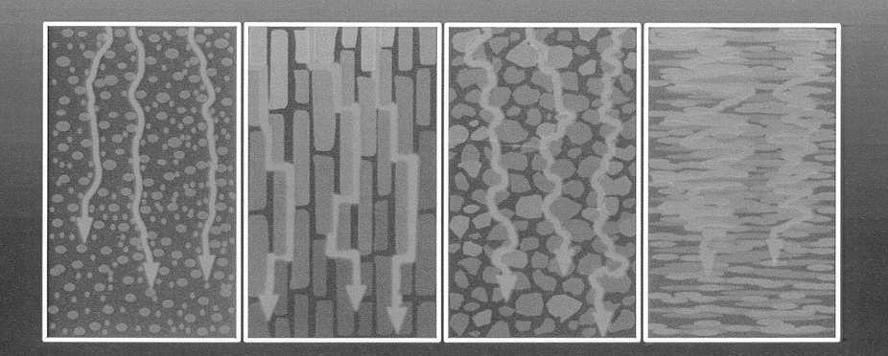

Figure 6. Water movement through soils.
DEPTH OF SOIL

The depth of soil is determined by the total thickness of soil layers that are significant to soil use and management. Restrictive features limit the movement of air, water, or the penetration of plant roots. A restrictive layer can be bedrock, clay pans or hardpans of various kinds. Depth shall be considered to the bottom of the excavated pit unless marked or given on the site card.

    - Very deep – More than 60 inches deep

    - Deep – >40 to 60 inches deep

    - Moderately deep – >20 to 40 inches deep

    - Shallow – >10 to 20 inches deep

    - Very shallow – Less than 10 inches deep

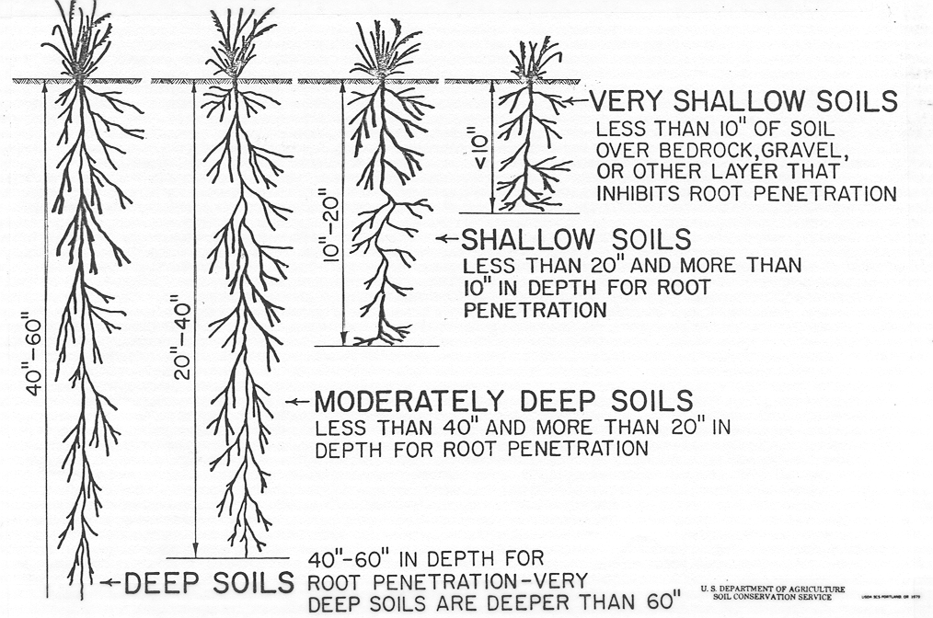

MORE THAN 40” TO 60” IN DEPTH FOR ROOT PENETRATION
MODERATELY DEEP SOILS
LESS THAN OR EQUAL TO 40” AND MORE THAN 20” IN DEPTH FOR ROOT PENETRATION
VERY SHALLOW SOILS
LESS THAN 10” OF SOIL OVER BEDROCKOR OTHER LAYER THAT INHIBITS ROOT PENETRATION
SHALLOW SOILS
LESS THAN OR EQUAL TO 20” AND MORE THAN OR EQUAL TO 10” IN DEPTH FOR ROOT PENETRATION
DEEP SOILS

VERY DEEP SOILS ARE DEEPER THAN 60”

Figure 7. Soil Depth Class

SLOPE
Slope will be measured in the field by contestants on two marked points. This slope is the number of vertical feet rise or fall in each 100 feet distance.
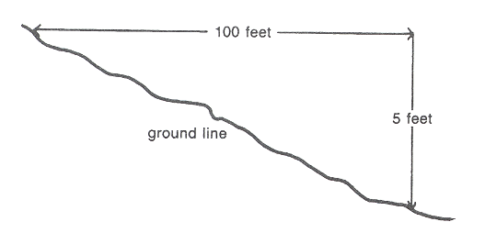
Figure 8. Diagram showing a 5 percent slope

For example, Figure 8 shows a vertical rise or fall of 5 feet in 100 feet of distance is a 5 percent slope. (5:100 = .05 x 100 = 50%). The following slope designations are used for non-irrigated and irrigated cropland in the State of Washington. For official contests slope-measuring instruments will be provided.

Land Capability Class |  | Non-Irrigated* |  | Irrigated
I |  | 0 to 3 percent |  | 0 to 2 percent
II |  | >3 to 8 percent |  | >2 to 5 percent
III |  | >8 to 15 percent |  | >5 to 10 percent
IV |  | >15 to 30 percent |  | >10 to 15 percent
VI |  | >30 to 40 percent |  | ----
VII |  | Above 40 percent |  | ----
*Rangeland or Woodland would have the same slope designation as non-irrigated cropland.

On borderline slope breaks, contestants should consider a 100 foot square area as marked to determine dominant slope.

EROSION – WIND AND WATER

Erosion is the loss of soil by wind and/or water. Soil erosion by water may be identified by small rills and lager gullies that appear like channels on the soil surface. The following are definitions of erosion classes:

CLASSES

    - None to slight – Less than 25 percent of the original topsoil removed. Rills may be present.

    - Moderate – 25 to 75 percent of the original topsoil removed. Rills and gullies crossable with farm machinery. Gullies would be expected to be more than 6 inches wide and 12 inches deep. Moderate erosion may or may not change a capability class, but it always is a factor to keep an area out of Class I land.

    - Severe – 75 percent or more of the original topsoil with or without occasional noncrossable gullies (gullies more than 100 feet apart) and/or severe blowouts and accumulations by wind.

    - Very severe – Little or no original topsoil remains. Many areas may have frequent noncrossable gullies (gullies less than 100 feet apart) and/or very severe blowouts and accumulations by wind. Some areas may be smooth, but most have an intricate pattern of gullies.

SURFACE RUNOFF (Refers only to runoff resulting from natural precipitation)

Surface runoff refers to the relative rate water is removed by flow over the surface of the soil. Such flow is determined by the characteristics of the soil profile, soil surface condition, soil slope, climate, and cover from vegetation or crop residue. Table 1 is used to determine runoff class based on slope percent and permeability class.

    - Rapid – A large proportion of the precipitation moves rapidly over the surface of the soil and a small part moves through the soil profile. Surface water runs off nearly as fast as it is added. Soils with rapid runoff are usually on slopes above 20 percent or have low infiltration capacities. The erosion hazard is severe or very severe.

    - Moderate – Surface water flows away at such a rate that a moderate proportion of the water enters the soil profile and free water lies on the surface for only short periods. A large part of the precipitation absorbed by the soil and used for plant growth is lost by evaporation or moves downward into underground channels. Soils with moderate runoff usually have slopes from 6 to 20 percent. The erosion hazard is moderate.

    - Slow – Surface water flows away so slowly that free water covers the soil for significant periods or enters the soil rapidly and a large part of the water passes through the profile or evaporates into the air. Soils with a slow rate of surface runoff usually have slopes from 0 to 5 percent or absorb precipitation very rapidly. The erosion hazard is slight.

    - Very slow or ponded – Surface water flows away so very slowly that free water lies on the surface for long periods, or enters immediately into the soil. Much of the water either passes through the soil or evaporates into the air. Soils with very slow surface runoff are commonly nearly level to concave or very porous. The erosion hazard is none to slight.

SURFACE RUNOFF CLASSES
SLOPE PERCENT | PERMEABILITY CLASS
 | RAPID | MODERATE | SLOW | VERY SLOW
< 1.0 | VERY SLOW/PONDED | VERY SLOW/PONDED | SLOW | MODERATE
1 - 5 | VERY SLOW/PONDED | SLOW | SLOW | RAPID
6 - 10 | SLOW | MODERATE | MODERATE | RAPID
11 - 20 | SLOW | MODERATE | RAPID | RAPID
> 20 | SLOW | RAPID | RAPID | RAPID

Table 1. Runoff classes

SURFACE STONES & ROCK OUTCROP

Stony – Greater than 3 percent of the site area (100 ft. x 100 ft.) has rock fragments >10 inches in size (diameter) on the soil surface. Rock fragments (any size) excavated from pit are not considered. Rock outcrop (exposed bedrock) is only considered where it exceeds 90% of the site area.

FLOODING

Flooding is water flow from overtopping of natural or artificial banks of a stream, river or other watercourse. Flooding is a given factor and contestants will be given how often an area floods.

    - None – Never floods.

    - Rare – On an average, 1 time or less in 20 years ( 1 – 5% )

    - Occasional – 1 time in 2 years ( 6 – 50% )

    - Frequent – More often than every other year ( >50% )

MAJOR FACTORS THAT KEEP AREA OUT OF CLASS I LAND

On Class I land, check Factor 9. Any one or more factors that would keep the area out of Class I should be checked.

    - Surface texture – Surface soil texture is a factor in sandy and clayey textures.

    - Permeability – Rapid, slow, or very slow permeability are factors.

    - Depth – Moderately deep, shallow, or very shallow are factors.

    - Slope – Any slope greater than 2 percent irrigated and greater than 3 percent non-irrigated are factors.

    - Erosion – More than 25 percent lost of the original surface soil is a factor.

    - Rock fragments – (surface rocks) – Only stony surface will be a factor.

    - Flooding – Occasional and frequent flooding are factors.

    - Other – Any other factor that keeps an area out of Class I land. Climate and seasonal high water table as given on the site card.

    - None – Used only on Class I land.

LAND CAPABILITY CLASS DEFINED

Suited for cultivation and other uses such as grazing, forestry, or wildlife food and cover.

    - Class I – Soils in Class I have none or few limitations that restrict their use.

    - Class II – Soils in Class II have some limitations that reduce the choice of plants or require moderate conservation practices.

    - Class III – Soils in Class III have severe limitations that reduce the choice of plants or require special conservation practices, or both.

    - Class IV – Soils in Class IV have very severe limitations that restrict the choice of plants, require very careful management, or both.

    - Class V – Soils in Class V have little or no erosion hazard but have other limitations impractical to remove that limit their use largely to pasture, range, woodland, or wildlife.

    - Class VI – Soils in Class VI have severe limitations that make them generally unsuited for cultivation and limit their use largely to pasture, range, woodland, or wildlife.

    - Class VII – Soils in Class VII have very severe limitations that make them unsuited for cultivation and that restrict their use largely to range, woodland, or wildlife.

    - Class VIII – Soils and land forms in Class VIII have limitations (such as rock outcrop) that preclude their use for commercial plant production and restrict their use to wildlife, recreation, water supply, or aesthetic purposes.

GENERAL GUIDE FOR SELECTING LAND CAPABILITY CLASSES
 |  |  | Best Land Class
Soil Features |  |  | Possible
- Surface Texture
- Coarse |  |  | IV
- Mod. Coarse |  |  | II
- Medium |  |  | I
- Mod. Fine |  |  | II
- Fine |  |  | III
- Permeability
- Rapid |  |  | III
- Moderate |  |  | I
- Slow |  |  | II
- Very slow |  |  | III
- Depth of Soil
- Deep & very deep |  |  | I
- Moderately deep |  |  | III
- Shallow |  |  | IV
- Very shallow |  |  | VII
- Slope
Non-irrigated |  | Irrigated
 | Best Land
% Slope | Class Possible | %Slope
- 0-3% | I | 0-2% | I
- >3-8% | II | >2-5% | II
- >8-15% | III | >5-8% | III
- >15-30% | IV | >8-15% | IV
- >30-40% | VI
- 40+% | VII
- Erosion – Wind and Water
- None to slight |  |  | I
- Moderate |  |  | II
- Severe |  |  | IV
- Very severe |  |  | VI

- Surface stones (detached) or Rock Outcrop (exposed bedrock)

- Stony soils on land greater than 3 percent slope |  |  |  |  |  |  |  |  |  | VI
 |  |  | - less than 3 percent slopes |  |  |  |  |  |  | V
- Nonstony |  |  |  |  |  |  |  |  |  | I
- Rock outcrop (>90% of area has exposed bedrock) |  |  |  |  |  |  |  |  |  | VIII
- Flooding
- None |  |  |  |  |  |  |  |  |  | I
- Rare |  |  |  |  |  |  |  |  |  | I
- Occasional |  |  |  |  |  |  |  |  |  | III
- Frequent |  |  |  |  |  |  |  |  |  | IV
- Other Factors
  - Climate
- Frost-Free Days |  |  |  |  |  |  | - Precipitation
(Irrigated & Non-Irrigated Cropland) |  |  |  |  |  |  |  | (Non-Irrigated Cropland Only)
 |  |  |  | LCC |  |  |  |  | PPT (Inches) |  | LCC
 | >140 days |  |  | I |  |  |  |  | 23” or more |  |  |  |  | I
 | >100 to 140 days |  |  | II |  |  |  |  | 12 to 22” |  |  |  |  | II
 | >80 to 100 days |  |  | III |  |  |  |  | 9 to 11” |  |  |  |  | III
 | >50 to 80 days |  |  | IV |  |  |  |  | 6 to 8” |  |  |  |  | IV
 |  | 30 to 50 days |  | VI |  |  |  |  | Less than 6” |  |  |  |  | VI
b.Seasonal High Water table & Drainage Classes
(Permanent or Temporary)
Well drained – water table not evident in soil profile or “redox features” are present they are greater than 40 inches from the soil surface. |  |  |  |  |  |  |  |  |  |  |  |  |  | I
Somewhat poorly – a water table or evidence of a fluctuating water table as indicated by “redox features” would be found >20 to 40 inches from the soil surface. |  |  |  |  |  |  |  |  |  |  |  |  |  | II
Poorly – a water table or evidence of a fluctuating water table as indicated by “redox features” would be found within 10 to 20 inches from the soil surface. |  |  |  |  |  |  |  |  |  |  |  |  |  | IV
Very poorly – ponded or water table less than 10 inches from the soil surface. |  |  |  |  |  |  |  |  |  |  |  |  |  | V

Management Options:
These recommendations are Management Choices and are in addition practices to land recommendations.- ( Example Class 2 land 1,5,6 plus 9,11 for Wind Break.)
A. Needs Wind Break – When indicated requires vegetative treatments 9 and 11 in addition to any other recommended treatments.
B. Desires Wood Lot – When indicated requires vegetative treatments 9, 11, and 12 in addition to any other recommended treatments.
C. Timber Production – When indicated requires vegetative treatments 9, 11, and 12 in addition to any other recommended treatments.
- Brush and Trees – Refer to page 25, item 14.

DEFINITIONS AND INTERPRETATIONS FOR LAND TREATMENT ON THE LAND JUDGING CARD – PART II

A conservation management system needs to be applied to the land to provide adequate erosion control depending upon the severity of the resource problem and climatic factors. Conditions that determine the protection needed include soil erodibility, steepness and length of the slope, and rainfall or wind energy of the area. The soil capability class and subclass are means of indicating the severity and the type of problem. Generally as the soil capability class increases the severity of the problem increases, the potential of the site is more limiting, and more conservation practices are needed to adequately protect the soil. The conservation practices generally include management such as rotation with soil conserving crops and residue management systems, and/or structural practices.

VEGETATIVE TREATMENT

For Cropland use (Class I through VI land) use soil conserving crops* and/or soil improving crops**:
- Every 4th or 5th year – |  | applicable to Class I and II land.
- Every 3rd or 4th year – |  | applicable to Class III land.
- Every 2nd year – |  | applicable to Class IV land.
- Every year – |  | applicable to Class VI land*** when cropped.
- Do not burn crop residue – |  | applicable to all cropland
- Residue management – | provides for a protective cover by leaving crop residue of any previous crop as a mulch on and mixed in the surface tillage layer of the soil.
 |  | applicable to all cropland

*Soil conserving crops – are considered to be those crops that prevent or retard erosion and tend to maintain rather than deplete soil organic matter. Close seeded crops are generally regarded as soil conserving crops.

**Soil improving crops – they help maintain soil organic matter; improve soil structure and tilth; increase water intake and in general increase the productivity of the soil. Grasses and legumes would be such crops.

***Class VI land – generally is not considered cropland, but maybe cropped with severe limitations; when soils are deep and very deep and slopes are greater than 30 percent.

Vegetative Treatments and Practices
The following is a guide to be used in deciding vegetative treatments.

Class I | Practices 1, 5, and 6
Class II | Practices 1, 5, and 6
Class III | Practices 2, 5, and 6
Class IV | Practices 3, 5, and 6
Class VI (Potential to be cropped.) | Practices 4, 5, and 6

For Pastures, Range, Wildlife, or Woodlands:

- Establish recommended grass – this practice is to be used on lands not producing suitable permanent vegetation. This practice is important on Class V, VI, and VII lands.

- Proper pasture and range management – the application of practices to keep plant growth active over as long a period as possible; and to encourage the growth of desirable grasses and legumes while crowding out weeds, brush, and undesirable grasses. This practice will be used on all Class V, VI, and VII lands.

- Protect from unplanned burning – do not burn grasses, legumes, or timber without a prescribed burning plan. This practice will be used on Class V, VI, and VII lands.

- Control grazing – to carry out a system of grazing that will maintain or improve desirable vegetation on pasture or range (deferred grazing, rotation grazing, and proper stocking are some of the practices.). This practice will be used on all Class V, VI, and VII land.

- Plant recommended trees – for postlots, farmstead windbreaks, field windbreaks, and commercial woodland plantings.

- Harvest trees selectively – a system of cutting in which single trees (usually the largest, diseased, or deformed) or small groups of such trees are removed and reproduction enhanced under the remaining stand.

- Use only for wildlife or recreation area – this means protection or the development of areas that cannot be used for grazing, forestry, cultivation, or urban. This practice will be used for Class VIII land.

Vegetative Treatments and Practices
Class V | Practices 7, 8, 9, and 10
Class VI | Practices 7, 8, 9, and 10.  If Cropped 4,5,6
Class VII | Practices 7, 8, 9, and 10
Class VIII | Practice 13

MECHANICAL

This column cannot be specific in all cases. It is the job of the contestants to pick out the treatments that apply. For example, a site can be found that it would need no mechanical treatment for the most intensive use. Therefore, practice 19 would be selected. A similar site in soil, slope, and erosion could be covered with undesirable brush and trees and need practice 14. Should a site also be gullied, practices 14 and 18 would be used. Depending on soil, slope, cover, erosion, and most intensive use, practices14, 15, 16, and 17 could be the correct answer.

Class 1 land in grass or cultivation would require practice 19. The same class of land covered in brush and trees would require practice 14. In other words, any site will need to have one or more of the possible mechanical practices checked that are shown under the heading “Mechanical” on the scorecard.

- Control brush or trees – this may be accomplished by spraying with chemicals and/or use of specialized machinery other than those used in normal farming practices. The purpose is to improve the desirable vegetative cover by removing or killing undesirable brush and trees, or removing timber so land can be farmed. Brush or trees would be expected to have more than a 2 inch diameter trunk at 5 feet.

- Farm on contour, cross slope – conduct farming operations on the contour or cross slope at right angles to slope direction.

- Divided slopes or strips – practices that are effective in reducing wind and water erosion. (Mechanical practices 15 and 16 are used on all cultivated land (II-IV, VI if cropped) with slopes above 3 percent non-irrigated or 2 percent irrigated).

- Construct level terraces – a level terrace is an earthen embankment with a supporting ridge on the lower side. They are used to catch or divert runoff water on Class II, III, and IV lands with 3 to 8 percent slopes. Overland flow (surface runoff) will be a factor and this will be given information.

- Grassed waterways and/or diversions – a conservation practice that will control concentrated flow of water preventing the formation of gullies on Class II, III and IV lands on slopes less than 15 percent. Concentrated flow will be given information.

- No mechanical treatment needed – use when one or more mechanical practices (numbers 14-18) would not be recommended.

FERTILIZER AND SOIL AMENDMENTS

For numbers 20 through 24 a soil test will be available at each site for evaluation and recommendations by the contestant. The information will be placed on a field sign. The following information will be given: soil pH, phosphorus (P) and potassium (K) and nitrogen (N) expressed as adequate or deficient.

pH

Soil pH is a measure of the acidity or alkalinity of the soil solution from which plant roots remove nutrients for growth. pH, however, is only a general guide of the soil’s need to be limed. Soils with a pH above 6 generally do not need lime, except possibly for a new legume seedling such as alfalfa. Soils with a pH below 6 (generally between 4 and 6) may need lime. This can be determined by a lime requirement test. You should check practice number 20 for a field pH value less than 6.

Phosphorus

Phosphorus is a given on soil test reports as the nutrient P and expressed in parts per million (PPM). A soil test phosphorus level at which no more phosphorus fertilizer is needed will vary with the crop and the area of the state. For purposes of this handbook and the contests, a value of 10 PPM P will be considered the value above which no crop response to P fertilizer will be achieved. Check practice number 21 if soil test phosphorus is less than 10 PPM.

Note: While soil test phosphorus refers to elemental phosphorus (P), fertilizer phosphorus is given as the oxide (P₂O₅).

Potassium

Potassium is also reported on the soil test as K and expressed in parts per million. Check practice number 22 if the soil test value for K is deficient. A value of 75 PPM would be adequate for wheat in dryland eastern Washington, but for potatoes and grapes in irrigated central Washington the corresponding value for K would be 240 PPM. Fertilizer K is expressed as the oxide of K (K₂O). For contest purposes: Check practice number 22 if potassium is less than 150 PPM.

Nitrogen (N)

Many things happen to nitrogen after application to the soil besides uptake by the crop. For this reason a soil test is generally not used to determine the amount of nitrogen to apply for crop production. Nitrogen requirements for specific crops, soils, and management practices are established only after extensive field and laboratory studies. Check practice number 23 if the field card indicates nitrogen is deficient.

Fertilizer guides are available for most crops grown in Washington. They are available from the Cooperative Extension Service, Washington State University, Pullman, Washington 99164. With a soil test and the appropriate Fertilizer Guide (FG), the guesswork is removed from fertilization for optimum crop production.

HOW TO USE THE HOMESITE EVALUATION SCORE CARD

INTRODUCTION

This part of the contest is designed to emphasize the importance of soils and their limitations for non-agricultural purposes. While the contest focuses on homesite development, soil suitability ratings for parks, playgrounds, roads and streets, and other uses are equally important.

Many of the soil properties and site parameters used in judging soils for agricultural use are also used in evaluating an area for a homesite. The information in this section (including the tables) has been modified and simplified for purposes of the contest. More detailed information can be found in the National Soils Handbook, Part 620, (430-VI-NSH, September 1996).

The contestants should be given 15 to 20 minutes to complete the score cards at each site. However, if both land and homesite judging are conducted at the same site (s), a combined time of 25 to 30 minutes will be ample. It is recommended two homesites be judged to give the contestants a range of soil and site properties to evaluate.

- The total possible score on one site is 100 points.

- The total possible score of Part I is 28 points, and 68 points for Part II.

- Four points are awarded if you correctly identify whether the soil would or would not be classified as prime agricultural land.

- Part I of the score card lists the soil and site features to be evaluated. Part II requires the contestant to determine the severity of the limitation the soil and site conditions have on the planned use.

- The final evaluation is determined by summation of the “degree of limitation” for the site.
WASHINGTON

LAND JUDGING FOR HOMESITE EVALUATION SCORE CARD

Contestant No.___________________________________________ Field No.___________________________
Name______________________________________________________________________________________________

Part 1 |  |  |  |  |  | Part 2 Planned Use- -One Family Dwelling
Soil and Land Factors |  |  |  |  |  | Dwelling Site
Features of the site considered |  |  |  |  |  | Degree of | Dwellings | Lawns, Land- | Septic Tank | Local Roads
 |  |  |  |  |  | Limitation | without | scaping, and | Absorption | and Streets
SCORE |  |  |  |  |  |  | Basement | Golf Fairways | Fields
- SOIL DEPTH (inches)
- Shallow |  |  | <20” |  |  | Slight | - >40” | - >40” | - >60” | - >40”
- Mod. Deep |  |  | >20-40” |  |  | Moderate | - >20-40” | - >20-40” | - >40-60” | - >20-40”
- Deep |  |  | >40-60” |  |  | Severe | - <20” | - <20” | - <40” | - <20”
- V. Deep |  |  | over 60”
4 points |  |  |  |  |  |  | 3 points | 2 points | 3 points | 2 points
- SEASONAL HIGH WATER TABLE (in feet)
- Greater than 2.5’ below surface |  |  |  |  |  | Slight | - >2.5’ | - >2’ | - >6’ | - >2.5’
- >1-½ to 2-½’ below surface |  |  |  |  |  | Moderate | - >1.5-2.5’ | - >1-2’ | - >4-6’ | - >1.0-2.5’
- 0 to 1-½’ below surface |  |  |  |  |  | Severe | - 0-1.5’ | - 0-1’ | - 0-4’ | - 0-1.0’
4 points |  |  |  |  |  |  | 3 points | 2 points | 3 points | 2 points
- FLOODING
- None or Protected |  |  |  |  |  | Slight
- Rare |  |  |  |  |  | Moderate
- Occasional, frequent |  |  |  |  |  | Severe
4 points |  |  |  |  |  |  | 2 points | 2 points | 2 points | 2 points
- SLOPE (percent)
- 0-8% |  |  |  |  |  | Slight
- >8-15% |  |  |  |  |  | Moderate
- 15+% |  |  |  |  |  | Severe
4 points |  |  |  |  |  |  | 3 points | 2 points | 3 points | 2 points
- PERMEABILITY (inches per hour) [24 to 60 inches]
- Very Slow |  |  |  | <0.06 |  | Severe
- Slow |  |  |  | 0.06-0.6 |  | Severe
- Moderate |  |  |  | >0.6-2.0 |  | Moderate
- Rapid |  |  |  | >2.0-6.0 |  | Slight
- V. Rapid |  |  |  | >6.0 |  | Severe
- Not rated |  |  |  | Soil depth ≤ 24 inches |  | Severe
4 points |  |  |  |  |  |  |  |  | 3 points
- SHRINK-SWELL
- Low |  |  |  |  |  | Slight
- Moderate |  |  |  |  |  | Moderate
- High |  |  |  |  |  | Severe
4 points |  |  |  |  |  |  | 3 points |  |  | 2 points
- TEXTURE – SURFACE
- Loamy |  |  |  |  |  | Slight
- Sandy |  |  |  |  |  | Moderate
- Clayey |  |  |  |  |  | Severe
4 points |  |  |  |  |  |  |  | 2 points
FINAL EVALUATION Part 2
All factors none to slight |  |  |  |  |  | Slight
One or more factors moderate & none severe |  |  |  |  |  | Moderate
One or more factors severe |  |  |  |  |  | Severe
 |  |  |  |  |  |  | 6 points | 4 points | 6 points | 4 points
SCORE PART 3 _ _ _ _ _ _ _ _ _ _ _ |  |  |  |  |  | SCORE PART 2 _ _ _ _ |  | _ _ _ _ | _ _ _ _ | _ _ _ _
Total Point 28 |  |  |  |  |  |  | Total Points 68
PRIME FARMLAND
Total 4 points YES NO
Possible Final Score of 100

RATING TERMS

Ratings for proposed uses are given in terms of limitations and restrictive features, suitability and restrictive features, or only restrictive features. Only the most restrictive features are listed. Other features may need to be treated to overcome soil limitations for a specific purpose.

Limitation ratings. Soils are rated in their “natural” state, that is; no unusual modification of the soil site or material is made other than that which is considered normal practice for the rated use. Only the most restrictive features are listed. In rating soils for engineering uses, it is important to remember that engineers and others can modify soil features or can design or adjust the plans for a structure to compensate for most degrees of limitations. Most of these practices, however, are costly. The owner may be willing to live with a few limitations, provided the use does not violate community codes or regulations. The final decision in selecting a site for a particular use is a personal one and generally involves weighing the costs for site preparation and maintenance.

Slight is the rating given soils that have properties favorable for the use. The degree of limitation is minor and can be overcome easily. Good performance and low maintenance can be expected.

Moderate is the rating given soils that have properties moderately favorable for the use. This degree of limitation can be overcome or modified by special planning, design, or maintenance. During some part of the year, the expected performance of the structure or other planned use is somewhat less desirable than for soils rated slight. Some soils rated moderate require treatment such as control of runoff to reduce erosion, extended septic tank absorption fields, extra excavation, or some modification of certain features of the soil. For these soils, modification is needed for those construction plans generally used for soils of slight limitation. Modification may include specially designed foundations, extra reinforcement of structures, sump pumps, and the like.

Severe is the rating given soils that have one or more properties unfavorable for the rated use, such as steep slopes, bedrock near the surface, flooding, high shrink-swell potential, a seasonal high water table, or low strength. This degree of limitation generally requires major soil reclamation, special design, or intensive maintenance. Some of these soils, however, can be improved by reducing or removing the soil feature that limits use, but in most situations, it is difficult and costly to alter the soil or to design a structure so as to compensate for a severe degree of limitation.

APPLICATION OF SOIL INFORMATION

- Dwellings without basements. See table 1. Dwellings without basements are single-family houses of three stories or less without basements. The foundation is assumed to be spread footings of reinforced concrete built on undisturbed soil at a depth of 2 feet or the depth of maximum frost penetration, whichever is deeper.

  - The ratings are based on properties affecting soil strength and settlement under a load and those that affect excavation and construction costs. The properties affecting soil strength and settlement are presence of a high water table and flooding and the shrink-swell behavior. Properties influencing the ease and amount of excavation are flooding, high water table, slope, soil depth, and the amount of coarse fragments.

  - If the slippage is observed or if combinations of soil properties and geologic conditions suggest the susceptibility to or probability of such phenomena, the soil is rated SEVERE and SLIPPAGE is the restrictive feature.

  - Homesite selection should include a thorough evaluation of the landscape to insure that the site is not susceptible to flash flooding, ponding of water or soil slippage, or other potential problems.

  - Shrink-swell potential is the susceptibility of soil to volume changes due to loss or gain in moisture content. The amount and type of clay minerals in the soil influence shrink-swell volume change.

Soils high in clay (clay texture) generally have high shrink-swell potential that can damage buildings and other structures. High shrink-swell can also damage plant roots.

Sandy soils have low amounts of clay and their shrink-swell potential is low.
Application of Soil Information

Table 1. Dwellings without basements
PROPERTY | LIMITS |  |  | RESTRICTIVE  FEATURE
 | SLIGHT | MODERATE | SEVERE
- FLOODING | NONE | --- | ANY FLOODING | FLOODING
- DEPTH TO SEASONAL  HIGH WATER TABLE (FT) | >2.5 | 1.5-2.5 | <1.5 | WETNESS
- 1SHRINK-SWELL BASED  ON SOIL TEXTURE | SANDY | LOAMY | CLAYEY | SHRINK-SWELL
- SLOPE (PCT) | <8 | >8-15 | >15 | SLOPE
- SOIL DEPTH (IN) | >40 | >20-40 | <20 | SOIL DEPTH
- 2STONES (VOLUME  PERCENT) | <10 | 10-35 | >35 | STONES
- DOWNSLOPE MOVEMENT | --- | --- | 3 | SLIPPAGE
- DIFFERENTIAL SETTLING | --- | --- | 4 | UNSTABLE FILL

Application of Soil Information

- Lawns, landscaping, and golf fairways. See table 2. The soils are rated for their use in establishing and maintaining turf for lawns and golf fairways and ornamental trees and shrubs for residential type landscaping. The ratings are based on the use of soil material at the location with some land smoothing. Irrigation may or may not be needed and is not a criterion in rating. Traps, trees, roughs, and greens are not considered as part of the golf fairway. The properties considered are those that affect plant growth and trafficability after vegetation is established. The properties that affect plant growth are the content of fertility, depth to the water table, depth to bedrock or cemented pan, and the available water capacity of the upper 40 inches of soil. The properties that affect trafficability after vegetation is established are flooding, wetness, slope, stoniness, and the amount of clay, sand, or organic matter in the surface layer.

Application of Soil Information

Table 2. Lawns, landscaping, and golf fairways.
PROPERTY | LIMITS |  |  | RESTRICTIVE  FEATURE
 | SLIGHT | MODERATE | SEVERE
- STONES (VOLUME  PERCENT)  (IN SURFACE LAYER) | <5 | 5-15 | >15 | LARGE STONES
- DEPTH TO HIGH WATER  TABLE (FT) | >2 | >1-2 | <1 | WETNESS
- AVAILABILITY WATER  CAPACITY1 | HIGH  (LOAMY TEXTURE) | MODERATE  (CLAYEY TEXTURE) | LOW  (SANDY TEXTURE) | DROUGHTY
- FLOODING | NONE, RARE | OCCAS | FREQ | FLOODING
- SLOPE (PCT) | <8 | >8-15 | >15 | SLOPE
6. SOIL DEPTH (IN) | >40 | >20-40 | <20 | SOIL DEPTH
- USDA TEXTURE  (SURFACE LAYER) | --- | --- | CLAYEY | TOO CLAYEY
- USDA TEXTURE  (SURFACE LAYER) | --- | --- | SANDY | TOO SANDY

Application of Soil Information

- Septic tank absorption fields. See table 3. Septic tank absorption fields are subsurface systems of tile or perforated pipe that distribute effluent from a septic tank into the natural soil. The centerline depth of the tile is assumed to be at a depth of 24 inches. Only the soil between depths of 24 and 60 inches is considered in making the ratings. The soil properties and site features considered are those that affect the absorption of the effluent, those that affect the construction and maintenance of the system, and those that may affect public health.

  - Properties and features that affect the absorption of the effluent are permeability, depth to a seasonal high water table, soil depth, and susceptibility to flooding. Stones, boulders, and a shallow depth to bedrock, or a cemented pan interfere with installation. Excessive slope may cause lateral seepage and surfacing of the effluent in downslope areas. Also, soil erosion is a hazard where absorption fields are installed in sloping soils.

  - Some soils are underlain by loose sand and gravel or fractured bedrock at a depth less than 4 feet below the distribution lines. In these soils the absorption field may not adequately filter the effluent, particularly when the system is new, and as a result the groundwater supply may be contaminated. Soils that have a hazard of inadequate filtration are given a severe rating.

  - Percolation tests are used by some regulatory agencies to evaluate the soil’s suitability for septic tank absorption fields. These tests should be performed during the season when the water table is highest and the soil is at a minimum absorptive capacity. The percolation rates do not correspond to the permeability rates because they are measured by different methods. Experience indicates that soils that have a percolation rate faster than 45 minutes per inch function satisfactorily, soils that have a rate between 45 and 60 minutes per inch have moderate limitations, and soils that have a rate slower than 60 minutes per inch have severe limitations.
Application of Soil Information

Table 3. Septic tank absorption fields.
PROPERTY | LIMITS |  |  | RESTRICTIVE  FEATURES
 | SLIGHT | MODERATE | SEVERE
- FLOODING | NONE | RARE | OCCAS, FREQ | FLOODING
- SOIL DEPTH (INCHES) | >60 | >40-60 | <40 | SOIL DEPTH
- DEPTH TO HIGH WATER  TABLE (FT) | >6 | >4-6 | <4 | WETNESS
- PERMEABILITY  (24-60”) | RAPID | MODERATE | V. SLOW | PERCS SLOWLY
 |  |  | SLOW
 |  |  | V. RAPID1
- SLOPE (PCT) | <8 | 8-15 | >15 | SLOPE
- 2STONES  (VOLUME PERCENT) | <10 | 10-35 | >35 | LARGE STONES

Application of Soil Information

- Local roads and streets. See table 4. Limitation ratings are given for the use of soils for construction of improved local roads and streets that have all-weather surfacing--commonly of asphalt or concrete--and that are expected to carry automobile traffic all year. The roads and streets consist of (1) the underlying local soil material, whether cut or fill, which is called “the subgrade”; (2) the base material, which is either flexible (asphalt), rigid (concrete), or gravel with binder in it. These roads and streets are graded to shed water, and conventional drainage measures are provided. With the probable exception of the hard surface, roads and streets are built mainly from the soil at hand.

  - The properties that affect local roads and streets are those that influence the ease of excavation and grading and traffic supporting capacity. The properties that affect the ease of excavation and grading are depth to bedrock or a cemented pan, depth to the water table, flooding, the amount of large stones, and slope. The properties that affect traffic supporting capacity are shrink-swell behavior, frost action, and depth to the high water table.

  - If slippage or pitting is observed or if combinations of soil properties and geologic conditions suggest the susceptibility to or probability of such phenomena, the soil is rated SEVERE and SLIPPAGE or UNSTABLE FILL is the restrictive feature.
Application of Soil Information

Table 4. Local roads and streets.
PROPERTY | LIMITS |  |  | RESTRICTIVE  FEATURE
 | SLIGHT | MODERATE | SEVERE
- SOIL DEPTH (IN) | >40 | >20-40 | <20 | SOIL DEPTH
- SHRINK-SWELL1  BASED ON TEXTURE | SANDY | LOAMY | CLAYEY | SHRINK-SWELL
- DEPTH TO HIGH WATER  TABLE (FT) | >2.5 | >1.0-2.5 | <1.0 | WETNESS
- SLOPE (PCT) | <8 | >8-15 | >15 | SLOPE
- FLOODING | NONE | RARE | OCCAS, FREQ | FLOODING
- STONES2  (VOLUME PERCENT) | <10 | 10-15 | >50 | LARGE STONES
- DOWNSLOPE MOVEMENT | --- | --- | 3 | SLIPPAGE
- DIFFERENTIAL  SETTLING | --- | --- | 4 | UNSTABLE FILL

PRIME FARMLAND DEFINITION AND CRITERIA

Prime farmland is land that has the best combination of physical and chemical characteristics for producing food, feed, fiber, forage, and oilseed crops and is available to these uses (the land could be cropland, pastureland, rangeland, forest land, or other land but not urban built-up land or water). It has the soil quality, growing season, and moisture supply needed to economically produce sustained high yields of crops when treated and managed, including water management, according to acceptable farming methods.*

Prime farmland must meet all the following criteria:

- Prime farmlands have an adequate and dependable water supply from precipitation or irrigation. Non-irrigated areas must receive more than 14 inches of precipitation; and

- The soils have a favorable temperature regime and growing season (more than 100 days) to produce commonly grown crops; and

- The soils have a pH between 4.5 and 8.4 in all horizons in the root zone above depth of 40 inches; and

- The soils do not have a water table or have a water table that can be maintained by drainage at a sufficient depth during the cropping season to allow cultivated crops common to the area to be grown; and

- The soils have only minor amounts of detrimental salt or alkali.

- The soils can be flooded rarely or occasionally but not frequently during the growing season (less often than once in 2 years); and

- Slopes may range from 0 to 5 percent depending on the natural erodibility of the soil.

- There should not be stones on or in the surface soil that would interfere with normal tillage operations; and

- The soils should have sufficient rooting depth and shall not have root restrictive layers within 20 inches. (Depth of soil is greater than 20 inches)

Criteria, as needed, will be furnished on site card to help contestants make prime farmland determination.

*This is a general definition and criteria for the land-judging contest only.

1 Thickest layer between 10 and 40 inches.
2 Volume of cobbles and stones to 40 inches depth. Cobbles are rock fragments 3 to10 inches in size.
3 If the soil is susceptible to movement downslope when loaded, excavated, or wet, rate “SEVERE-SLIPPAGE.”
4 If the soil is susceptible to differential settling, rate “SEVERE-UNSTABLE FILL.”
¹ Based on texture groups listed on page 13.
U.S. Department of Health, Education, and Welfare, Public Health Service, 1969 Manual of Septic Tanks, PHSE Publication No. 526, p. 8.
1 V. Rapid may contribute to groundwater pollution (poor filter).
2 Volume of cobbles and stones to 40 inches depth. Cobbles are rock fragments 3 to10 inches in size.
1Thickest layer between 10 and 40 inches. Mineralogy is ignored for purposes of this contest.
2 Volume of cobbles and stones to 40 inches depth. Cobbles are rock fragments 3 to10 inches in size. ³ If the soil is susceptible to movement downslope when loaded, excavated, or wet, rate “SEVERE-SLIPPAGE.” ⁴ If the soil is of low strength and susceptible to differential settlement when loaded or saturated, rate “SEVERE-UNSTABLE FILL.”

