WHOBUDDIES
Conservation Heroes
WATER

To receive the water natural resource and Otus card, complete at least two items below, along with the class activity.

At home, check all the faucets to see if any are leaking.

With an adult go to a nearby stream and talk about if you think it is a clean stream or dirty stream.

Name three Iowa animals that depend on water.

Name the river that is located on Iowa’s eastern border.

With an adult take a walk on nearby sidewalks and look for stormwater drains, then discuss where they flow to.

Class Activity-Look on a map and discuss the watershed that the school is in.

_____________________________________________________________________________________________
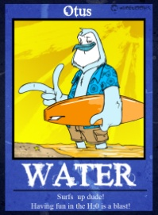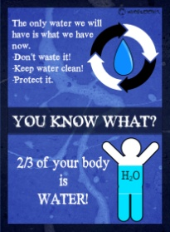
Otus says…
- 97% of the earth’s water is in the oceans. Only 3% of the earth’s water can be used for drinking. That is great for surfing dudes, but it means we really have to be super careful with the other 3%. We have to keep it clean and use it wisely.

- Major water pollutants are sediment, chemical, 0xygen depleting nutrients, metals, and biological pollution.

- The average person in the United States uses 80-100 gallons of water each day. Whoa! That’s a lot of water.
