Instructions for Using NASIS Export to Staging Server Pre Check Report

Introduction
When a soil survey is exported from NASIS to the Staging Server, a "Fatal Error" script is automatically run during the export. This script checks the survey area for 21 fatal errors (Table 1). If one these errors occurs, the export will fail and the user receives notification via e-mail.

The export process is time consuming, with users having to:
- Load soil survey areas into NASIS.
- Export soil surveys areas from NASIS to Staging Server.
- Wait for e-mail notification indicating export success or failure.
- Fix errors and try again.

This process is even more tedious during the annual SSURGO Refresh when over 3000 soil surveys are exported from NASIS to the Staging Server in a matter of weeks. This mass export overwhelms the system, causing significant delays in the e-mail notifications.

In an effort to make the annual SSURGO Refresh more efficient, the Database Focus Team has created a NASIS report that replicates 15 of the fatal errors (Table 1.). It doesn't include 6 fatal errors because those are related to either the:
- Formatting of the non-MLRA symbol
  - This is outside the control of the Regions and States
  - There should be no errors in the formatting of these symbols.
- Errors in NASIS interpretations.
  - National interpretations are outside of the control of Regions and States and there should be no errors in the national interpretations.
  - Errors may exist in Regional interpretations but use age of these can not be predicted, which means we can’t figure out which Regional interpretations to check with the report.

Table 1. List of errors that are checked for when a survey area is exported from NASIS to the Staging Server. Errors highlighted in red are not included in NASIS pre-check report.
 | Errors Checked For During Export | In NASIS Report | NASIS Table
1 | Looks at area symbol used in legend to see if it’s not a non-MLRA SSA owned by the NSSC_Pangaea NASIS Site. | yes | Legend
2 | Badly formed area symbols. | no | Area
3 | Area symbols more than 7 characters long. | no | Area
4 | Areas with name or acres missing. | no | Area
5 | No state is populated in the Legend Area Overlap table. | yes | Legend Area Overlap
6 | No county is populated in the Legend Area Overlap table that corresponds to the state. For example, if the state is Oregon, a county of Oregon must also be in the legend area overlap table. | yes | Legend Area Overlap
7 | No corresponding state exists in the Legend Area Overlap table for the county that is populated. For example, if a county for Wisconsin is populated, the state of Wisconsin must also be populated. | yes | Legend Area Overlap
8 | NULL project scale. | yes | Legend
9 | Duplicated map unit symbols exist. This can occur if the map unit status is different. | yes | Legend Mapunit
10 | NULL map unit name. | yes | Mapunit
11 | Data map unit used more than once in the correlation table as representative. | yes | Correlation
12 | NOTCOM map unit symbol is not capitalized. | yes | Legend Mapunit
13 | NOTCOM map unit symbols not linked to the national NOTCOM map unit. | yes | Legend Mapunit
14 | National NOTCOM map unit is used in the legend, but is not using a NOTCOM map unit symbol. | yes | Legend Mapunit
15 | NULL component name. | yes | Component
16 | Components that have data in the component month table but at least one record in the table has a NULL month. | yes | Component Month
17 | Entries in the Component Text table have a component text kind of nontechnical description but have a NULL category. | yes | Component Text
18 | Components that don’t have a record in the Component Text table with a component text kind of nontechnical description. | yes | Component Text
19 | Interpretations don’t meet SDV requirements. | no | Rule
20 | Primary rule is not marked ready to use. | no | Rule
21 | National interpretations use rules not owned by Pangaea. | no | Rule

The report is designed as pre-check that can be run in advance of exporting a soil survey. It will allow the State Soil Scientist to identify survey areas that will fail the export. It can be run on a single survey area or an entire state.

Report Overview and Instructions
There are two versions of the report. The outputs are identical. The only differences are the report locations and the parameters that can be selected prior to running the report:
- Web based report
  - Can be run via URL.
  - Only one parameter, which means report makes more assumptions about what survey areas should be include.
  - Slim chance data could be excluded
  - Chance that undesirable data may be included.
  - Can only be run on an entire state.

- NASIS based report
  - Must run from with in NASIS
  - Has four parameters, which gives the user more control over the output.
  - Can run on a single soil survey area or entire state.

Web Based Version of the Report
This version can be run outside of NASIS and it only has one parameter as an option. It makes more assumptions than the NASIS version, but it should work for most of the country. There is a chance a survey area could accidentally be excluded or extra surveys errors could be included in the report output.

Name
- NASIS Export To Staging Server: Fatal Error Pre-Check

Location
- On web based master list of NASIS reports, under State Soil Scientist Reports

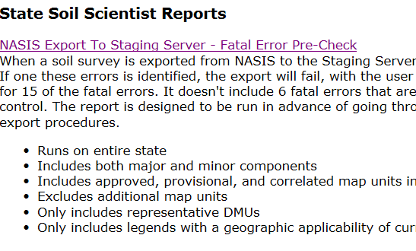

How to Use Web Based Report

- Click on the report to run (direct link to report here) and choose your state from the drop down list.

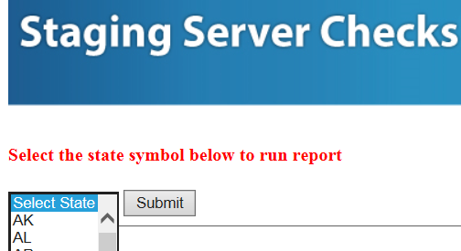

- Report will run against the national NASIS database and all surveys for the selected state will be included in the output. The upper part of the report output includes the list of fatal errors being checked and information about how the report works.

- The survey areas are listed on the left.

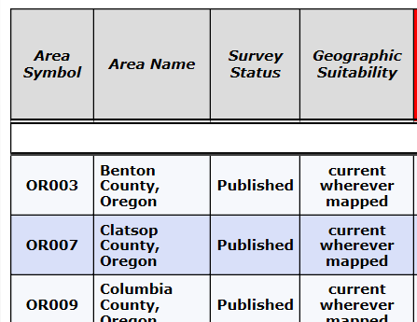3

- Each survey area is evaluated in the Staging Server Export PASS/FAIL Check Column.

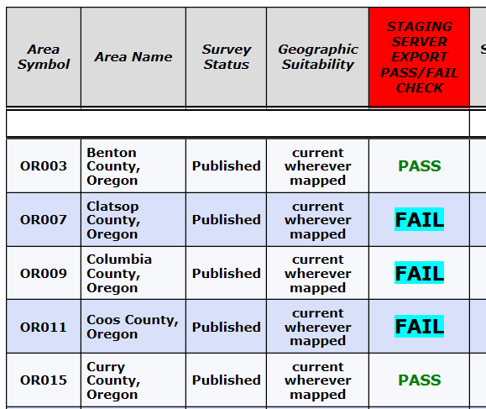

  - If you see PASS, than that survey area passed all 15 fatal pre-checks. The survey should successfully export, although you could still run into problems if there are errors related to local regional office interpretations.
  - If you see FAIL, than your survey failed at least one of the 15 checks and it will not successfully pass the export process.
    - IMPORTANT NOTE, the URL report includes minor components, provisional map units, and approved map units. These map units and minor components may not be part of your intended export and they could cause false errors.

- The 15 fatal errors are checked on each survey and they are numbered one through 15 in the second row. These numbers correspond to the list containing fatal error check details at the top of the report.

  - IMPORTANT NOTE: Only errors are displayed. Empty cells mean there is no error.

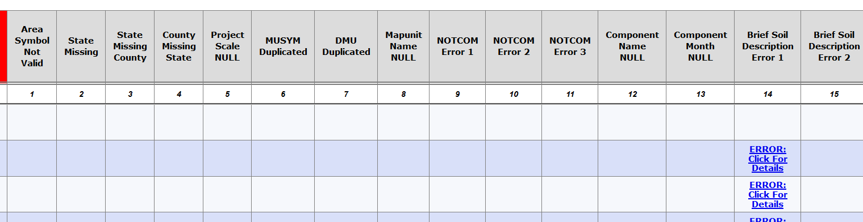

- If you see a red error, it is related to the legend. You will need to load that legend in NASIS and correct the error.

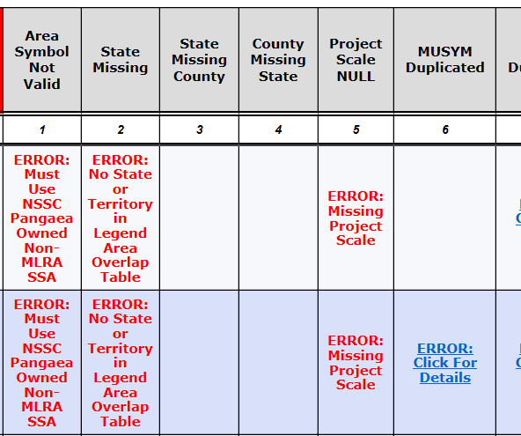

- If you see ERROR: Click For Details, it is related to map units or data map units. The error can be clicked on and a sub report will open that displays the offending data.
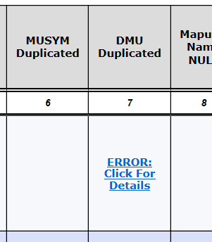
Click Link and sub report opens.

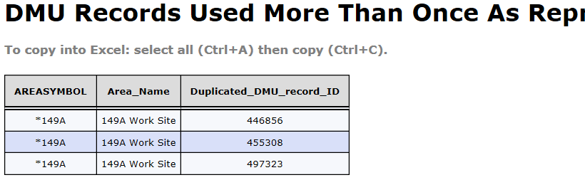

- Some sub reports will contain a comma delimited list of component record ids that can be used to quickly load the offended components into your selected set. They also reference the required query needed to load the data.

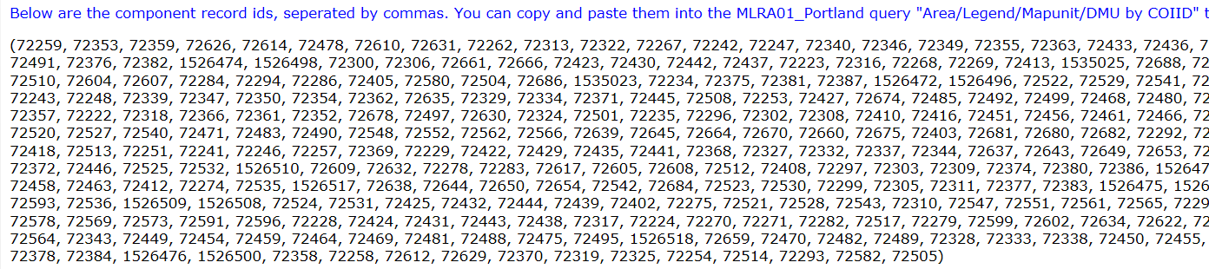

NASIS Based Version of the Report
This version can be run from within NASIS. While it requires you to log into NASIS, it gives the user more control of the output of data. It allows users to select several parameters that can assist with filtering the resultant data. It can be run on the national or local database, although it’s easier to run it on the national.

Name
- !_NASIS Export To Staging Server: Fatal Error Pre-Check

Location
- NSSC_Pangaea folder

How to Use NASIS version of the report

- Open NASIS and refresh your local database.

- Go to Reports > Open the NSSC_Pangaea folder > Right Click on !_NASIS to Staging Server Export - Fatal Errors Pre Check and choose Run Against National Database
  - It’s the first report in the list.

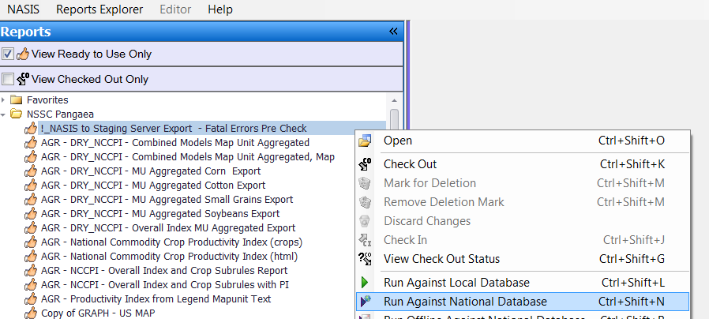

- Choose the appropriate parameter’s and click run.

