WHOBUDDIES
Conservation Heroes
SOIL

To receive the soil natural resource and Bubo card, complete at least two items below, along with the class activity.

At home, look at all the different types of plants growing in soil.

With an adult, dig a hole and take a really close look at the soil.

Name three Iowa plants that depend on soil.

Name the three best ingredients in a good soil.

With an adult, go to a nearby stream and collect a sample of water to see if it contains soil.

Class Activity-Look on a map and discuss the characteristics of the soil type that the school building sits on.

_____________________________________________________________________________________________
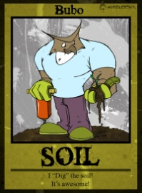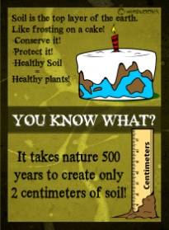
Bubo says…
- An average soil sample is 45% minerals, 25% water, 25% air, and 5% organic matter.

- Soil erosion can occur by water and wind.

- Soil has living and dead material in it.

- Different sized mineral particles, such as sand, silt, and clay, give soil its texture.
