WHOBUDDIES
Conservation Heroes
PLANTS

To receive the plants’ natural resource and Ninox card, complete at least two items below, along with the class activity.

At home, look to see how many different kinds of plants are around your home.

With an adult, identify three species of trees.

Name three ways plants benefit your life.

Name three of your favorite foods that come from plants.

With an adult help plant a tree or a plant of some kind.

Class Activity-Go outside to find a tree, and discuss its different parts.

_____________________________________________________________________________________________
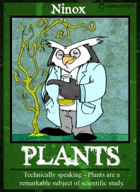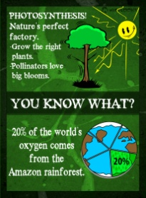
Ninox says…
- A single tree can absorb 10 pounds of air pollution a year.

- More than 2/3 of all cancer fighting medicine comes from rainforest plants.

- 30% of all the food you eat is the direct result of pollinators.

- There are over 200,000 identified plant species and this list is growing all the time.

