Highlights of the NASIS 7.4.1 Database Model

This is NOT A COMPLETE LIST of all changes. This document only highlights some of the major changes in the database model. Please refer to the “Comprehensive List of all changes” for the complete list.

Tables Added

Component Ecological Site History
  - Table Definition - This table records the ecological site correlation history of a component record from the time it is first described and correlated in the field and throughout the life of the data record.
  - A new child table of the Component Ecological Site table.
  - Designed to capture ecological site to component correlation changes over time.
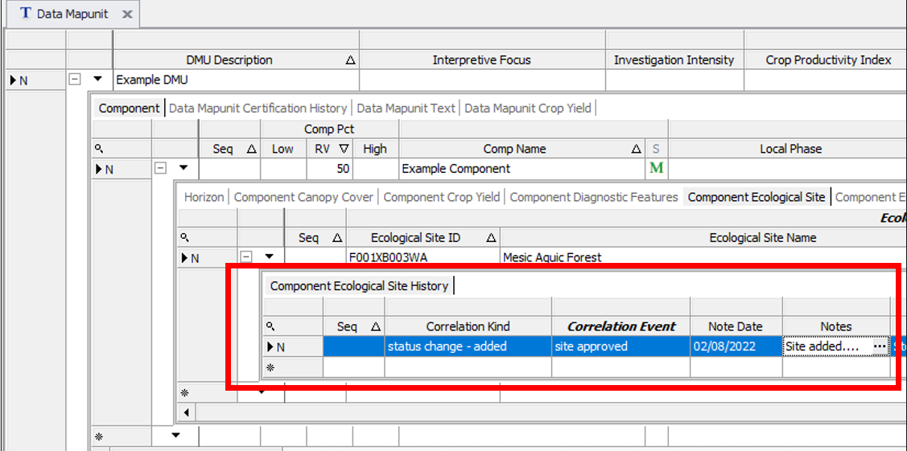

Component Inundation Type
  - Table Definition - This table lists the kinds of inundation types that occur on this component in this mapunit. One row in this table is marked as the representative inundation type for this component.
  - A new child table of the Component table.
  - Designed to capture the type of inundation by water.
  - Populate “continuous” for subaqueous soils.
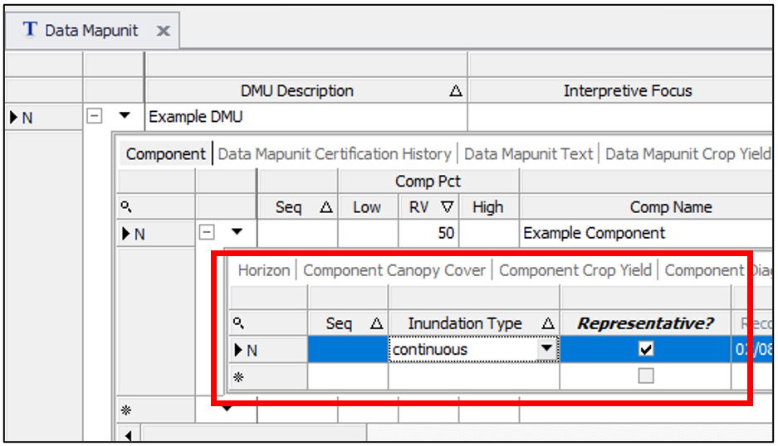

Project Subtype
  - Table Definition - Added as a lookup table for NHQ management requirements to aid in managing different subtypes of projects.
  - A new standalone table that will be used to manage a list of project subtypes.
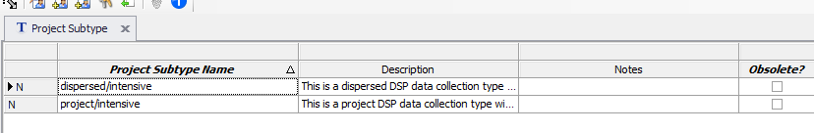
  - Is a companion to the exiting Project Type table and it will be used to subdivide project types. This will assist with categorization of projects to improve data mining for NHQ and Regional reporting and planning purposes.
  - Is linked to the Project table so project subtypes will be available as a choice in the project table. Screen shot below shows what the new project subtype column will look like in the project table.
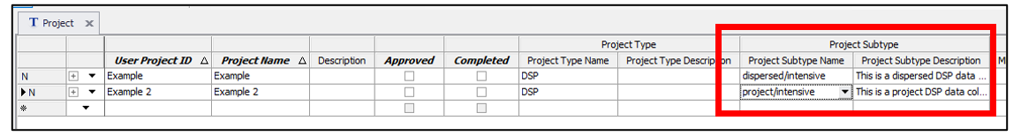

Tables Deleted

Technical Soil Service Area Overlap
  - Wasn’t used consistently or frequently
  - Only table deleted in NASIS 7.4.1.

Columns Added to Existing Tables

Rep Tex Mod and Class
  - Added to Horizon table.
  - Stores the representative texture modifier and class for the horizon.
  - Can only be calculated based on the data in the Horizon Texture Group table. Official calculation still needs to be created.
  - All component horizons with a single representative texture in the Horizon Texture Group had this new column automatically populated during the database model release.
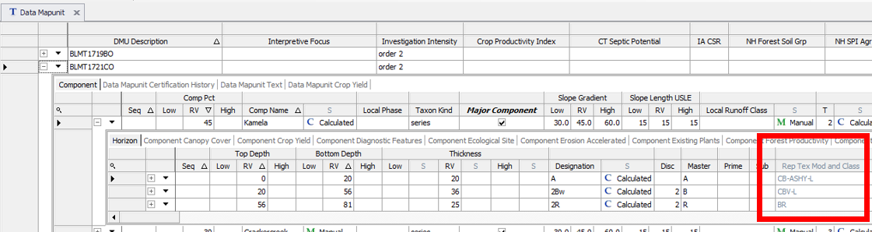

Db Satiated
  - Added to Horizon table.
  - Will be used to stores the bulk density of satiated subaqueous soils.
  - Can be left NULL for non-satiated soils.
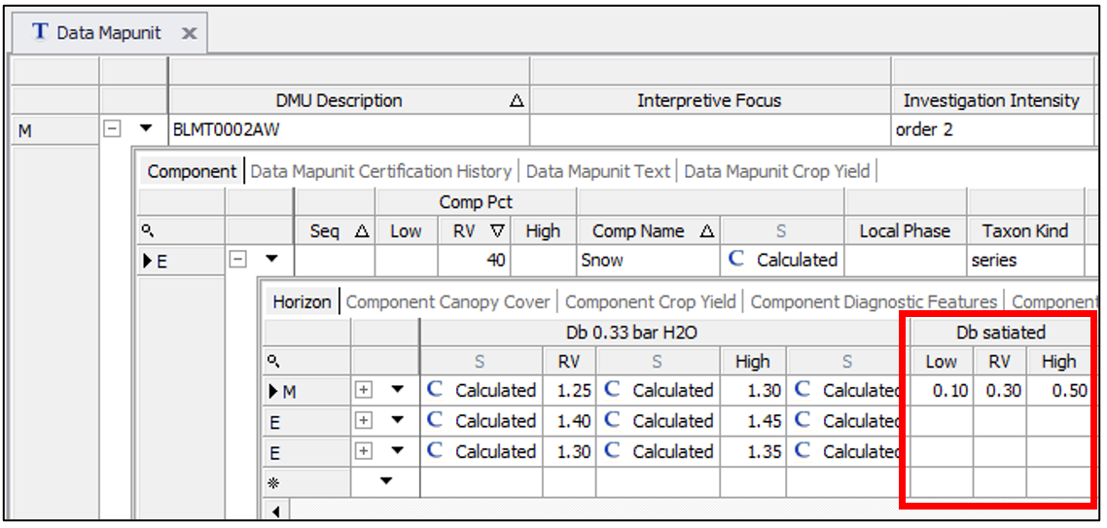

Flooding Type
  - Added to the Component table.
  - If a component floods, this will allow users to indicate the type of flooding.
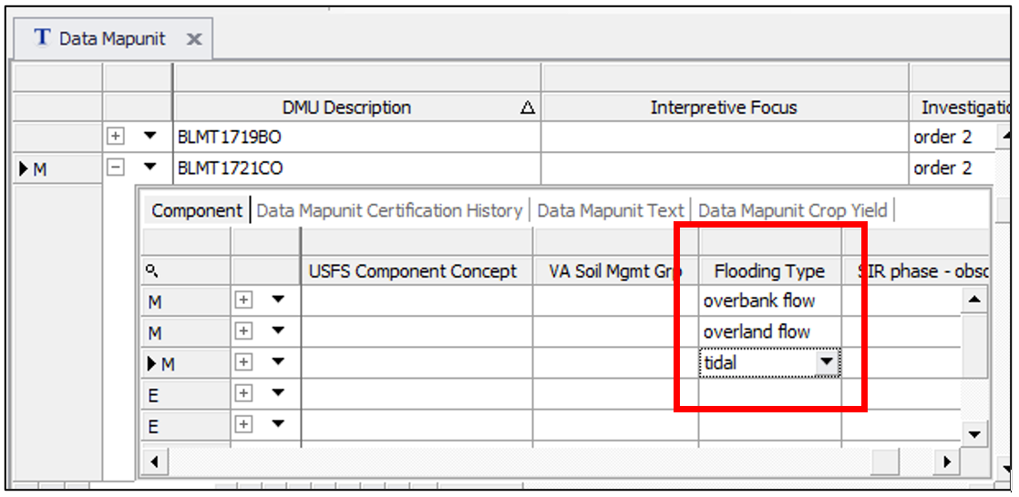

Ecological Site Status
  - Added to the Component Ecological Site table.
  - Ecological Site status is populated in the EDIT database and this information is sent to NASIS automatically.
  - In NASIS 7.4.1, when you populate an ecological site in the Component Ecological Site table, the status will automatically appear.
  - This will help with quality control of ecological sites correlated to components.
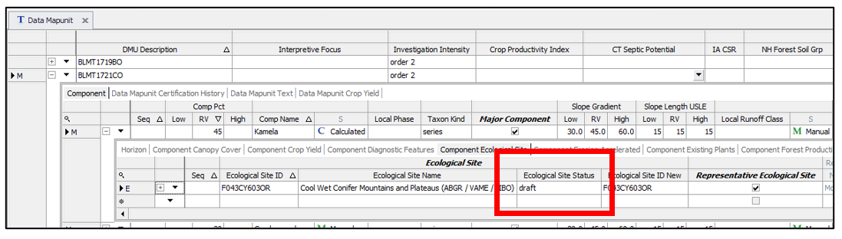

Ecological Site ID New
  - Added to the Component Ecological Site table.
  - EDIT stores two identifiers for ecological sites. The original 11 character ID and the new ID which can be up to 12 characters in length.
  - The new ID has NOT, been universally adopted. Therefore, both the new and old ID will continue to appear in NASIS. In fact, in most instances the new ID simply matches the old ID, although some ecosites do have different New and Old IDs.
  - Both the new and old IDs are now sent form EDIT to NASIS and both are now presented to users in the Component Ecological Site table.
  - The 11 character original ID is unchanged and is in the Ecological Site ID column.
  - The new 12 character ID is a new column called Ecological Site ID New.
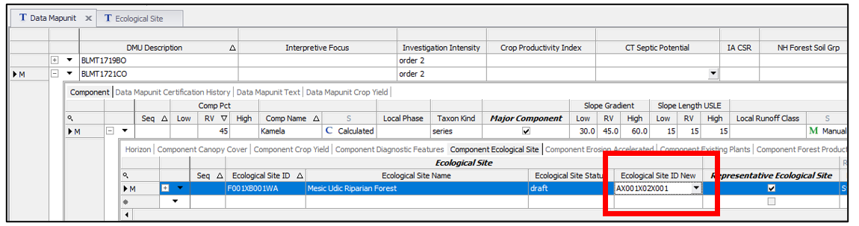

Representative Ecological Site
  - Added to the Component Ecological Site table.
  - A check box used to indicate the representative ecological site, which is needed when more than one is populated in the Component Ecological Site.
  - All records in the Component Ecological Site table where marked representative by default during the database mode release. This did result in some instances of multiple ecological sites being marked representative for a component.
  - Eventually, the NASIS exports to Staging Server will only allow a single representative ecological site to be exported.
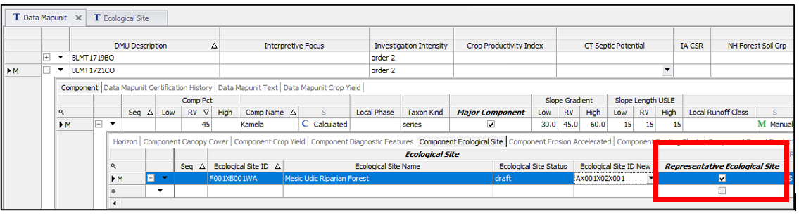

Dominant MLRA
  - Added to the Legend Mapunit table.
  - This represents one of the bigger changes in the database model.
  - A new column was added to the legend mapunit table that allows users to assign a single MLRA to a legend mapunit.
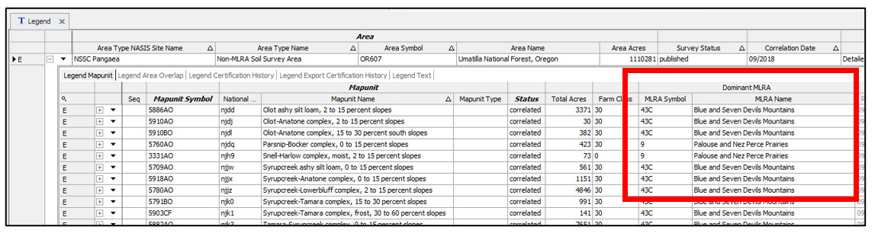
  - The rationale for this new column is that we have had historically inconsistent correlations of MLRAs to legend mapunits in the legend area overlap tables. Many legend mapunits are not assigned to any MLRA and numerous others are assigned to a more than one MLRA. This column makes it easier to populate and maintain MLRA mapunit correlations and it enforces a one to one standard.
  - The new column is called dominant MLRA because it is recognized that in rare cases, a legend mapunit does occur in more than one MLRA.
  - The existing Legend Area Overlap tables are unchanged. For now, continue to populate the legend area overlaps according to your historic Regional guidance but begin populating this new column as well.
  - The NSSH plans to analyze and assist with mass populating of this column.
  - This column was auto populated for all instances where there was a one-to-one relationship between legend mapunit and MLRA.

Project Subtype
  - Added to the Project table.
  - See New Tables Added above for information about this new column.

Project Completed
  - Added to the Project table.
  - This is a new check box in the project table that can be used to mark a project complete.
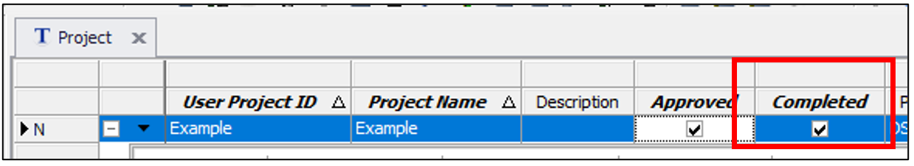
  - Prior to this, project completion could only be captured in the project milestone table with the project complete date milestone.
  - All projects that had a project milestone of “project complete data” with any date in the “Milestone Date Completed” column were marked as complete in the new project complete column.
  - Begin using this new Completed column to mark projects completed.

Alternative ID
  - Added to the Site table.
  - This is a new column in the Site table that lets a user assign other identifiers to sites records. It is intended to be used for Sites linked to external special projects that have their own identifiers.
  - For example, a special University project has their own database with their own site IDs but they are working with USDA-NRCS Soil Scientists to enter Sites into NASIS. This new field allows the two databases to be better connected.
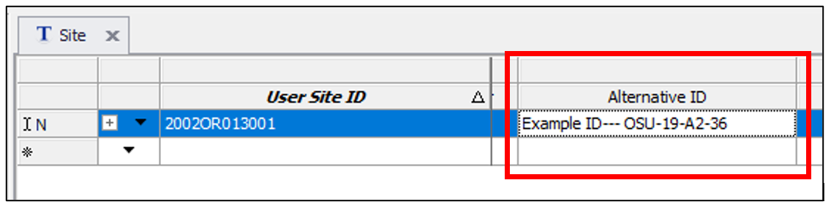

DSP Site Type
  - Added to the Site table.
  - A new column in the Site table that will help categorize Dynamic Soil Property Sites.
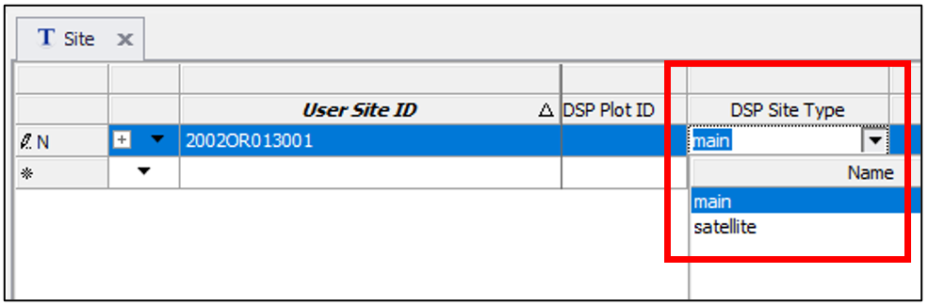

Column Modifications

Std Latitude, Std Longitude, Coordinate Source, GPS Positional Error, GPS PDOP
  - These occur in the Site table.
  - All 5 columns were moved all the way to the left, directly next to User Site ID to elevate the importance of populating the national standard latitude and longitude, and associated data.
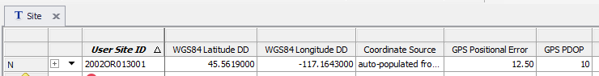
  - Std Latitude and Std Longitude columns were also renamed to WGS84 Latitude DD and WGS94 Longitude DD.
  - The renaming makes it clear that the coordinates are always in decimal degrees WGS84. No exception.

All columns used to Populate UTM and Lat/Long in DMS
  - These occur in the Site table.
  - These 12 columns were moved all the way to the right, at the end of the table.
  - This deemphasizes their importance and is a precursor to locking the columns and archiving the data. Eventually, we envision only being able to populate the std lat/long data so everyone is using a single standard.
  - You can edit these columns and populate them but their value is diminishing.

Field size changes to column

horizon designation
    - Occurs in Horizon, Pedon Horizon tables
    - Increased from 12 to 25 characters

milestone type description
    - Occurs in the Milestone Type table
    - Increased form 240 to 475 characters

project name
    - Occurs in Project table
    - Increased from 120 to 254 characters

report name
    - Occurs in Report table
    - Increased from 60 to 80 characters

Tree diameter breast height minimum value lowered
  - Occurs in the Basal Area Trees Counted, Crop Tree Details, Main Forest Stand Details, Plot Tree Site Index Details, Site Trees Counted, and Vegetation Transect Plant Summary tables.
  - Changed from 1 to 0.01

Domain Changes

concen_redox_hardness
  - This domain is used in the following table.columns:
    - Pedon Horizon Concentrations.Hardness
    - Pedon Horizon Redoximporhic Features.Hardness
  - All instances of the word cemented where replaced by coherent. For example, moderately cemented was changed moderately coherent.

rupture_resist_block_cem
  - This domain is used in the following table.columns
    - Horizon Consistence.Rupture Cement
    - Horizon Fragments. Hardness
    - Component Restrictions.Hardness
    - Component Surface Fragments.Hardness
    - Pedon Restrictions.Hardenss
    - Pedon Horizon Fragments.Hardness
    - Pedon.Rupture Cement Block
    - Site Bedrock.Hardness
    - Site Surface Fragments.Hardness
  - All instances of the word cemented where replaced by coherent. For example, moderately cemented was changed moderately coherent.

