Introduction to Using Excel 232 Forms
By George Teachman

An Excel 232 form is an Excel-based form that can be used to record pedon description data which can then be imported into the NASIS National database.
There are four methods of getting soils information into NASIS. Deciding which method to use is somewhat dependent on the amount of detailed pedon description data you wish to add to NASIS.
To input the least amount of data, you can use the Excel-based 232 form. Excel-based 232 forms record the most commonly collected morphological, physical, and chemical data. Users entering pedon description data into NASIS utilizing this method do not have the necessary privileges to modify the forms or the NASIS scripts used to import the data in these forms. The forms are set up to mimic the very familiar paper 232 forms. The data from these Excel workbooks can be imported into NASIS by clicking on the spreadsheet icon in NASIS.
For a moderate level of detail, you can use the Pedon PC program. The level of detail of the pedon description data that can be recorded using Pedon PC is significantly higher than the Excel-based 232 forms but less than that which can be recorded using the NASIS interface. Users entering pedon description data into NASIS utilizing this method do not have the necessary privileges to modify the Pedon PC program or the NASIS script used to import the data in Pedon PC. The user of the Pedon PC program can arrange the tables and columns to suit their method of recording data. The data from these Microsoft Access databases can be imported into NASIS by clicking on the appropriate icon in NASIS.
To record the highest level of detail requires entering data directly into the NASIS database using NASIS as the data entry tool. Users entering pedon description data into NASIS via the native NASIS interface where the tables and columns are presented in the hierarchical order determined by the data model are able to rearrange columns and hide those not being used but cannot change the basic look and feel of the table/column approach.
The fourth method, which was introduced in NASIS version 7.0 uses NASIS Forms. An advanced user can create new forms or edit existing ones to more closely match the way the user collects pedon description data. The amount of data in these forms can vary from a very basic set, i.e., field notes, to every data element ever used to hold pedon description data. It just depends on the user requirements and the user’s skill in creating the forms.
The difficulty of entering data into NASIS is directly proportional to the level of detail required.
Anecdotal evidence indicates that using the Excel-based 232 forms to import pedon data into NASIS is faster than using either Pedon PC or NASIS itself.
There are four variants of the Excel-based 232 form to choose from. There is one for Histosols, one for subaqueous soils (SAS), and two for mineral soils.
With the exception of the 232 SAS form, each variant can be used to record and import into NASIS either historical or new descriptions. Historical descriptions can be taken from old paper 232 forms, field notes, or even taxonomic unit descriptions (TUDS) from published soil survey reports.
When entering historical pedon descriptions, it is NRCS Soil Science Division policy to enter the codes exactly as described in the historical record, except for the pedon”s taxonomic classification. The pedon is to be classified using the latest keys to taxonomy based on the data in the description. This means that it is necessary to record obsolete terms and codes.
Since describing SAS soils is a very new practice, there are no historical descriptions for these soils, and thus the SAS 232 form does not allow obsolete terms and codes.

How to Use a 232 Excel Form

The following section of this document describes how to use a 232 form. A set of Excel-based 232 forms has been developed and posted to the NASIS Downloads web page. The forms are listed below. Note that all the file names as shown on the website include the date of the last update. In the file names below, the dates have been left out to reduce confusion regarding which date to use. To make communication easier, the version number and date and extension have been left off of the file names listed below.
232 Histosol
232 JC232
Minl Mxd DE
232 SAS and VibraCore Log

NOTE: Each of these files can print either in ledger size (11 inches by 17 inches) or legal size (8.5 inches by 14 inches). The default is to print in ledger size. There are instructions displayed in each file when opened to print in the legal size.
Figure 1 is a generalized screenshot of the top of the forms.

Figure 1

Controlling Cursor Movement

Earlier versions of these forms required the user to move the mouse cursor to a data entry field and do a left click to put the cursor in that field. Or, the user could use the Tab key, the Enter key, and/or the Arrow keys to move the cursor to the data entry field of interest. These actions are very repetitive and lengthen the amount of time it takes to enter all the profile data. They also have the potential to create errors or even inadvertently modify the form to the point that the import into NASIS could fail or that the data was imported into the wrong columns in the database. One of the most often seen errors is using the Tab key to move the cursor out of the data entry field after the user completed entering the data. If the user fails to press the Tab key enough times to move the cursor past labels and starts typing the data entry for the field the user thinks they are in the label field can be overwritten and the data would not be imported into NASIS.
In this version there are two ways to control the cursor movement, i.e., Predefined Cursor Path or PCP. The first way is to click on the button labeled PCP at the top of the form. This method is used only in the site section of the form. When the PCP is enabled, the user can enter data into the first field, the Sample Date, and then click the Tab (or Enter) key to move to the next data entry field. At the end of a row the Tab (or Enter) key will move the cursor to the first field on the PCP in the next row. When the form is first opened the PCP will be enabled and the form looks like the example in Figure 2. NOTE: The Right Arrow key does not act like the Tab key in this situation. Using the Right Arrow key will disable the PCP.

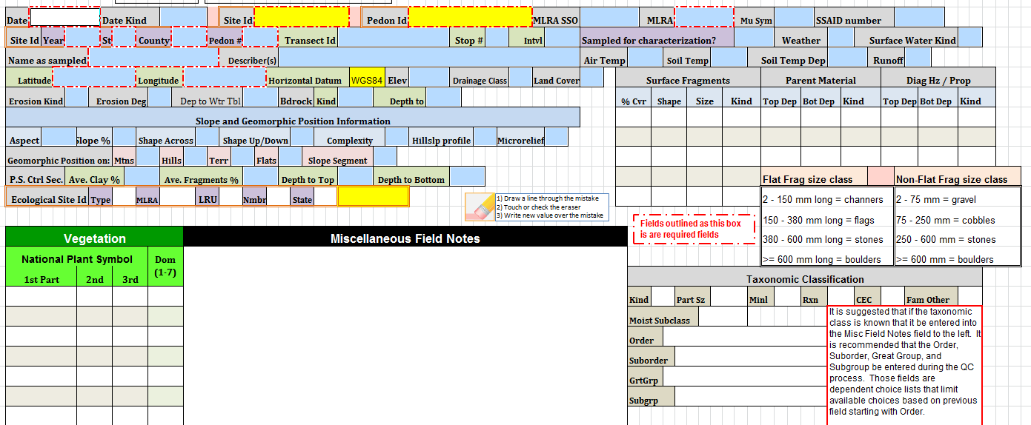
Figure 2
If the user uses any of the arrow movement keys or uses the mouse to click on any cell not included in the PCP, the PCP is disabled and returns the Tab (or Enter) key to its normal behavior. To reset the PCP click on the pink button with the label “PCP” at the top left of the form, as shown in Figure 1. This will re-enable the PCP and puts the cursor in the Sample Date field. The user will need to Tab (or Enter key), or Shift Tab to go in reverse, through the fields to get to the field they left off at. Once the cursor is in the last field of the PCP clicking the Tab (or Enter) key again will wrap the cursor around to the first field, the Sample Date field.
A drawback to this method is that only a limited number of data entry fields can be included in the PCP definition. However, this method is safe and has only a limited potential for introducing errors to the data or the form.
The second method of defining the PCP has the potential for losing data. This method relies on the non-data entry fields being protected from change. If this method is enabled (by protecting the worksheet), the cursor will only stop in data entry fields. There is no limit to the number of fields that can be tagged to be skipped in contrast to the very limited number of fields in the first PCP method. In this method, using the Tab key will move the cursor horizontally across the form and wrap around to the next available data entry field after the last data entry field on the row.
The Arrow keys retain their normal behavior, for the most part. Depending on the design of the form the Arrow keys may exhibit a little different behavior than normal. The user will quickly come to know how the Arrow keys behave after using a particular form a few times.
To determine the protection status of the worksheet the user needs to click on the Files tab with the worksheet open and active. Clicking on the File tab at the upper left corner of the ribbon area of the workbook will display some basic information about the workbook. See Figure 3 below:

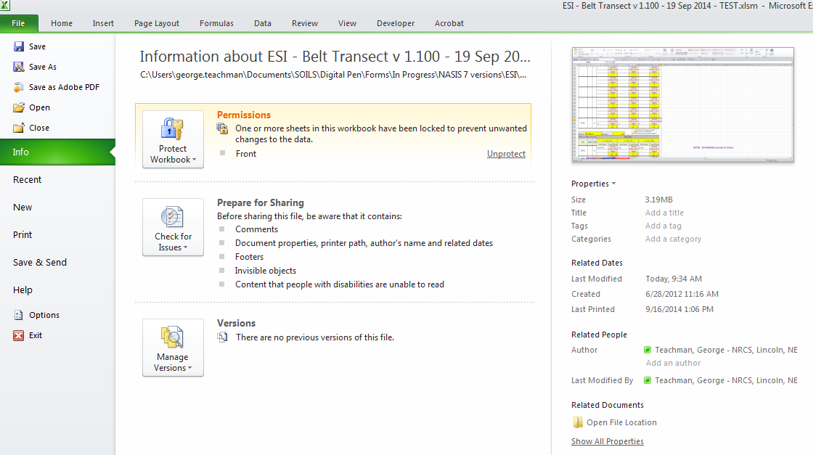
Figure 3
If the form is protected, the highlighted section on the File tab, the Permissions section, will show “Front” and at the right side of that section will be an underlined word, “Unprotect” as depicted in Figure 4.
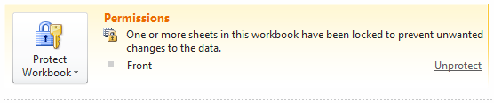
Figure 4
The user will need to save the file with an appropriate name and in an appropriate location. The original file that was downloaded from the storage site is in a read-only mode. It is best if you keep this file as is and then save it with a different name, prior to adding any data.
When the cursor is in a choice list field the user can use the mouse to click on the downward pointing triangle to access the choice list and select the appropriate choice.
TIP: This action is also available via the keyboard. Simultaneously click and hold the Alt and Down Arrow keys to open the choice list. Then, using the Up/Down Arrow keys to move to the wanted choice and clicking the Enter key will put the choice in the data entry field. This action will not disable the PCP.

Managing Choice Lists

One of the major benefits of the forms is the ability for the user to record obsolete codes often found in older (historic) descriptions. Obsolete codes can be used in any field that may have obsolete codes, with the exception of the taxonomic classification fields. As previously noted the taxonomic classification fields do not allow the use of obsolete codes. This allows for the entry of historic pedon data which may contain codes that are now obsolete. Since there are no historic subaqueous soil descriptions, the SAS 232 forms do not have the option of entering historic codes.
The forms also use the concept of dependent choice lists where the choices available for a field are dependent upon the choice in a previous field. Dependent choice lists are used in limiting the choices for County FIPS code; based on the value entered in the State field. Dependent choice lists are also used in the Taxonomic Order, Suborder, Great Group, and Subgroup fields.
Some of the fields in NASIS, Pedon PC, or the Excel 232 forms have a large number of allowable choices. The user now has the capability to limit the number of choices displayed by removing those fields that do not apply to the area, and/or soils that do not exist in their area of concern. Table 1 lists the fields that have large numbers of allowable choices. The user can edit (remove choices only) these choice lists in three of the four versions of the 232 forms. NOTE: The SAS form only allows the user to modify the choice lists for the Parent Material, Fragment Kind, Landscape, and Landform.

Parent Material | Bedrock Kind
Fragment Kind | Surface Fragment Kind
Diagnostic Feature Kind | Concentration Kind
Landscape | Landform
Table 1
The following section contains instructions on how to edit the long choice lists.

Method to Remove Choices from Long Choice Lists

Two methods have been incorporated into the 232 workbooks to limit the choices displayed, thus decreasing the amount of time needed to complete the form.
The first method, using Dependent Choice Lists, has already been addressed. It should be noted that this method is automatically used. This means the user does not need to do anything to invoke this method.
The second method is to allow the user to interactively select which choices will be displayed. Unlike the first method, the user must invoke this capability. The user can utilize this method on one or more of the eight long choice lists.
With the second method, the user selects which choices they want to remove from the original choice list. This method is very useful when done prior to any data entry. It creates a default set of choice lists. In this way, the office or individual user can create a default workbook.

Using the Dependent Choice List Capability

Figure 5 shows the Taxonomic Classification section on the first page of the Front form/worksheet. The cursor is in the Order field, which shows the choices available, and “inceptisols” is selected.
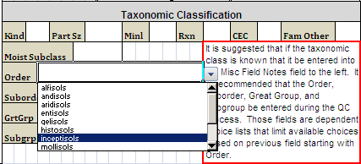
Figure 5

After selecting an order, the following fields will have choices limited to just the selected order, in this case Inceptisols. After moving to the Suborder field and clicking on the downward-pointed triangle, it can be seen that only a few choices are allowable. Figure 6 shows that Inceptisols has been selected as the order and that the user has highlighted “udepts” as the suborder.
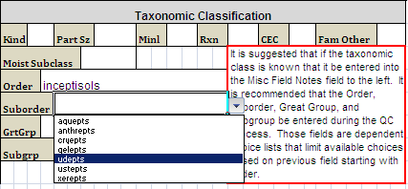
Figure 6

The same process is repeated in the Great Group and Subgroup fields until the user has selected “dystric fluventic eutrudepts” as the choice for Subgroup (shown in Figure 7). Notice that in the case of Subgroup, because there are more choices than can fit in the choice list box, a vertical scroll bar has been added to allow the user to scroll through the list.
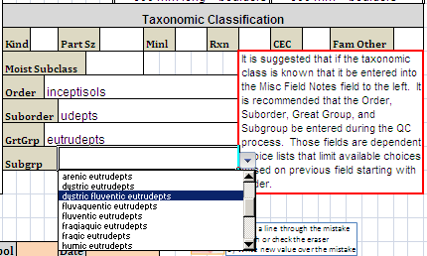
Figure 7

Editing Long Choice Lists

To edit the choice list for one of the fields mentioned above, the user must click on the yellow tab at the bottom of the Excel window. The user will see the eight choice lists available in all 232 workbooks. NOTE: The four names highlighted in yellow (shown in Table 2) are the only ones available in the 232 SAS workbooks.
Parent Material | Bedrock Kind
Fragment Kind | Surface Fragment Kind
Diagnostic Feature Kind | Concentration Kind
Landscape | Landform
Table 2
To edit one or more of these lists, follow the steps shown in Figure 8.
After clicking on the yellow tab labeled “Advanced”, scroll horizontally until you see the name of the list from which you want to remove choices. For this example, the Parent Material list is used.
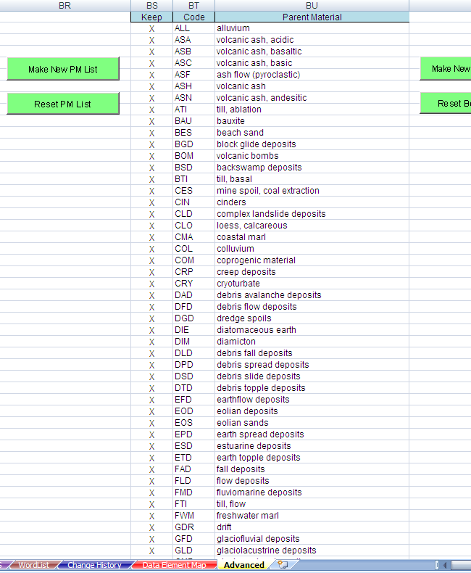
Figure 8

Put the cursor in the second row of the column named Keep. Then moving down the column one row at a time, delete the “X” out of the cell of the row with the choice you do not want displayed in the choice list for that field. Figure 9 shows that several rows (both contiguous and noncontiguous) have had the “X” deleted.
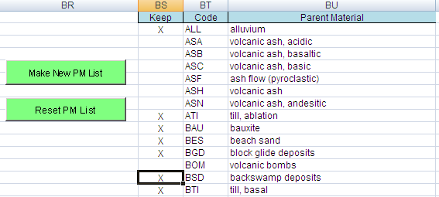
Figure 9

If you inadvertently delete the “X” from a row you want to keep or simply decide after deleting the “X” that you do want to display that choice, simply type upper case “X” in the appropriate cell.
After indicating the choice(s) you do not want displayed in the choice list, click on the Make New PM List button. The screen will flash and may show processing. At the end of the processing, the cursor will be located in the second row of the column named Code, as shown in Figure 10.
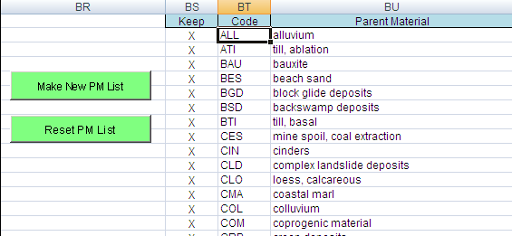
Figure 10

Once you have edited one or more of the available choice lists, click on the green tab with the name Front and save the workbook with an appropriate name, for example, SSO 12-GRR - 232 JC – default – 3 Mar 2014.
When you put the cursor on the field whose choices you have limited, you will notice that the choice list displays the last eight choices instead of the first eight and that there will be a blank space where a choice has been removed. You will need to scroll up to find the choice you want.
If a choice or choices were removed but should be included and the error was not noticed until after clicking on the Make New PM List button, you will need to click on the Reset PM List button to display the original choice list and then redo the selection process.

Adding Data from Historic Pedon Descriptions

Another major capability of the Excel 232 forms is the ability to record data as it was originally recorded. With the exception of the Taxonomic Classification fields the user has the ability to add previously used, but currently obsolete, codes and terms to the list of allowable entries for a large number of fields. To do this, follow the instructions found in Figures 11 through 17.
Figure 11 shows a section of the top of the form that addresses historic pedon data entry.

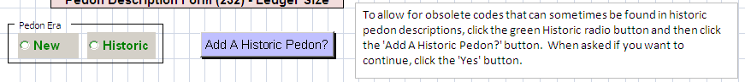
Figure 11
The text box provides a short description of how to prepare a 232 form to allow the entry of obsolete codes. Below is a more detailed description with screen shots of what you can expect to see.
NOTE: The option of entering historic data only applies to pedon data you are entering via the keyboard.
When an Excel-based 232 form is first opened obsolete codes cannot be entered. They are not available in the drop down choice lists.
When entering a historic pedon, you will not know if the describer actually used any of the now obsolete codes but it should probably be assumed that such codes were used. Thus, the choice lists must be modified to include obsolete codes. Follow the steps below.
Left click on the word “Historic” (in green) in the radio button group entitled “Pedon Era.” A black dot will appear in the circle to the left of “Historic,” as seen Figure 12.

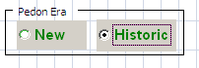
Figure 12
Next, click on the button labeled “Add A Historic Pedon?” The following dialog box will appear.

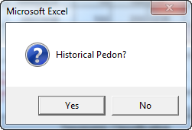
Figure 13
If you are entering data from a historic pedon, click on the “Yes” button. If not, click on the “No” button. When the “Yes” button is selected, the following dialog box will be displayed.

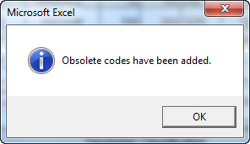
Figure 14
Codes that have been identified as obsolete have been added to the appropriate choice lists, and you will be able to select them like any other code. Click on the “OK” button and start entering data.
If you click on “No” in the “Historical Pedon?” dialog box, the following will appear.

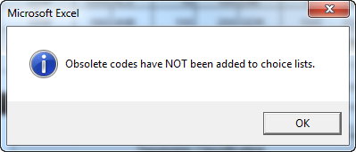
Figure 15
Click on “OK” and enter pedon data. You will not be able to select obsolete codes.
The set of Choice Lists that are modified for use when entering Historic pedons is shown in Table 3.

Bedrock Kind | Landform | Redoximorphic Kind
Color Chroma | Landscape | Redoximorphic Location
Color Hue | Microrelief | Redoximorphic Size
Concentration Kind | Mottles Size | Root Size
Consistence Dry | Parent Material | Runoff
Consistence Moist | pH Method | Slope Position
Diagnostic Feature Kind | Pore Shape | Slope Shape Across
Effervescence Agent | Pore Size | Slope Shape Up/Down
Erosion Kind | PVSF Distinctness | Structure Grade
Fragment Kind | PVSF Kind | Structure Size
Geomorphic Component Flats | PVSF Location | Structure Type
Geomorphic Component Hills | Redoximorphic Hardness | Surface Fragment Kind
Land Cover
Table 3: Choice Lists Modified
An additional macro has been added that can be used to reset choice lists that have been expanded for use with historic pedon descriptions back to the current allowable choices. There is no button for this macro. The user will need to click on the Developer tab to display the Macros icon, as shown in Figure 16.

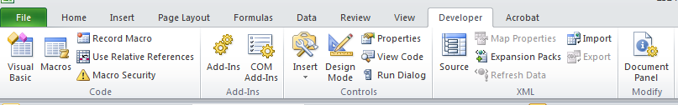
Figure 16
Clicking on the Macros icon will display, as shown in Figure 17, a list of available macros which change depending on what the user selects in the “Macros in: ” field. The user should select the “This Workbook” in this field. Then in the list of macros scroll down to the macro named “Sheet3.ResetChoiceLists” and double click on it or click one-time and then click on the Run button.

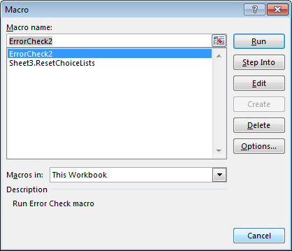
Figure 17

Quality Control of Data to be Imported into NASIS

To find errors that may cause the import into NASIS to fail you should run the Error Check macro, by clicking on the green button labeled “Error Check.”
The Error Check button/macro may interact with the user prior to completing if the user indicated that this form was a continuation form. Other than this potential interaction the error checking process will display a popup message box when it completes the error check.
The Error Check macro checks for a multitude of potential errors and potential inconsistencies. When it identifies an error or inconsistency it writes a message to the error log file that is displayed after the macro is completed. Figure 18 is an example of the message displayed when the error checking is completed.
A Fatal error is one that will cause the import into NASIS to fail. Clicking on the OK button will display the error log file containing information about the error and where it was found. The Error Report shown in Figure 18 is not the one linked to the Error Check Report example shown in Figure 19.
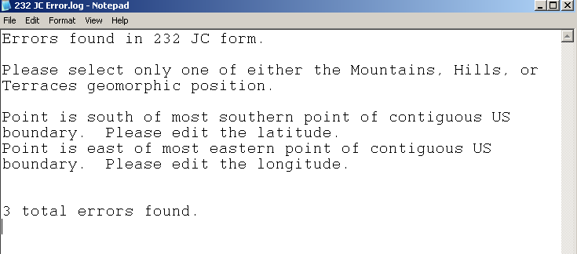
Figure 18
This file can be found in the C:\temp directory on your computer. It can also be printed to help you fix the errors that were found.
Once you have fixed the errors, you should run the Error Check macro again. At some point during the error fixing iterations, you will have fixed all the errors that have been found and you will get a message dialog box like the one shown in Figure 19.
The final error check is made when you import the spreadsheet into NASIS. NASIS is able to identify errors that the data validation methods cannot. Some validations, however, can catch some potential inconsistency type errors that NASIS does not check upon import (such as checking if the horizon lower depth is less than the horizon upper depth).

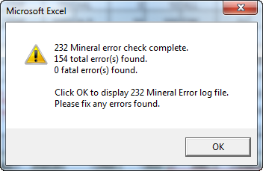
Figure 19
Each of the Excel-based 232 form variants operates in much the same manner as described above.

Adding Plants

Please refer to Figure 20 for the following discussion on how to add plants found to the forms.
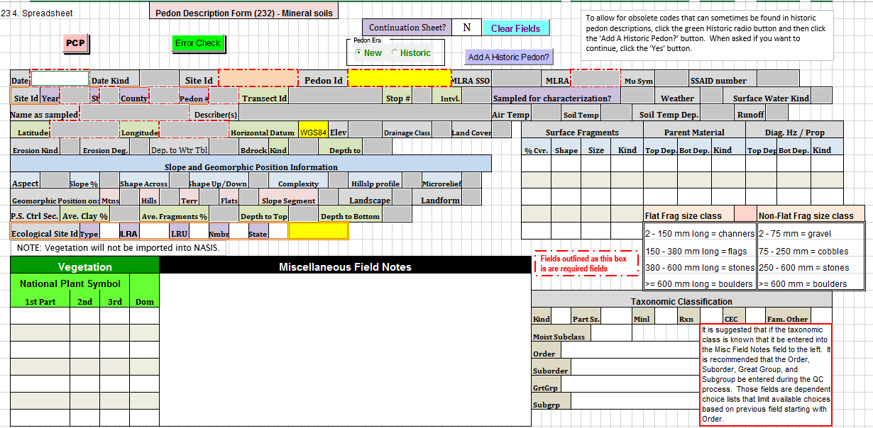
Figure 20
To enter plants found you will need to know the National Plant Symbol (NPS) as listed in the USDA PLANTS database. You do not need a common name. The NPS field has been separated into the three distinct pieces that make up the National Plant Symbol. NOTE: The reason for splitting the NPS into its constituent pieces is that the Capturx for Excel optical character recognition software has problems with a field that mixes both alphabetic and numeric characters.
- First part is a four-alpha character field. This is the only required field of the three that make up the NPS. It must be four characters and each must be a letter.
- Second part is a one-alpha character field. This is an optional field and if used must be one letter.
- Third part is a one- or two-digit numeric field. This is an optional field and if used must be greater than or equal to 2 and less than or equal to 99.
The Error Check macro checks the concatenated value against the most recent list of National Plant Symbols in the NASIS Plant table.
NOTE: The plants data is not imported into NASIS because if ESI data associated with the User_Site_Id already in NASIS is imported a second Vegetation Plot record is created and this will cause problems when analyzing and reporting vegetation data. The only way we could ensure that this did not happen is by not importing the vegetation data from the 232 forms. If the user knows that this site will never have any other vegetation data associated with it then the user will need to go into NASIS and create the necessary link to the Site Observation record to the Vegetation Plot table and enter the data into the Plot Plant Inventory table by hand.

Adding Some of the Super 7 Data Elements

A recent major change to the two mineral 232 forms is an additional page containing fields for values for what have been called the “Super 7” data elements. Some of the Super 7 data elements have fields for their values in other areas of the form. The remaining fields are located in the new Field Estimate of specific data elements page as shown in Figure 21.
- %CF. This is an auto-populated field (thus the yellow color of the field) that is derived from the sum of the estimated % Fragments fields in the Horizon section of the form. The Pedon_Horizon_Fragment table is a child table of the Pedon_Horizon table. Since, there can only be up to three records in any of the Pedon_Horizon child tables, the %CF is the sum of the three Fragments Pct. fields in each horizon
  - This value is stored in the Fragment_Volume_Total field in Pedon_Horizon table.
- % Sand. The value is the field estimate of total sand. This is not a measured value. If you have a measured value it should be entered into the Pedon Horizon Lab Results table using NASIS.
  - This value is stored in the Sand_Total_Estimated field in the Pedon_Horizon table.
- % Silt. The value is the field estimate of total silt. This is not a measured value. If you have a measured value it should be entered into the Pedon Horizon Lab Results table using NASIS.
  - This value is stored in the Silt_Total_Estimated field in the Pedon_Horizon table.
- % Clay. The value is the field estimate of total clay. This is not a measured value. If you have a measured value it should be entered into the Pedon Horizon Lab Results table using NASIS.

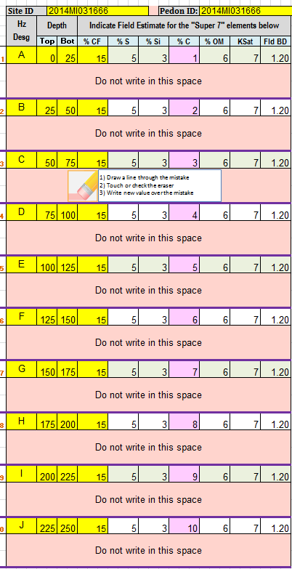
Figure 21

  - This field is auto-populated from the % Clay field in the Horizon section of the form. However, the user can overwrite this field if they wish. This is why the field is pink and not yellow, like the other auto-populated fields.
  - This value is stored in the Clay_Total_Estimated field in the Pedon_Horizon table.
  - If for some reason the user does not want to use the %Clay field in the first horizon section of the form they can enter the %Clay in this cell so as to keep most of the Super 7 values together in one section to aid in the use and analysis of this data.
  - The user needs to know that once the user enters data into this field it is no longer linked to its respective %Clay field further up on the form.
  - NOTE: The import process only looks at the value of this field when it imports percent clay. It does not import any data entered in the first %Clay field.
- % OM. The value is the field estimate of total organic matter present. This is not a measured value.
  - This value is stored in the Pedon_Horizon_Field_Measured_Properties as Estimated % OM with the unit of measure as “percent”.
- Ksat. The value is the field estimate for the horizon”s Ksat. This is not a measured field.
  - This value is stored in the Pedon_Horizon_Field_Measured_Properties as Estimated Ksat with the unit of measure as “um/s”.
- Field BD. The value is the field estimate for the bulk density of the soil at the time the soil was described. This is not a measured value.
  - This value is stored in the Pedon_Horizon_Field_Measured_Properties as Estimated Field Bulk Density with the unit of measure as “g/cc”.

What does the choice list code mean?

An often heard comment/complaint about the 232 forms is that the user does not always know what the codes in the choice lists relate to. When the user is filling out the form in the field they must often pull out the Field Book and find the section that corresponds to the section on the form to find a list of allowable codes and their meanings.
The forms now have most of the choice lists, with codes and their meanings, displayed on the form itself. In most cases the choice lists are printed on the page of the form they are used. Also, the choice lists with a large number of choices, those described in the section of this document on personalizing choice lists, are not displayed. An example is shown in Figure 22.

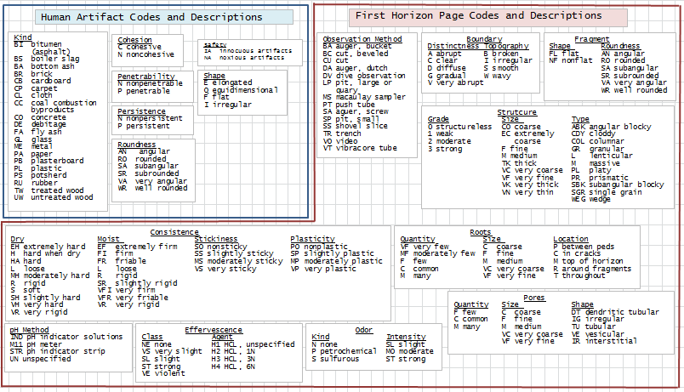
Figure 22

More Than Ten Horizons?

The 232 forms only have space for ten horizons. Note that this is only a limitation of the 232 Excel-based forms. Neither Pedon PC nor NASIS has a limit on the number of horizons that can be described for a single pedon. Ten horizons are usually more than enough to completely describe a pedon”s profile. However, there are times when ten horizons are not enough. What does the user do then?
In Figure 1 there is the “Continuation?” label. The field associated with this label is a Y(es) or N(o) field. If the user needs to describe more horizons, then they should change this field from the default of “N” to “Y”.
After entering a “Y” into the “Continuation?” field the data entered in the horizon section of the form will need to be erased. Click on the “Clear Fields” button to clear all the fields the user entered data in all the horizons. NOTE: It will not clear the fields in the site portion of the form.
The user now enters data for the extra horizons as normal.
Importing a continuation form into NASIS will fail if the data from the first ten horizons has not yet been entered. When the pedon data described on the two or more forms is imported into NASIS they must be entered in order. Meaning, the first form used to describe the first ten horizons must be imported prior to any additional continuation forms. If there are more than one continuation forms then the first continuation form must be imported first, and so on.
The most important thing to remember when using a continuation form is not to change any of fields in the Site section of the form. To help avoid this the data fields in the Site section of the continuation workbook will have their status changed from editable to protected once the user enters “Y” in the Continuation field and clicks on the Clear Fields button.
Once the Clear Fields process is complete, and it may take a couple of seconds, the cursor will be placed in the first data field in the horizon section of the form. Just start entering data from there. Remember to save the continuation form file with a different name than the first form was called so you can tell which of the forms the continuation form is to be linked with.

