Introduction to Using Excel TSS Form
By George Teachman

An Excel TSS form is an Excel-based form that can be used to record Technical Soil Services information which can then be imported into the NASIS National database.
There are two methods of getting TSS information into NASIS. Using the Excel TSS Form or inputting the information directly into the database using the NASIS editing pane.
The difference between the two concerns the multiple ways of entering location data. There are three different methods of entering location data. Decimal Degrees; Degrees, Minutes, Seconds (DSM); and UTM.
The TSS Form has columns for DMS and UTM methods along with Horizontal Datum. These are not imported into NASIS because all location data entry is now required to be in Decimal Degrees.
If, for some unknowable reason, it is necessary to have either DMS or UTM fields populated, then that will need to be done after the record is imported into NASIS.
To input the least amount of data, you can use the Excel-based TSS form. This is misleading, because all the fields in the NASIS TSS table are included in the TSS form. However, not all are imported into NASIS.
A third method does exist. It was introduced in NASIS version 7.0 and uses the NASIS Forms capability. An advanced user can create new forms or edit existing forms to more closely match the way the user wants to enter TSS job information.
Anecdotal evidence indicates that using the Excel-based TSS forms to import TSS data into NASIS is faster than using either NASIS editor or the NASIS Forms based data entry itself.

How to Use an Excel Form

The following section of this document describes how to use a TSS form. An Excel-based TSS form has been developed and posted to the NASIS Downloads web page. The TSS Form to download has a name similar to Tech Soil Service Form.
Figure 1 is a screenshot of the top of the TSS form.

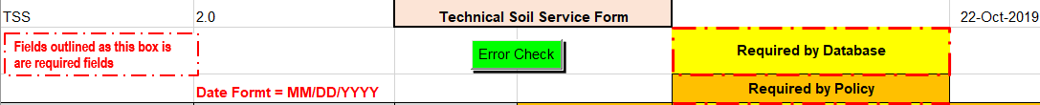
Figure 1

To determine the protection status of the worksheet the user needs to click on the Files tab with the worksheet open and active. Clicking on the File tab at the upper left corner of the ribbon area of the workbook will display some basic information about the workbook. See Figure 2 below:

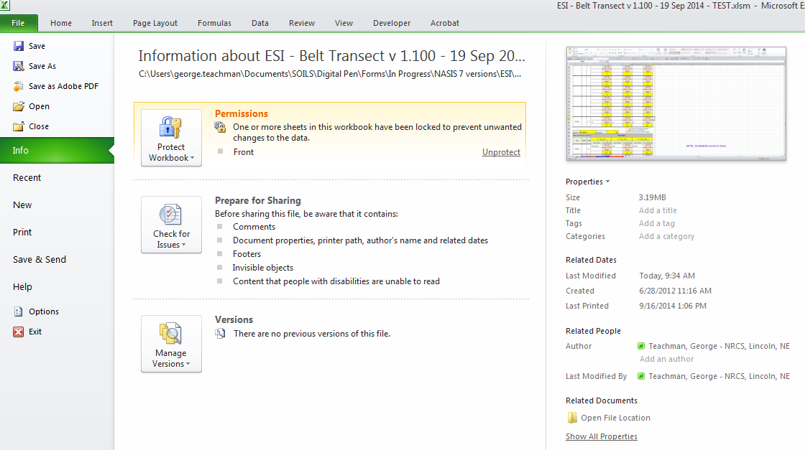
Figure 2
If the form is protected, the highlighted section on the File tab, the Permissions section, will show “Front” and at the right side of that section will be an underlined word, “Unprotect” as depicted in Figure 3.
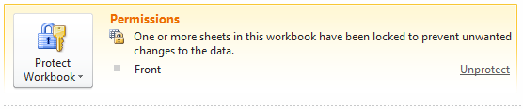
Figure 3
The user will need to save the file with an appropriate name and in an appropriate location. The original file that was downloaded from the storage site is in a read-only mode. It is best if you keep this file as is and then save it with a different name, prior to adding any data.
When the cursor is in a choice list field the user can use the mouse to click on the downward pointing triangle to access the choice list and select the appropriate choice.
TIP: This action is also available via the keyboard. Simultaneously click and hold the Alt and Down Arrow keys to open the choice list. Then, using the Up/Down Arrow keys to move to the wanted choice and clicking the Enter key will put the choice in the data entry field.

Managing Choice Lists

The forms use the concept of dependent choice lists where the choices available for a field are dependent upon the choice in a previous field. Dependent choice lists are used in limiting the choices for County FIPS code; based on the value entered in the State field
Some of the fields in the TSS form have a large number of allowable choices. The user now has the capability to limit the number of choices displayed by removing those choices that do not apply to the area. Table 1 lists the fields that have large numbers of allowable choices. The user can edit (remove choices only) these choice lists.
TSS Type Service | MLRA
Recipient | State
Provider
Program
Table 1
The following section contains instructions on how to edit the long choice lists.

Method to Remove Choices from Long Choice Lists

Two methods have been incorporated into the TSS workbook to limit the choices displayed, thus decreasing the amount of time needed to complete the form.
The first method, using Dependent Choice Lists, has already been addressed. It should be noted that this method is automatically used. This means the user does not need to do anything to invoke this method. This method is used when entering State and County. Enter the State, or select from the choice list, and only those counties in that State will be presented as a choice.
The second method is to allow the user to interactively select which choices will be displayed. Unlike the first method, the user must invoke this capability. The user can utilize this method on one or more of the six long choice lists.
With the second method, the user selects which choices they want to remove from the original choice list. This method is very useful when done prior to any data entry. It creates a default set of choice lists. In this way, the office or individual user can create a default workbook.

Using the Dependent Choice List Capability

Figure 4 shows the State and County part of the Front worksheet. The cursor is in the County field, which shows the choices available for counties in MI and "MI031" is selected.
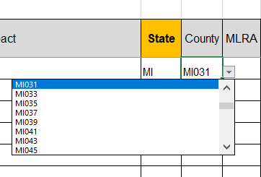
Figure 4

After selecting a state, the county field will have choices limited to just the selected state, in this case MI. After moving to the County field and clicking on the downward-pointed triangle, it can be seen that only a few choices are allowable.

Editing Long Choice Lists

To edit the choice list for one of the fields mentioned above, the user must click on the yellow tab at the bottom of the Excel window. The user will see the seven choice lists available in TSS workbooks.
TSS Type Service | MLRA
Recipient | State
Provider
Program
Table 2
To edit one or more of these lists, follow the steps shown in Figure 5.
After clicking on the yellow tab labeled “Advanced”, scroll horizontally until you see the name of the list from which you want to remove choices. For this example, the Parent Material list is used. Note: This is an example from one of the Excel 232 forms, but the process is the same in the Excel TSS Form.
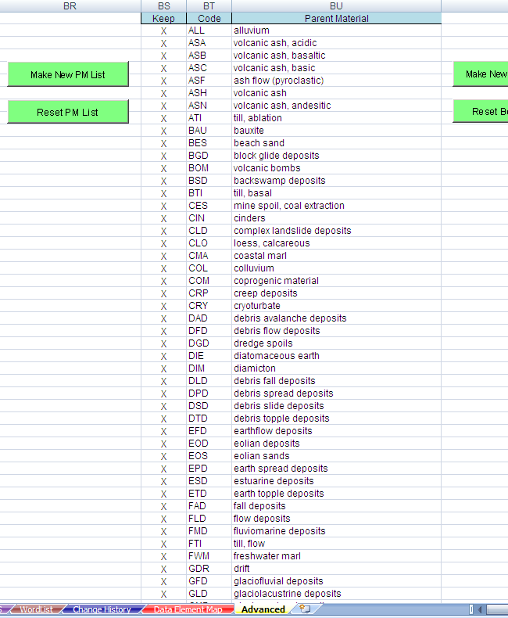
Figure 5

Put the cursor in the second row of the column named Keep. Then moving down the column one row at a time, delete the “X” out of the cell of the row with the choice you do not want displayed in the choice list for that field. Figure 6 shows that several rows (both contiguous and noncontiguous) have had the “X” deleted.
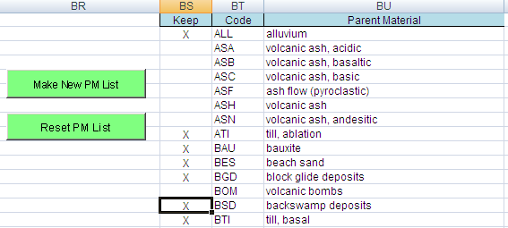
Figure 6

If you inadvertently delete the “X” from a row you want to keep or simply decide after deleting the “X” that you do want to display that choice, simply type UPPER case “X” in the appropriate cell.
After indicating the choice(s) you do not want displayed in the choice list, click on the Make New PM List button. The screen will flash and may show processing. At the end of the processing, the cursor will be located in the second row of the column named Code, as shown in Figure 7.
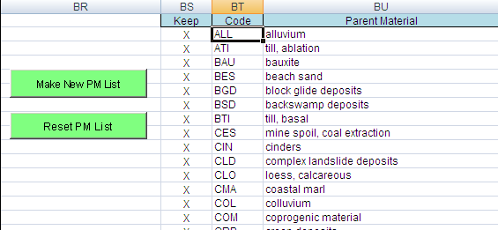
Figure 7

Once you have edited one or more of the available choice lists, click on the green tab with the name Front and save the workbook with an appropriate name, for example, TSS Your Name – 25 Oct 2019.xlms.
When you put the cursor in the field whose choices you have limited, you will notice that the choice list displays the first eight choices. If a choice or choices were removed but should be included and the error was not noticed until after clicking on the Make New PM List button, you will need to click on the Reset PM List button to display the original choice list and then redo the selection process.

Quality Control of Data to be Imported into NASIS

To find errors that may cause the import into NASIS to fail you should run the Error Check macro, by clicking on the green button labeled “Error Check.”
The Error Check button/macro may interact with the user prior to completing to display some information on errors found. Other than this interaction, the error checking process will display a popup message box when it completes the error check.
The Error Check macro checks for a multitude of potential errors and potential inconsistencies. When it identifies an error or inconsistency it writes a message to the error log file that is displayed after the macro is completed. Figure 8 is an example of the message displayed when the error checking is completed.
Clicking on the OK button will display the error log file containing information about the error and where it was found. A Fatal error is one that will cause the import into NASIS to fail. The Error Report shown in Figure 8 is not the one linked to the Error Check Report example shown in Figure 9.
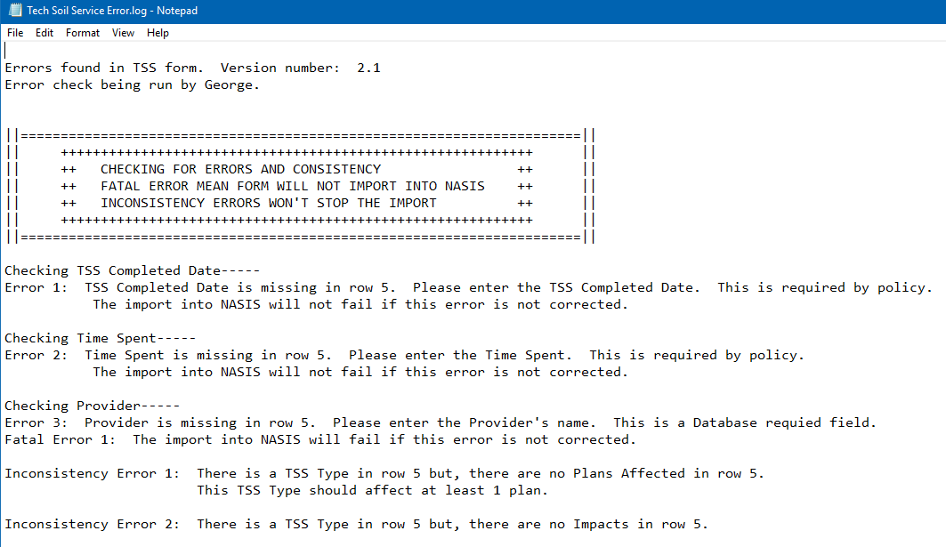
Figure 8
This file can be found in the C:\temp directory on your computer. It can also be printed to help you fix the errors that were found.
Once you have fixed the errors, you should run the Error Check macro again. At some point during the error fixing iterations, you will have fixed all the errors that have been found and you will get a message dialog box like the one shown in Figure 9.
The final Fatal Error check is made when you import the spreadsheet into NASIS. NASIS is able to identify errors that the data validation methods cannot. Some validations, however, can catch some potential inconsistency type errors that NASIS does not check upon import (such as checking if the horizon lower depth is less than the horizon upper depth).

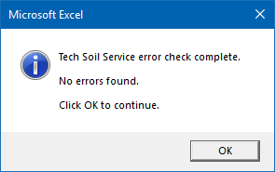
Figure 9

