Asian & Pacific Islander Month & The Potluck Challenge

May is National Asian and Pacific Islander Heritage Month

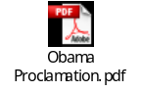Click on this link to see the Proclamation by President Barack Obama.

It’s Back! Asian American Pacific Islander Statewide Potluck Challenge!
Join in the fun. Schedule & experience a potluck at your NRCS office featuring food from Asia and the Pacific Islands! Include our other USDA conservation partners in this challenge. Take pictures of your event, send them to me to show that you have participated in the event. If you participate you can put this event on your performance plan & in your Civil Rights file.
Click on the link Photos API Potluck 2008 to view pictures & captions from South Dakota’s 2008 API Potluck Challenge. Everyone that participated enjoyed sharing API foods with their coworkers.
* * * * * * * * * * * * * * * * * * * * * * * * * * * * * * * * * * *
Sioux Falls Festival of Cultures
South Dakota is a little lacking in Asian and Pacific Islander events this month, but I wanted to make you aware of the Sioux Falls Festival of Cultures, an annual FREE event taking place this year on Saturday, June 20, 2009 between 11:00 am & 7:00 pm at Falls Park. The celebration begins with the “Walk of Cultures”, where children ages 6 to 12 are invited to carry the flags of nearly 200 countries and Native American nations. All cultures come together in celebration of diversity, enjoying ethnic food, music and dancing, arts and crafts, and children’s activities from around the globe.

Submitted by Mary Ellen Vaillancourt, Soil Conservationist & SD AAPI SEPM, May 2009

2009 AAPI Heritage Month Poster Winner:

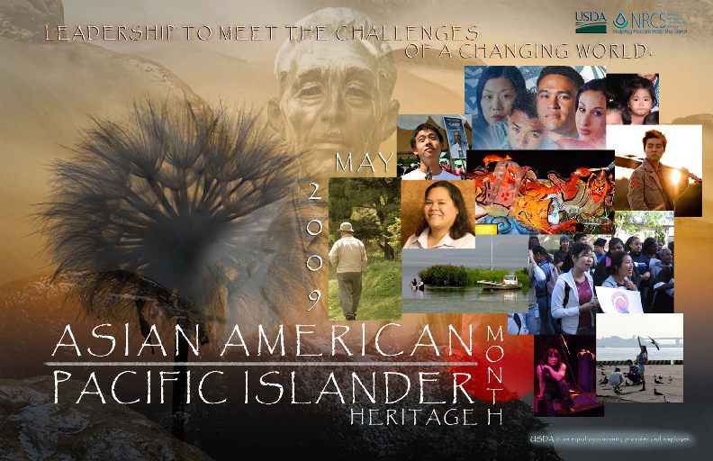

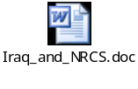 Thomas Share created the winning poster for the 2009 Asian American/Pacific Islander Heritage Month Poster Contest. Tom is a Civil Engineering Technician with the Watershed Planning Staff in the NRCS State Office in Davis, California, where his primary duties are GIS, cartography, and support. With the skills that he has developed in his job and his interest in graphic design, Tom has been called upon by the public affairs staff to help with the design and layout of presentation displays, posters, and publications. Tom says “I get to do a lot of the stuff I love to do and get paid to do it! How can it get any better?”
When asked about the inspiration behind his poster design, Tom replied “in designing this poster I wanted to show our challenges in a diverse way and emphasize that all cultures and ages are facing them together. The old man in the background was a late addition that I feel kind of completes the story that the challenges and changes we see span the generations.

To print the poster, double-click on the icon below:
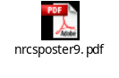

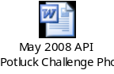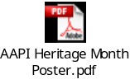
References

http://74.125.113.132/search?q=cache:BoHYfhVCvFsJ:www.siouxfallsevents.com/eventDetails.CFM%3FEventID%3D6952+South+Dakota+Cultural+Diversity+Events&cd=6&hl=en&ct=clnk&gl=us
http://www.dtsf.com/events/?showdate=2009-06-20&goto=1

